Boat Tips

Clean Water
Many people in Florida enjoy using local rivers, waterways and lakes for fishing, skiing, etc. Learn to use your boat wisely, to limit your impact and help preserve our precious water resources.

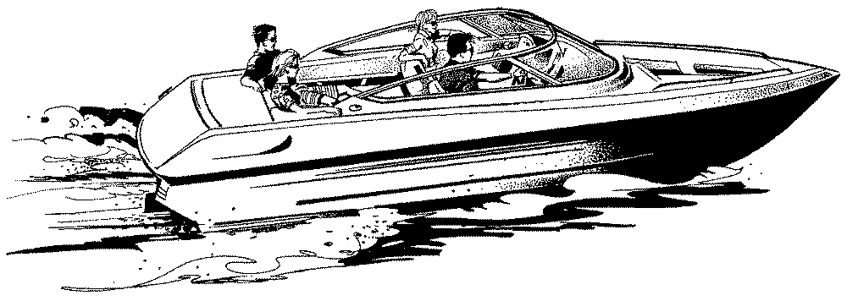
Use on-shore garbage and sewage facilities as much as possible.

Always use pump-out facilities to empty on-board sewage holding tanks.

Minimize the use of plastic disposable objects. If used, be sure to dispose of them properly on land.

Keep a sealable container for garbage on your boat. Make sure everyone uses it. When disposing of your garbage at a marina, follow their recycling rules.

Never litter. Retrieve all items dropped into water, especially old fishing line. Retrieve any litter found in the water.

Place a bilge pillow-an oil absorbing sponge available in marine stores-in your bilge to remove oil from your bilge water.

Do not fill bottles or cans with water and try to sink them. Dispose of them properly on shore.
Check your engine regularly to see if it is leaking oil or gas. When filling gas tanks or adding oil, be careful not to spill.

When cleaning your boat, avoid toxic polishes or stain removers near the water line.

