Chapter 7 IMPLEMENTATION For Northern Palm Beach County Regional Model

7.1 Introductions

The configuration and validation of the Northern Palm Beach County Model were presented in Chapter 6. This chapter presents the simulation results of the model to explore the opportunity to capture and store excess runoff from the C-18 Basin and L-8 Basin during wet season and export water to the Northwest Fork of Loxahatchee River during dry season.

The Loxahatchee River and Estuary and its watershed are located on the East Coast of Florida within northern Palm Beach and southern Martin Counties. It is unique in south Florida for the amount of natural areas that still remain intact. The Loxahatchee Estuary central embayment is at the confluence of three major tributaries: the Northwest Fork, the North Fork, and the Southwest Fork. The Northwest Fork represents one of the largest vestiges of native cypress river-swamp within southeast Florida. However, human activities have dramatically altered the natural drainage patterns within the Loxahatchee River watershed. The upstream migration of salt water into the historic freshwater reaches is the likely cause of the altered floodplain cypress forest community along the Northwest Fork and some of its tributaries. The Minimum Flows and Levels for the Northwest Fork were determined by South Florida Water Management District (SFWMD) based on previous studies. The question that we were trying to answer in this chapter is how to deliver supplemental water to the Northwest Fork of Loxahatchee River to meet the minimum flow request.

In our simulation, focuses on the three structures that are the outlet of the C-18 Canal. Structure S-46 is a gated spillway located on C-18 Canal just north of Indiantown Road. It delivers water to the Southwest Fork of Loxahatchee River. The gate of the structure S-46 is operated to maintain an optimum headwater elevation through automatic operation of the gates. The Lainhart Dam is a small weir structure located on the SIRCWD’s C-14 Canal upstream of the Northwest Fork of Loxahatchee River. Structure G-92 is a gated culvert, it diverts water from C-18 Canal to C-14 Canal. The structure is operated via remote telemetry from the SFWMD Operations Control Room under a joint agreement with the South Indian River Water Control District (SIRWCD) to permit conveyance of flows to the Northwest Fork of the Loxahatchee River through Lainhart Dam. More details can be found in Chapter 6 on these structures.

The minimum flow criteria used in this report were the water flow delivered to the Northwest Fork of Loxahatchee River through Lainhart Dam. According to Loxahatchee River Minimum Flows and Levels (MFL) (SFWMD, 2002), the proposed technical criteria for minimum flows were 35 cubic feet per second (cfs). A 65-cfs target flow was proposed in the North Palm Beach County Comprehensive Water Management Plan (SFWMD, 2002). SFWMD was also requested by the Bureau of Natural and Cultural Resources, Division of Recreation and Parks to provide 200 cfs or a minimum flow and level that will move the saltwater wedge outside the Jonathan Dickinson State Park boundary. The MFL criteria used in this report were 35 cfs, 65 cfs, and 100 cfs.

The target is to meet the criteria of minimum flows 100% of the time. The results from simulation of existing condition have been presented in Chapter 6. Under the existing conditions, the percent of time that the minimum flow of 35 cfs, 65 cfs, and 100 cfs at Lainhart Dam were met were 70%, 60%, and 54%, respectively in 1995−the year of simulation. Review of U.S. Geological Survey (USGS) flow records over the last 10 years show that the 65-cfs flow target is met only 57% of time under current conditions (SFWMD, 2002). The 1995 rainfall was above average and is expected to account for the substantive differences in meeting the identified flow rates.

In order to meet the minimum flow request, surface water storage facilities (e.g. reservoirs) were proposed in the C-18 Basin and the L-8 Basin. As addressed by SFWMD in Northern Palm Beach County CERP Project-Part 1 Project PIR/EIS, Goals, Objectives and Performance Measures (2003), a storage facility in the western C-18 Basin might help increase flows to the Northwest Fork of Loxahatchee River during the dry season and to reduce storm event discharges to the river via structure S-46 during wet season. Excess surface waters from the Corbett Water Management Area (Corbett WMA) and other land areas within the L-8 Basin might have less regional impact if a water storage facility were developed in the L-8 Basin to capture and at least detain storm event runoff prior to release to downstream area in more natural pattern. Further, development of a storage facility with adequate capacity could potentially offer regional water supply benefits if wet season runoff could be stored for subsequent use to manage regional water demands during at least a portion of the subsequent dry season, or during shorter term dry weather conditions. If adequate conveyance mechanisms were available, such stored waters could be diverted to meet natural system management goals (e.g. minimum flow and level at the Northwest Fork of Loxahatchee River) and /or potable water supply objectives.

In this chapter four scenarios as shown in Table 7.1 were studied. The surface water storage reservoirs were the key elements in the scenarios. The target was to meet the criteria of minimum flows 100% of the time at Lainhart Dam upstream of the Northwest Fork of Loxahatchee River. Water will be pumped into the reservoir from the canals during the wet season when excess water is available, and returned to the canals during the dry season.

Two reservoirs were considered in the study: 1) C-18 Reservoir located at the upstream of West Branch of C-18 Canal, and 2) L-8 Alternative Reservoir sited near the junction of the L-8 Canal and the South L-8 Tieback Canal and immediately west to L-8 Canal, as shown by Figure 6.6 of Chapter 6. Both reservoirs were modeled on a possible footprint of 1,000 acres or 2,000 acres. The maximum water depth of the reservoirs varied from10 feet to 15 feet. The total storage volume for each of the reservoirs ranged from 10,000 acre-feet to 30,000 acre-feet. Table 7.1 gives four scenarios studied by numerical simulations. CASE 1 and CASE 2 included only the C-18 Reservoir with a footprint of 1,000 acres and 2,000 acres, respectively. CASE 3 included both C-18 and L-8 Alternative Reservoirs with a footprint of 1000 acres each. In CASE 4, only the L-8 Alternative Reservoir was modeled on a footprint of 2000 acres.

Table 7.1 Reservoirs in simulations
Scenario | Reservoirs Included | Footprint of  C-18 Reservoir  (acre) | Footprint of  L-8 Alternative Reservoir  (acre)
CASE 1 | C-18 Reservoir | 1000 | N/A
CASE 2 | C-18 Reservoir | 2000 | N/A
CASE 3 | C-18 Reservoir and  L-8 Alternative Reservoir | 1000 | 1000
CASE 4 | L-8 Alternative Reservoir | N/A | 2000

The results of numerical simulations of CASE 1 through 4 are presented in Section 7.2. Section 7.3 summarizes the simulation results and gives some conclusions and recommendations.
7.2 Simulation Results

7.2.1 Case 1

The C-18 Reservoir was modeled on a footprint of 1,000 acres with a maximum water depth ranging from 10 feet to 15 feet. Figure 7.1 shows the layout of reservoirs and canal network system. More details on the reservoirs, canal reaches, and hydraulic structures can be found in Chapter 6. Under existing conditions, the connection between the Grassy Waters Preserve (GWP) and East Branch of C-18 Canal is by way of sheet flow. The current flow is negligible due to flow barrier created by construction of the Northlake Boulevard. Therefore, the L-8 Canal System and C-18 Canal System were considered as separable system in this case.

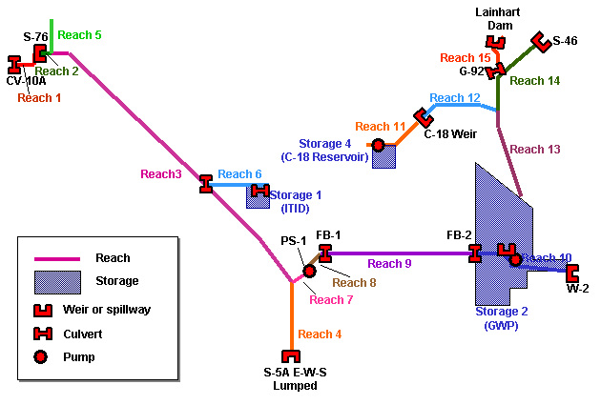
Figure 7.1 Reservoirs and canal network system in CASE 1

The connection between the reservoir and the West Branch of C-18 Canal was by way of a pump station with a capacity of up to 100 cfs. The operation of the pump was determined by the target flow and the actual flow at Lainhart Dam, water depth in the C-18 Reservoir, and water stage of the C-18 Canal near the pumping site. The three predefined target minimum flows were 35 cfs, 65 cfs, and 100 cfs, accordingly the simulations were named as CASE 1-35, CASE 1-65, and CASE 1-100, respectively. The results are presented in the subsequent sections.

7.2.1.1 Case 1-35

The target minimum flow at Lainhart Dam was set at 35 cfs. The parameters used in simulations A through D are given in Table 7.2. The maximum water depth of C-18 Reservoir was 10 feet for all simulations. The bottom elevation of the reservoir was assumed to be 12 feet NGVD. The initial water depth in the C-18 Reservoir was 6 feet for simulations A and B, 8 ft for simulation C, and 10 feet for simulations D. Back pumping means water being pumped from the C-18 Canal to C-18 Reservoir. The purposes of back pumping were: 1) capture and store water in the reservoir from the wet season runoff, and return the water to the canal during the dry season; and 2) reduce excessive discharge to the Loxahatchee River via structures S-46 and G-92 during the wet season.

Back pumping was disabled for simulation A but was allowed for simulations B, C, and D. The operating rules for the pump station at C-18 Reservoir are defined in Table 7.3. When the actual flow at Lainhart Dam was less than the target minimum flow of 35 cfs, and C-18 Reservoir was not empty, water was pumped out of the reservoir into C-18 Canal. Back pumping was triggered and water was pumped from the C-18 Canal back to C-18 Reservoir, when the flow at Lainhart Dam exceeded 130 cfs and stage of C-18 Canal at the pumping site is above 14 feet NGVD.

Table 7.2 Parameters for CASE 1-35
Simulation | Footprint of C-18 Reservoir (acre) | Max. Water Depth of  C-18 Reservoir  (feet) | Initial Water Depth of  C-18 Reservoir  (feet) | Target MF at Lainhart Dam  (cfs) | Back Pumping at C-18 Reservoir
1-35-A | 1,000 | 10 | 6 | 35 | No
1-35-B | 1,000 | 10 | 6 | 35 | Yes
1-35-C | 1,000 | 10 | 8 | 35 | Yes
1-35-D | 1,000 | 10 | 10 | 35 | Yes

Table 7.3 Pump operating rules for pump station at C-18 Reservoir
 | Pumping Rate (cfs) | Pumping Flow Direction
Flow at Lainhart Dam > 35 cfs | 0 | None
Flow at Lainhart Dam 35 cfs, and water depth of C-18 Reservoir > 0. | 35 | C-18 Reservoir → C-18 Canal
Back Pumping Option for simulations 1-35-B, 1-35-C, 1-35-D:  Flow at Lainhart Dam > 100 cfs, and water depth of C-18 Reservoir < Max. Water Depth, and water stage of C-18 Canal at pumping site > 14 ft | 35 | C-18 Canal → C-18 Reservoir
Otherwise | 0 | None

The target was to meet the 35-cfs minimum flows 100% of the time. Thus the pump station at C-18 Reservoir was operated to maintain a 35-cfs minimum flow according to the pump operating rules defined in Table 7.3. Table 7.4 gives the percent of time the target minimum flow was met at Lainhart Dam in the simulations. Though 35 cfs was the target flow, the percent of time that 65 cfs and 100 cfs were met are also given in the table for comparison. The cumulative flows through structures S-46, G-92, and Lainhart Dam were calculated in the simulations, the results are shown in Table 7.5. Table 7.6 gives the percent of time that the pump at C-18 Reservoir was turned on for pumping or back pumping and the quantities of water being pumped. The effective capacity and effectiveness of C-18 Reservoir are given in Table 7.7. The hydrograph at Lainhart Dam is presented in Figure 7.2. Figure 7.3 shows the variation of water stage in C-18 Reservoir in the year of simulation. The pumping rate of the pump at C-18 Reservoir is plotted as a function of time in Figure 7.4.

The results in Table 7.4 indicate that the 35-cfs target flow was met 100% of the time in the year of simulation for all four cases, as it can be also observed clearly in Figure 7.2 showing that the flow at Lainhart Dam remains above 35 cfs for all the time in the year of simulation. The variation of water stage in C-18 Reservoir is displayed in Figure 7.3. The lowest water stage of 15.8 ft or 3.8 ft in water depth occurred in simulation A.

Table 7.6 indicates that the pump was turned on 13% of the time (1140 hours in the year of simulation) in simulation A. In simulations B through D, the percentage of pumping time was 14%, compared to the percentage of back pumping that varied from 21% down to 8%. The amount of water being pumped out of C-18 Reservoir was 3,396 acre-feet for simulation A and 3425 acre-feet for simulations B through D. The back pumping was activated and the reservoir was filled to its full capacity (Figure 7.3 (b), (c), and (d)) during the wet season in simulations B through D, where the storage capacity of the reservoir can be fully utilized.

The definition of the effective capacity for a reservoir as proposed in Chapter 2 is the water storage corresponding to the minimum water-surface level in a given period of time. The effectiveness is defined as the ratio between the effective capacity and the total capacity of the reservoir. In the simulations conducted in this chapter, the effective capacity and effectiveness are modified due to releases and back pumping associated with the reservoir. We now use the term operational effectiveness. The operational effectiveness of C-18 Reservoir simulations is included in Table 7.7. The effectiveness increases from 38% in simulation A to 75% in simulation D. Generally, back pumping improves the operational effectiveness. The results from simulations B through D indicate that higher water storage at the beginning of the year increases the operational effectiveness of the reservoir. When the operational effectiveness is zero, the reservoir is at risk of not meeting releases. The conclusion that is drawn from the simulations presented in this section is that the C-18 Reservoir based on a 1,000 acre footprint with a maximum water depth of 10 feet was able to meet the 35-cfs target minimum flow 100% of the time in the year of simulation.

Table 7.4 Percent of time the target minimum flow is met at Lainhart Dam
Simulation | Percent of Time The Following Target Flow Was Met  (1/1/95 -12/31/95)
Simulation | ≥ 35 (cfs) | ≥ 65 (cfs) | ≥ 100 (cfs)
1-35-A | 100% | 59% | 54%
1-35-B | 100% | 59% | 51%
1-35-C | 100% | 59% | 51%
1-35-D | 100% | 59% | 54%

Table 7.5 Cumulative flow through structures S-46, G-92 and Lainhart Dam
Simulation | Cumulative Flow through the Following Structures (acre-feet)  (1/1/95 -12/31/95)
Simulation | S-46 | G-92 | Lainhart Dam
1-35-A | 104770 | 63394 | 80915
1-35-B | 100975 | 61949 | 79470
1-35-C | 102518 | 61970 | 79491
1-35-D | 103198 | 62928 | 80449

Table 7.6 Pumping operation at C-18 Reservoir
Simulation | Percent of Time the Pump Is in Operation  (1/1/95-12/31/95) |  |  |  |  | Amount of Water Being Pumped  (acre-feet)
Simulation | Pumping |  | Back Pumping |  | Off | Pumping |  | Back Pumping
1-35-A | 13% |  | 0% |  | 87% | 3396 |  | 0
1-35-B | 14% |  | 21% |  | 65% | 3425 |  | 5276
1-35-C | 14% |  | 15% |  | 71% | 3425 |  | 3714
1-35-D | 14% |  | 8% |  | 78% | 3425 |  | 2080

Table 7.7 Operational Effective Capacity and Effectiveness of C-18 Reservoir
Simulation |  | C-18 Reservoir
 |  | Total Capacity  (acre-feet) |  | Operational Effective Capacity  (acre-feet) |  |  | Operational Effectiveness
1-35-A |  | 10000 |  | 3800 |  |  | 38%
1-35-B |  | 10000 |  | 5100 |  |  | 51%
1-35-C |  | 10000 |  | 7100 |  |  | 71%
1-35-D |  | 10000 |  | 7500 |  |  | 75%

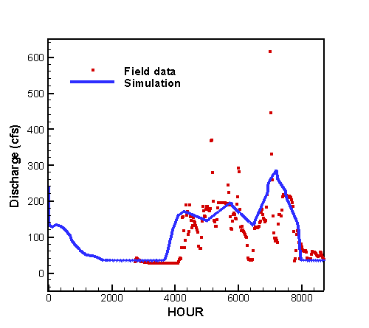 | 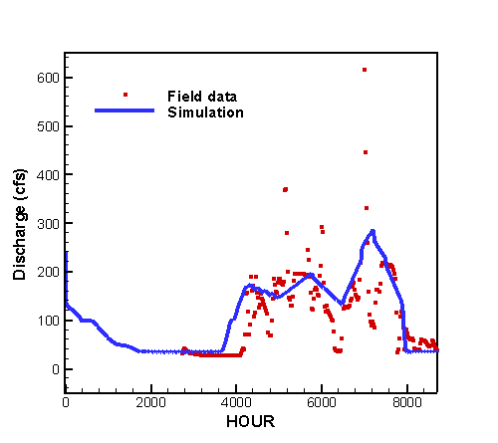
(a) Simulation 1-35-A | (b) Simulation 1-35-B
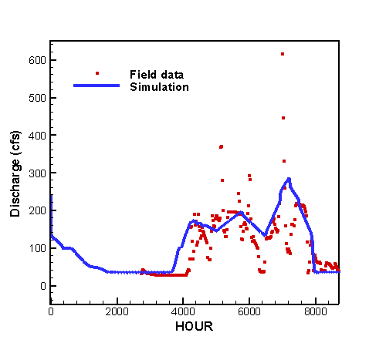 | 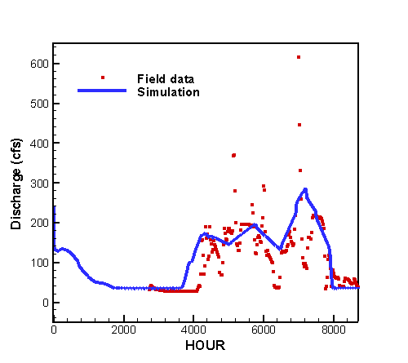
(c) Simulation 1-35-C | (d) Simulation 1-35-D

Figure 7.2 Hydrograph at Lainhart Dam from 1/1/95 through 12/31/95

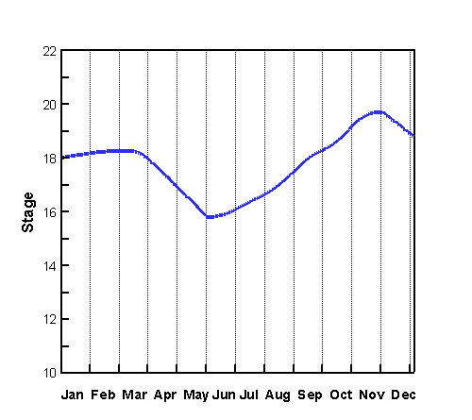 | 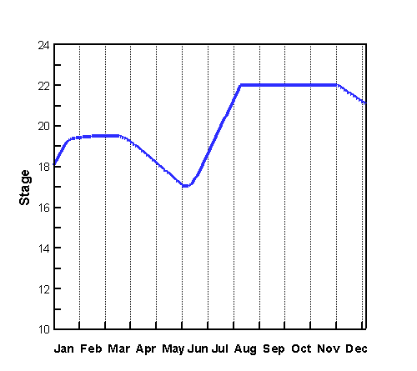
(a) Simulation 1-35-A | (b) Simulation 1-35-B
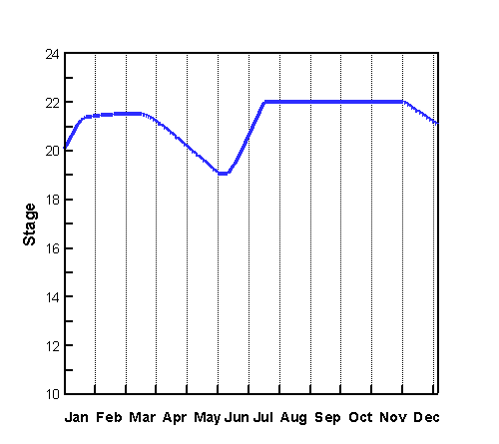 | 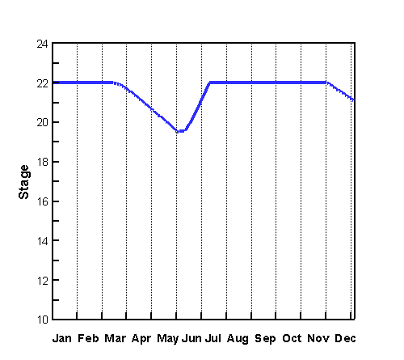
(c) Simulation 1-35-C | (d) Simulation 1-35-D

Figure 7.3 Water Stage of C-18 Reservoir from 1/1/95 through 12/31/95.

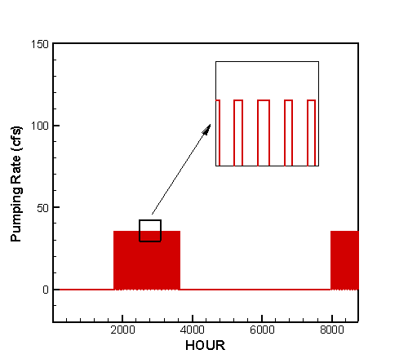 | 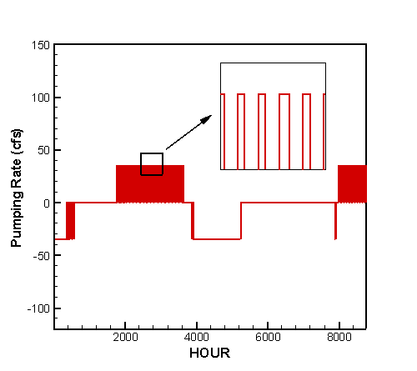
(a) Simulation 1-35-A | (b) Simulation 1-35-B
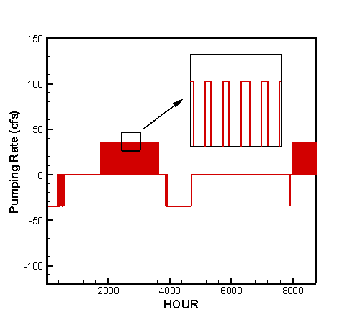 | 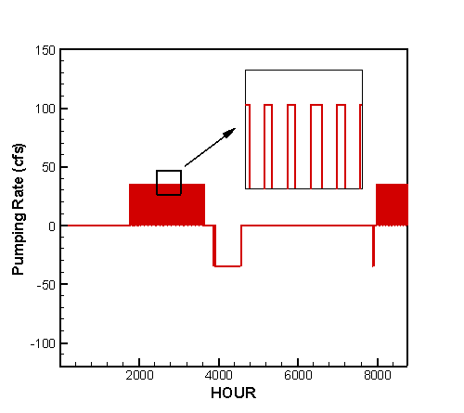
(c) Simulation 1-35-C | (d) Simulation 1-35-D

Figure 7.4 Pumping rate of pump at C-18 Reservoir from 1/1/95 through 12/31/95.

7.2.1.2 Case 1-65

This case set the target minimum flow at Lainhart Dam at 65 cfs. Six simulations were carried out as listed in Table 7.8, showing the parameters used in simulations A through F. The footprint of C-18 Reservoir was 1,000 acres for all simulations in this case. The bottom elevation of the reservoir was assumed to be 12 ft. The maximum water depth representing the maximum storage capacity of the reservoir was 10 ft for simulation A through D, 12 ft for simulation E, and 15 ft for simulation F.

The operating rules for the pump station at C-18 Reservoir are given in Table 7.9. When the flow at Lainhart Dam was less than the target minimum flow, and the C-18 Reservoir was not empty, water was pumped from the reservoir to the West Branch of C-18 Canal. Back pumping (water being pumped from the C-18 Canal to C-18 Reservoir) was disabled for simulation A. In simulations B through F, back pumping was triggered when the flow at Lainhart Dam exceeded 130 cfs. The aim of back pumping was to catch and store portion of runoff and to reduce excessive discharge to the Loxahatchee River via structures S-46 and G-92 during the wet season.

Table 7.8 Parameters for CASE 1-65
Simulation | Footprint of  C-18 Reservoir (acre) | Max. Water Depth of  C-18 Reservoir  (ft) | Initial Water Depth of  C-18 Reservoir  (ft) | Target MF at Lainhart Dam  (cfs) | Back Pumping at C-18 Reservoir
1-65-A | 1,000 | 10 | 6 | 65 | No
1-65-B | 1,000 | 10 | 6 | 65 | Yes
1-65-C | 1,000 | 10 | 8 | 65 | Yes
1-65-D | 1,000 | 10 | 10 | 65 | Yes
1-65-E | 1,000 | 12 | 12 | 65 | Yes
1-65-F | 1,000 | 15 | 15 | 65 | Yes

Table 7.9 Pump operating rules for pump station at C-18 Reservoir
 | Pumping Rate (cfs) | Pumping Flow Direction
Flow at Lainhart Dam > 65 cfs | 0 | None
Flow at Lainhart Dam 65 cfs, and water depth of C-18 Reservoir > 0. | 65 | C-18 Reservoir → C-18 Canal
Back Pumping Option for simulations 1-65-B, 1-65-C, 1-65-D, 1-65-E, 1-65-F:  Flow at Lainhart Dam > 130 cfs, and water depth of C-18 Reservoir < Max. Water Depth, and water stage of C-18 Canal at pumping site > 14 ft | 65 | C-18 Canal → C-18 Reservoir
Otherwise | 0 | None

The target was to meet the 65-cfs target minimum flows 100% of the time. Thus the pump station at C-18 Reservoir was operated to maintain a 65-cfs minimum flow at Lainhart Dam. Table 7.10 summarizes the percent of time that the 65-cfs target was met at Lainhart Dam in the simulations as well as the percentages for 35-cfs and 100-cfs minimum flows. The cumulative flows through structures S-46, G-92, and Lainhart Dam were calculated in the simulations, the results are shown in Table 7.11. Table 7.12 gives the percent of time that the pump at C-18 Reservoir is under operation and the amount of water being pumped. The effective capacity and effectiveness of C-18 Reservoir are listed in Table 7.13. The hydrograph at Lainhart Dam is presented in Figure 7.5. Figure 7.6 displays the variation of water stage in C-18 Reservoir in the year of simulation. The pumping rate of the pump at C-18 Reservoir is plotted as a function of time in Figure 7.7.

In simulations A and B, the C-18 Reservoir was totally drained to empty for a period of time in May and June of the simulation year, as shown by Figure 7.6 (a) and (b). During the same period of time, the pump at C-18 Reservoir was shut off, showing by Figure 7.7 (a) and (b). As a result, the flow at Lainhart Dam dropped below 65 cfs and even below 35 cfs (Figure 7.5 (a) and (b)). Thus the 65-cfs target minimum flow was met only 93% and 94% of the time in the year of simulation. In simulation A, back pumping was not activated for the pump at C-18 Reservoir. According to Table 7.12, 9132 acre-feet of water was pumped out of the reservoir in 1995, the falling of water stage in the reservoir due to out-pumping could not be recovered by rainfall. At the end of year, the water depth of C-18 Reservoir dropped to 1 ft which was much less than 6 ft – the initial water depth at the beginning of the year. This result indicates that back pumping is necessary to keep the reservoir in continuous operation. In simulations B through F, when back pumping was activated, the C-18 Reservoir was filled to its full capacity during the wet season, as shown in Figure 7.6 (b) through (f).

In simulations C through F, the target minimum flow of 65 cfs was met 100% of the time in the year of simulation. In these simulations, the yearly cumulative flow through Lainhart Dam was 88239 acre-feet (Table 7.11). However, showing by Figure 7.6, in simulations C and D, at the end of the year, water depth of C-18 Reservoir dropped to 7 ft, which means that the reservoir could provide much less water in the subsequent year and the 65-cfs target flow could be missed. A possible solution to this problem is to increase the maximum water depth of the reservoir. In simulations E and F, the maximum water depth of the reservoir was increased by 2 ft and 5 ft to a total depth of 12 ft and 15 ft, respectively. Showing by Table 7.10 and Figure 7.5, the 65-cfs target flow was met 100% of the time and the amount of water stored in the reservoir at the end of the year was likely to meet the demand for the subsequent year.

In simulations D through F, the pump at C-18 Reservoir was turned on 24% of the time (2102 hours) pumping water out of the reservoir and 15% of the time (1314 hours) pumping water back to the reservoir, as shown in Table 7.12.

Table 7.13 shows the operational effective capacity and effectiveness of C-18 Reservoir in the year of simulation. In simulations A and B, the C-18 Reservoir was drained to empty during the dry season. Thus, according to the definition given in Chapter 2, the effective capacity was 0 acre-feet and the effectiveness was 0%. The effectiveness increases from 3% in simulation C to 45% in simulation F. The results indicate that a deeper reservoir tends to have higher effectiveness.

The conclusion from this section is that the C-18 Reservoir based on a 1000-acre footprint with a maximum water depth of 12 ft was able to meet the 65-cfs target minimum flow request in the year of simulation.

Table 7.10 Percent of time the target minimum flow is met at Lainhart Dam
Simulation | Percent of Time The Following Target Flow Was Met  (1/1/95 -12/31/95)
Simulation | ≥ 35 (cfs) | ≥ 65 (cfs) | ≥ 100 (cfs)
1-65-A | 94% | 93% | 54%
1-65-B | 95% | 94% | 54%
1-65-C | 100% | 100% | 54%
1-65-D | 100% | 100% | 54%
1-65-E | 100% | 100% | 54%
1-65-F | 100% | 100% | 54%

Table 7.11 Cumulative flow through structures S-46, G-92 and Lainhart Dam
Simulation | Cumulative Flow through the Following Structures (acre-feet)  (1/1/95 -12/31/95)
Simulation | S-46 | G-92 | Lainhart Dam
1-65-A | 104770 | 69152 | 86660
1-65-B | 96330 | 69015 | 86552
1-65-C | 96556 | 70731 | 88239
1-65-D | 97982 | 70828 | 88335
1-65-E | 97982 | 70828 | 88335
1-65-F | 97982 | 70828 | 88335

Table 7.12 Pumping operation at C-18 Reservoir
Simulation | Percent of Time the Pump Is in Operation  (1/1/95-12/31/95) |  |  | Amount of Water Being Pumped  (acre-feet)
Simulation | Pumping | Back Pumping | Off | Pumping | Back Pumping
1-65-A | 19% | 0% | 81% | 9132 | 0
1-65-B | 21% | 19% | 60% | 9744 | 8965
1-65-C | 24% | 19% | 57% | 11436 | 8751
1-65-D | 24% | 15% | 61% | 11216 | 7220
1-65-E | 24% | 15% | 61% | 11216 | 7220
1-65-F | 24% | 15% | 61% | 11216 | 7220

Table 7.13 Operational Effective Capacity and Effectiveness of C-18 Reservoir
Simulation | C-18 Reservoir
Simulation | Total Capacity  (acre-feet) | Operational Effective Capacity  (acre-feet) | Operational Effectiveness
1-65-A | 10000 | 0 | 0%
1-65-B | 10000 | 0 | 0%
1-65-C | 10000 | 300 | 3%
1-65-D | 10000 | 1700 | 17%
1-65-E | 12000 | 3700 | 31%
1-65-F | 15000 | 6700 | 45%

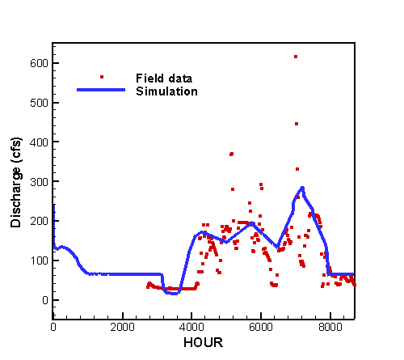 | 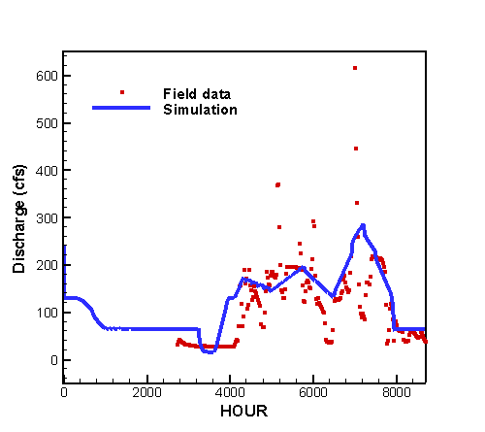
(a) Simulation 1-65-A | (b) Simulation 1-65-B
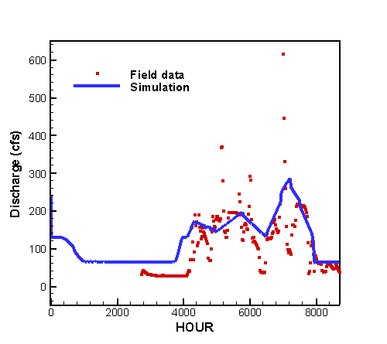 | 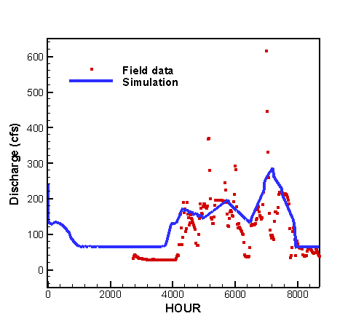
(c) Simulation 1-65-C | (d) Simulation 1-65-D
(e) Simulation 1-65-E | (f) Simulation 1-65-F

Figure 7.5 Hydrograph at Lainhart Dam from 1/1/95 through 12/31/95
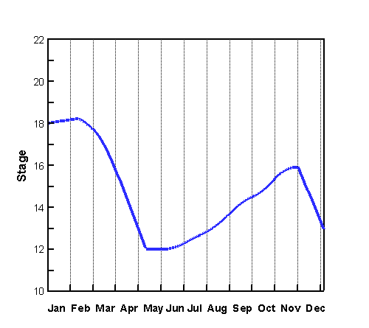 | 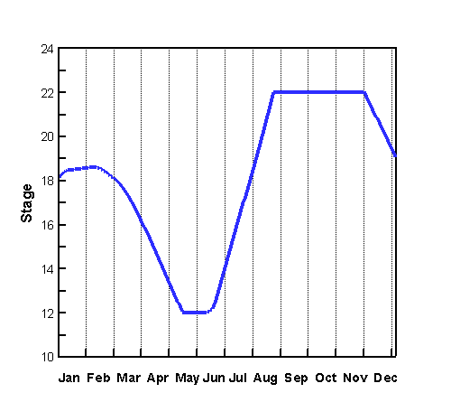
(a) Simulation 1-65-A | (b) Simulation 1-65-B
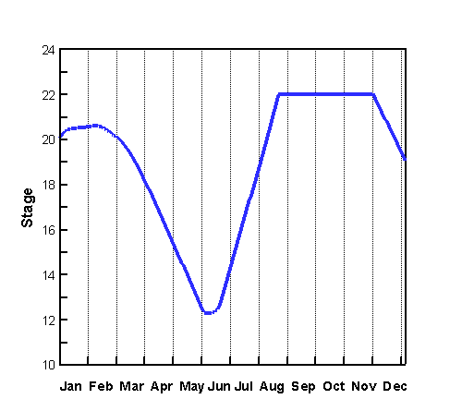 | 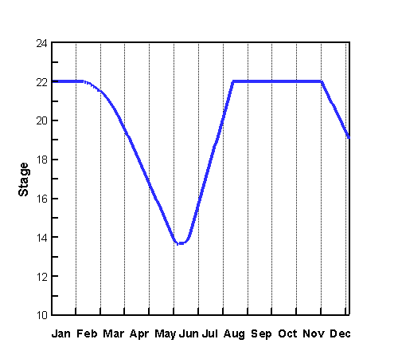
(c) Simulation 1-65-C | (d) Simulation 1-65-D
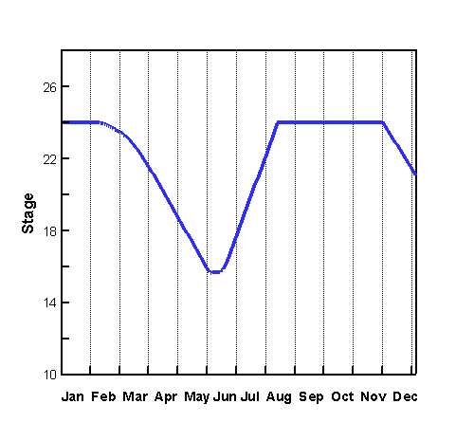 | 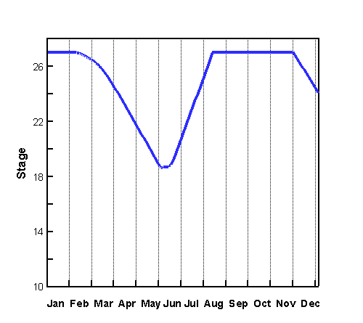
(e) Simulation 1-65-E | (f) Simulation 1-65-F
Figure 7.6 Water Stage of C-18 Reservoir from 1/1/95 through 12/31/95.

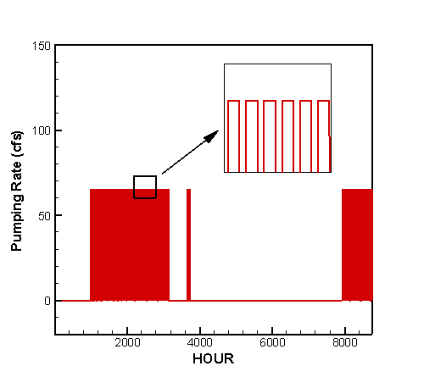 | 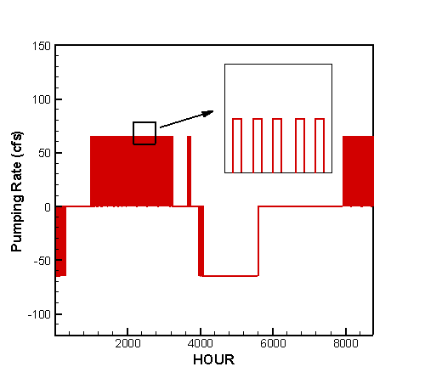
(a) Simulation 1-65-A | (b) Simulation 1-65-B
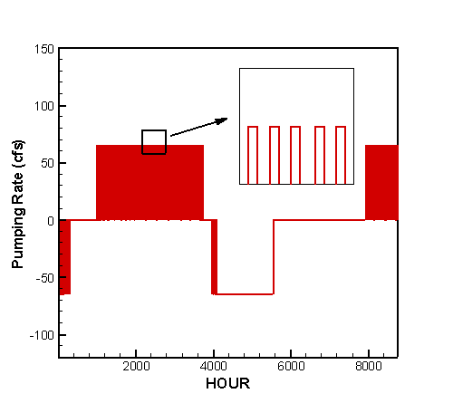 | 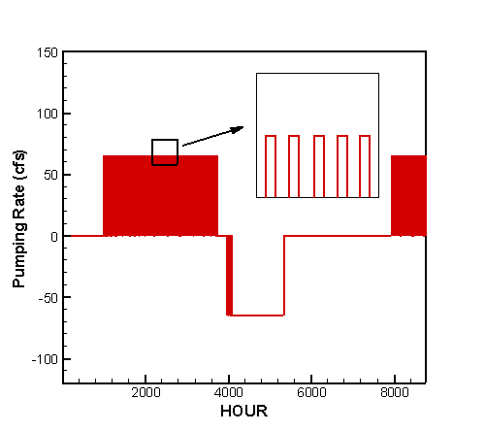
(c) Simulation 1-65-C | (d) Simulation 1-65-D
(e) Simulation 1-65-E | (f) Simulation 1-65-F
Figure 7.7 Pumping rate of pump at C-18 Reservoir from 1/1/95 through 12/31/95.

7.2.1.3 Case 1-100

In this case, the target minimum flow at Lainhart Dam was 100 cfs. The parameters used in the simulations A through F are given in Table 7.14, showing that the footprint of C-18 Reservoir was 1000 acres. The bottom elevation of the reservoir was assumed to be 12 feet NGVD. The maximum water depth of the reservoir that represents its maximum storage capacity was 10 feet for simulations A through D, 12 feet for simulation E, and 15 feet for simulation F.

Table 7.15 summarizes the operating rules for the pump station at C-18 Reservoir. When the flow at Lainhart Dam was less than the 100-cfs target minimum flow, and the C-18 Reservoir was not empty, water was pumped from the reservoir the West Branch of C-18 Canal. Back pumping refers to the operation that water is pumped from the C-18 Canal to C-18 Reservoir. There was no back pumping in simulation A. In simulations B through F, back pumping was triggered when the flow at Lainhart Dam exceeded 150 cfs.

Table 7.14 Parameters for CASE 1-100
Simulation | Footprint of  C-18 Reservoir (acre) | Max. Water Depth of  C-18 Reservoir  (ft) | Initial Water Depth of  C-18 Reservoir  (ft) | Target MF at Lainhart Dam  (cfs) | Back Pumping at C-18 Reservoir
1-100-A | 1,000 | 10 | 6 | 100 | No
1-100-B | 1,000 | 10 | 6 | 100 | Yes
1-100-C | 1,000 | 10 | 8 | 100 | Yes
1-100-D | 1,000 | 10 | 10 | 100 | Yes
1-100-E | 1,000 | 12 | 12 | 100 | Yes
1-100-F | 1,000 | 15 | 15 | 100 | Yes

Table 7.15 Pump operating rules for pump station at C-18 Reservoir
 | Pumping Rate (cfs) | Pumping Flow Direction
Flow at Lainhart Dam > 100 cfs | 0 | None
Flow at Lainhart Dam 100 cfs, and water depth of C-18 Reservoir > 0. | 100 | C-18 Reservoir → C-18 Canal
Back Pumping Option for simulations 1-100-B, 1-100-C, 1-100-D, 1-100-E, 1-100-F:  Flow at Lainhart Dam > 150 cfs, and water stage of C-18 Reservoir < Max. Water Depth, and water stage of C-18 Canal at pumping site > 14 ft | 100 | C-18 Canal → C-18 Reservoir
Otherwise | 0 | None

The target was to meet the 100-cfs minimum flows 100% of the time. Thus the pump station at C-18 Reservoir was operated to maintain a 100 cfs minimum flow at Lainhart Dam. Table 7.16 gives the percent of time the target minimum flow was met at Lainhart Dam in the simulations. The cumulative flows through structures S-46, G-92, and Lainhart Dam were calculated in the simulations, the results are shown in Table 7.17. Table 7.18 gives the percent of time that the pump at C-18 Reservoir is under operation and the amount of water being pumped. The effective capacity and effectiveness of C-18 Reservoir are shown in Table 7.19. The hydrograph at Lainhart Dam is presented in Figure 7.8. Figure 7.9 shows the variation of water stage in C-18 Reservoir in the year of simulation. The pumping rate of the pump at C-18 Reservoir is plotted as a function of time in Figure 7.10.

As shown in Table 7.16, though the percent of time that the 100-cfs target minimum flow was met increases from 78% in simulation A to 95% in simulation F, none of the simulations met the 100-cfs target flow 100% of the time. The reason is that the C-18 Reservoir was emptied for a portion of in the year of simulation, which can be observed from Figure 7.9, making it impossible to supply water. As a result, the pump at C-18 Reservoir stopped pumping water to the C-18 Canal (Figure 7.10). When the pump was turned off, the sudden drop that occurred to the hydrograph at Lainhart Dam (Figure 7.8) indicates that the flow fell below 100 cfs and the target was missed. Figure 7.9 shows that the C-18 Reservoir was filled to its full capacity in the summer in simulations with back pumping. Nevertheless, since the reservoir was drained to empty before the wet season came, back pumping could not guarantee to reach the 100-cfs target minimum flow 100% of the time if the capacity of the reservoir is not large enough. Based on a fixed footprint, the only way to enlarge a reservoir is to increase the depth. However, in simulation F, the maximum water depth of C-18 Reservoir had already been increased to 15 feet. Any depth beyond 15 feet would require a complex design and is outside of the scope of this report. Therefore, this report is recommending that other options should be pursued to meet the 100-cfs target flow.

The operational effective capacity for the C-18 Reservoir is given in Table 7.19, showing that the operational effective capacity was 0 acre-feet for all simulations in this case. This is because the C-18 Reservoir was drained to empty during the dry season. Thus, the reservoir would not be able to meet the 100 cfs MFLs in the Loxahatchee River all of the time. There is a risk in meeting the MFL for the period of simulation.

The conclusion from this section is that the C-18 Reservoir based on a 1,000-acre footprint with a maximum water depth of 15 feet was not able to meet the 100 cfs target minimum flow in the year of simulation.

Table 7.16 Percent of time the target minimum flow was met at Lainhart Dam
Simulation | Percent of Time The Following Target Flow Was Met  (1/1/95 -12/31/95)
Simulation | ≥ 35 (cfs) | ≥ 65 (cfs) | ≥ 100 (cfs)
1-100-A | 81% | 79% | 78%
1-100-B | 83% | 82% | 80%
1-100-C | 86% | 85% | 84%
1-100-D | 89% | 88% | 87%
1-100-E | 92% | 91% | 90%
1-100-F | 98% | 96% | 95%

Table 7.17 Cumulative flow through structures S-46, G-92 and Lainhart Dam
Simulation | Cumulative Flow through the Following Structures (acre-feet)  (1/1/95 -12/31/95)
Simulation | S-46 | G-92 | Lainhart Dam
1-100-A | 104770 | 70164 | 87692
1-100-B | 96036 | 71257 | 88752
1-100-C | 96035 | 73287 | 90782
1-100-D | 96079 | 75098 | 92593
1-100-E | 94329 | 77096 | 94591
1-100-F | 91771 | 80099 | 97595

Table 7.18 Pumping operation at C-18 Reservoir
Simulation | Percent of Time the Pump Is in Operation  (1/1/95-12/31/95) |  |  | Amount of Water Being Pumped  (acre-feet)
Simulation | Pumping | Back Pumping | Off | Pumping | Back Pumping
1-100-A | 14% | 0% | 86% | 10314 | 0
1-100-B | 16% | 12% | 72% | 11876 | 8950
1-100-C | 19% | 12% | 69% | 13867 | 8950
1-100-D | 22% | 12% | 66% | 15694 | 8901
1-100-E | 24% | 15% | 61% | 17685 | 10644
1-100-F | 29% | 18% | 53% | 20669 | 13190

Table 7.19 Operational Effective Capacity and Effectiveness of C-18 Reservoir
Simulation | C-18 Reservoir
Simulation | Total Capacity  (acre-feet) | Operational Effective Capacity  (acre-feet) | Operational Effectiveness
1-100-A | 10000 | 0 | 0%
1-100-B | 10000 | 0 | 0%
1-100-C | 10000 | 0 | 0%
1-100-D | 10000 | 0 | 0%
1-100-E | 12000 | 0 | 0%
1-100-F | 15000 | 0 | 0%

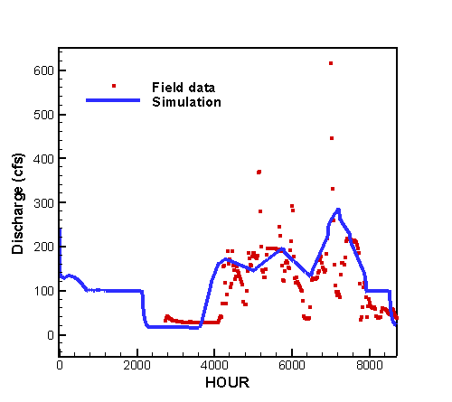 | 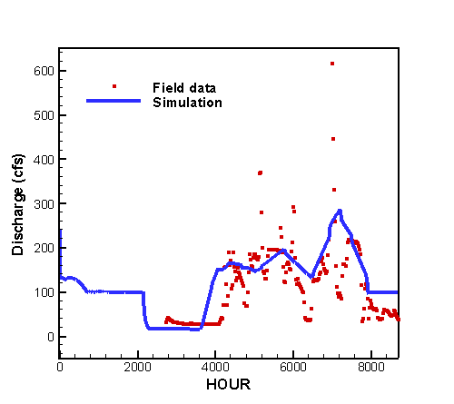
(a) Simulation 1-100-A | (b) Simulation 1-100-B
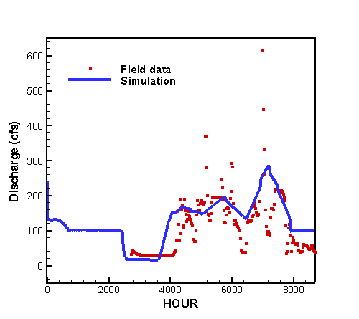 | 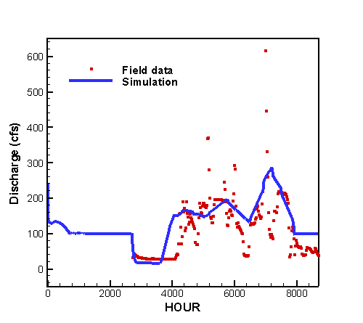
(c) Simulation 1-100-C | (d) Simulation 1-100-D
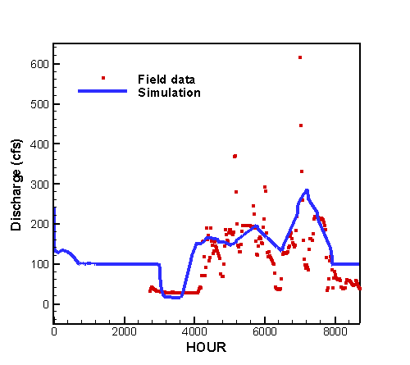 | 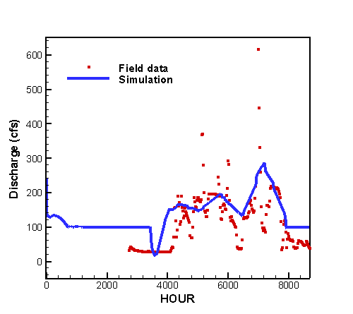
(e) Simulation 1-100-E | (f) Simulation 1-100-F

Figure 7.8 Hydrograph at Lainhart Dam from 1/1/95 through 12/31/95

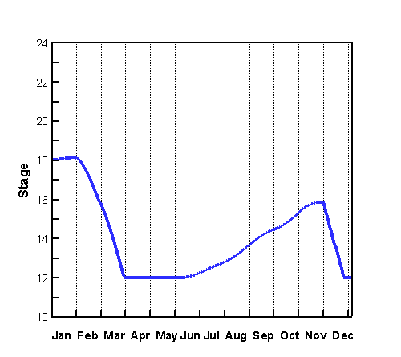 | 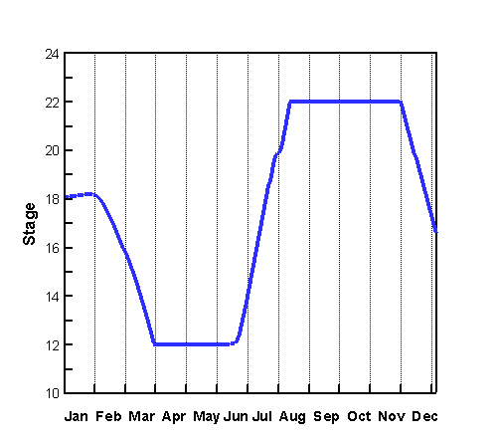
(a) Simulation 1-100-A | (b) Simulation 1-100-B
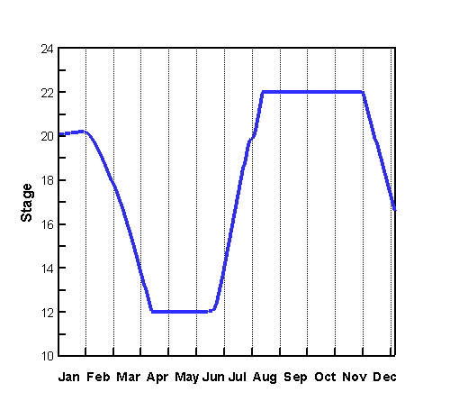 | 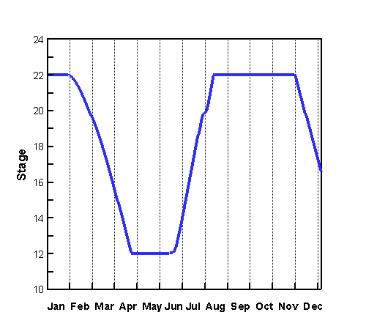
(c) Simulation 1-100-C | (d) Simulation 1-100-D
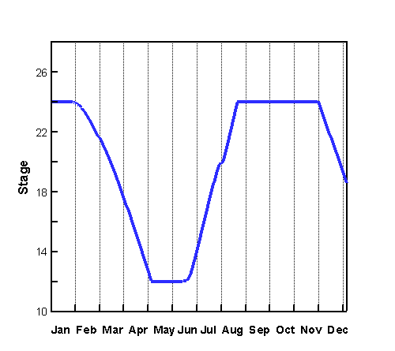 | 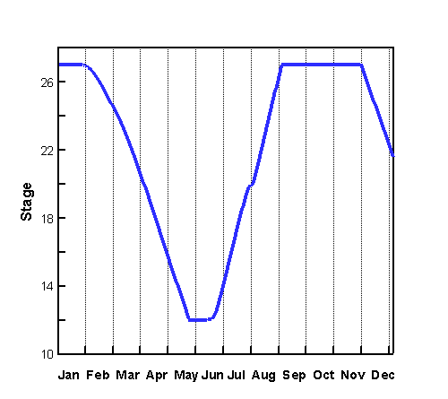
(e) Simulation 1-100-E | (f) Simulation 1-100-F
Figure 7.9 Water Stage of C-18 Reservoir from 1/1/95 through 12/31/95.

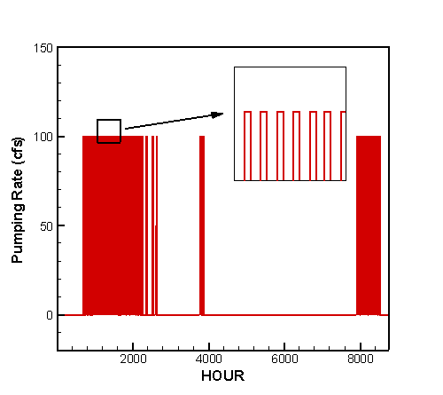 | 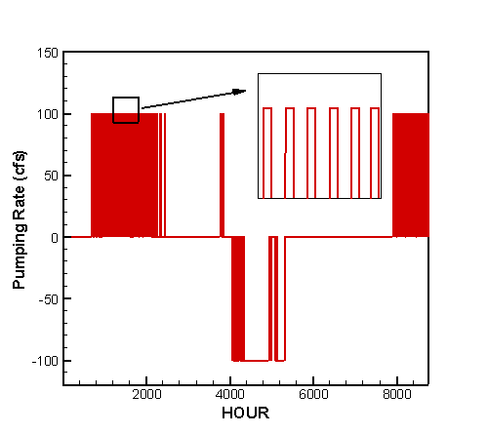
(a) Simulation 1-100-A | (b) Simulation 1-100-B
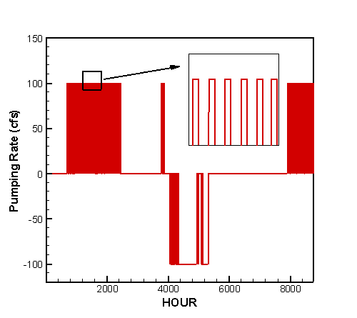 | 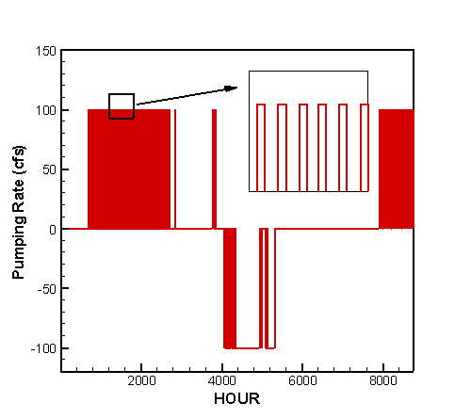
(c) Simulation 1-100-C | (d) Simulation 1-100-D
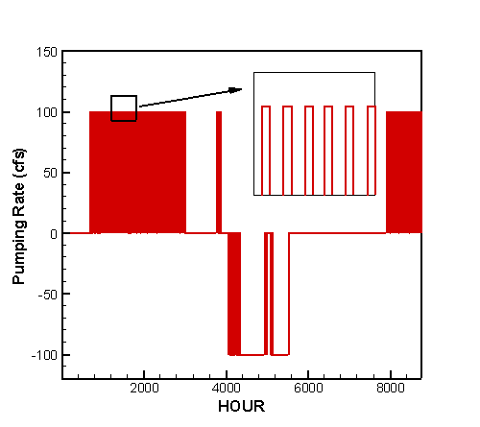 | 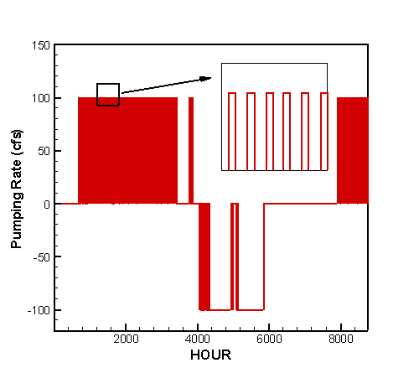
(e) Simulation 1-100-E | (f) Simulation 1-100-F
Figure 7.10 Pumping rate of pump at C-18 Reservoir from 1/1/95 through 12/31/95.
7.2.2 Case 2

The C-18 Reservoir was modeled on a footprint of 2,000 acres with a maximum water depth ranging from 10 feet to 15 feet. Figure 7.11 shows the layout of reservoirs and canal network system. More details on the reservoirs, canal reaches, and hydraulic structures are given in Chapter 6. Under existing conditions, the connection between the Grassy Waters Preserve (GWP) and East Branch of C-18 Canal is by way of sheet flow. The current flow is negligible due to flow barrier created by construction of Northlake Boulevard. Therefore, the L-8 Canal System and C-18 Canal System are considered as separable system in this case.

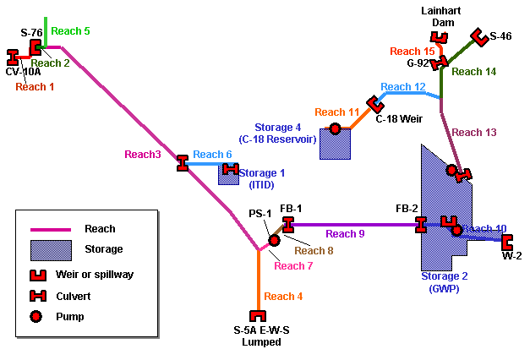
Figure 7.11 Reservoir and canal network system in CASE 2

The connection between the reservoir and C-18 Canal West Branch is by way of a pump station with a capacity of up to100 cfs. The operation of the pump was determined by the target minimum flow and the actual flow at Lainhart Dam, water depth in the C-18 Reservoir, and water stage of the C-18 Canal near the pumping site. The predefined target minimum flows were 35 cfs, 65 cfs, and 100 cfs. Since the 35-cfs target minimum flow was met 100% of the time in CASE 1 where the 10-feet deep C-18 Reservoir was based on a footprint of 1,000 acres, the target flow will definitely be met with a 10 feet deep reservoir on a 2000 acre footprint. For the simulations in CASE 2, the target flows were set at 65 cfs and 100 cfs. Accordingly the subsections were named as CASE 2-65 and CASE 2-100. The results are presented in the subsequent sections.

7.2.2.1 Case 2-65

In this case, four simulations were carried out to meet the 65-cfs target minimum flow at Lainhart Dam. The parameters for simulations A through D are given in Table 7.20. The C-18 Reservoir had a footprint of 2000 acres and a maximum water depth of 10 ft. The bottom elevation of the reservoir was assumed to be 12 feet NGVD. The initial water depth in the reservoir varied with different simulations.

The operating rules of the pump station at C-18 Reservoir are given in Table 7.21. There was no back pumping in simulation A. For simulations B through D, when the flow at Lainhart Dam was less than 65 cfs, and the C-18 Reservoir was not empty, water was pumped from the reservoir to the West Branch of C-18 Canal. Back pumping was triggered when the flow at Lainhart Dam exceeded 130 cfs and water stage in C-18 Canal at the pumping site was greater than 14 ft.

Table 7.20 Parameters for CASE 2-65
Simulation | Footprint of C-18 Reservoir (acre) | Max. Water Depth of  C-18 Reservoir  (feet) | Initial Water Depth of  C-18 Reservoir  (feet) | Target MF at Lainhart Dam  (cfs) | Back Pumping at C-18 Reservoir
2-65-A | 2,000 | 10 | 6 | 65 | No
2-65-B | 2,000 | 10 | 6 | 65 | Yes
2-65-C | 2,000 | 10 | 8 | 65 | Yes
2-65-D | 2,000 | 10 | 10 | 65 | Yes

Table 7.21 Pump operating rules for pump station at C-18 Reservoir
 | Pumping Rate (cfs) | Pumping Flow Direction
Flow at Lainhart Dam > 65 cfs | 0 | None
Flow at Lainhart Dam 65 cfs, and water depth of C-18 Reservoir > 0. | 65 | C-18 Reservoir → C-18 Canal
Back Pumping Option for simulations 2-65-B, 2-65-C, 2-65-D:  Flow at Lainhart Dam > 130 cfs, and water depth of C-18 Reservoir < Max. Water Depth, and water stage of C-18 Canal at pumping site > 14 ft | 65 | C-18 Canal → C-18 Reservoir
Otherwise | 0 | None

The target was to meet the 65 cfs minimum flows 100% of the time. Thus the pump station at C-18 Reservoir was operated to maintain a minimum flow of 65 cfs at Lainhart Dam. Table 7.22 gives the percent of time the target minimum flow was met at Lainhart Dam in the simulations. The cumulative flows through structures S-46, G-92, and Lainhart Dam were calculated in the simulations, the results are shown in Table 7.23. Table 7.24 gives the percent of time that the pump at C-18 Reservoir is under operation and the amount of water being pumped. The effective capacity and effectiveness of C-18 Reservoir are shown in Table 7.25. The hydrograph at Lainhart Dam is presented in Figure 7.12. Figure 7.13 shows the variation of water stage in C-18 Reservoir in the year of simulation. The pumping rate of the pump at C-18 Reservoir is plotted as a function of time in Figure 7.14.

As indicated by Table 7.22 as well as by Figure 7.12, the 65-cfs target minimum flow was met 100% of the time for all simulations in this case. However, in simulation A where there was no back pumping, 11,222 acre-feet of water (Table 7.24) was pumped out of C-18 Reservoir during the year of simulation. As a result, at the end of year, water depth in the reservoir fell to 4.6 feet. In simulations B through D, back pumping was activated to allow water being pumped into the reservoir during the wet season, and the water depth in the reservoir at the end of year was over 8 feet. During the wet seasons, the reservoir was filled to its full capacity for a period of time, as shown in Figure 7.13.

In simulations A through D, the pump at C-18 Reservoir was turned on 24% of the time (2100 hours) pumping water out of the reservoir. The percent of time that the pump was turned on for back pumping decreases from 25% in simulation B to 13% in simulation D.

For each simulation, the operational effective capacity and effectiveness of C-18 Reservoir were calculated. The results in Table 7.25 show that the effectiveness increases from 21% in simulation A to 59% in simulation D, and indicate that a deeper reservoir tends to have higher effectiveness.

The conclusion from this section is that the C-18 Reservoir based on a 2,000-acre footprint with a maximum water depth of 10 feet was able to meet the 65-cfs target minimum flow in the year of simulation.

Table 7.22 Percent of time the target minimum flow was met at Lainhart Dam
Simulation | Percent of Time The Following Target Flow Was Met  (1/1/95 -12/31/95)
Simulation | ≥ 35 (cfs) | ≥ 65 (cfs) | ≥ 100 (cfs)
2-65-A | 100% | 100% | 54%
2-65-B | 100% | 100% | 54%
2-65-C | 100% | 100% | 54%
2-65-D | 100% | 100% | 54%

Table 7.23 Cumulative flow through structures S-46, G-92 and Lainhart Dam
Simulation | Cumulative Flow through the Following Structures (acre-feet)  (1/1/95 -12/31/95)
Simulation | S-46 | G-92 | Lainhart Dam
2-65-A | 104770 | 71266 | 88773
2-65-B | 93718 | 70753 | 88261
2-65-C | 96361 | 70731 | 88239
2-65-D | 98873 | 70826 | 88334

Table 7.24 Pumping operation at C-18 Reservoir
Simulation | Percent of Time the Pump Is in Operation  (1/1/95-12/31/95) |  |  | Amount of Water Being Pumped  (acre-feet)
Simulation | Pumping | Back Pumping | Off | Pumping | Back Pumping
2-65-A | 24% | 0% | 76% | 11222 | 0
2-65-B | 24% | 25% | 51% | 11436 | 11571
2-65-C | 24% | 19% | 57% | 11436 | 8949
2-65-D | 24% | 13% | 63% | 11222 | 6333

Table 7.25 Operational Effective Capacity and Effectiveness of C-18 Reservoir
Simulation | C-18 Reservoir
Simulation | Total Capacity  (acre-feet) | Operational Effective Capacity  (acre-feet) | Operational Effectiveness
2-65-A | 20000 | 4200 | 21%
2-65-B | 20000 | 4600 | 23%
2-65-C | 20000 | 8600 | 43%
2-65-D | 20000 | 11800 | 59%

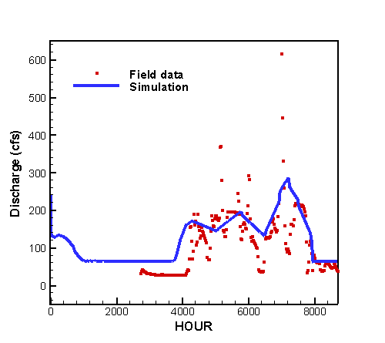 | 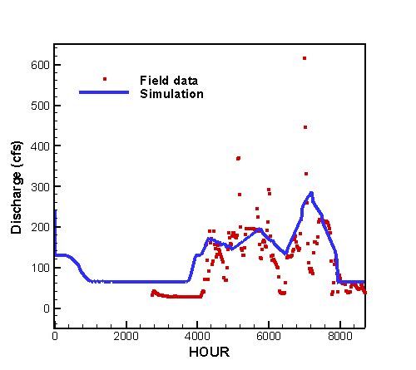
(a) Simulation 2-65-A | (b) Simulation 2-65-B
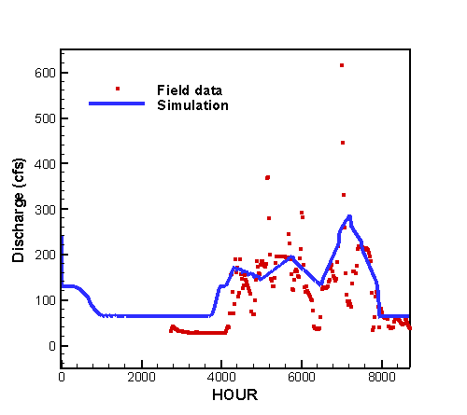 | 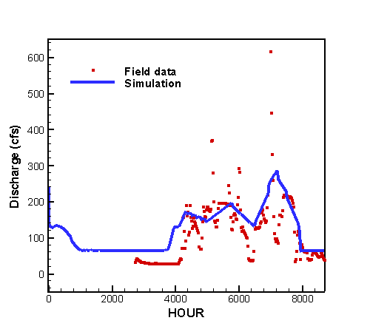
(c) Simulation 2-65-C | (d) Simulation 2-65-D

Figure 7.12 Hydrograph at Lainhart Dam from 1/1/95 through 12/31/95

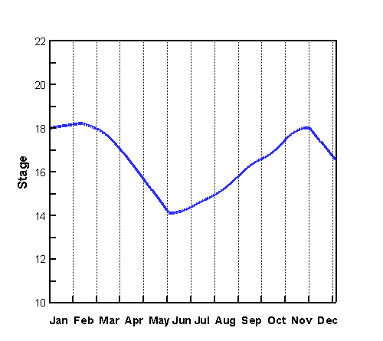 | 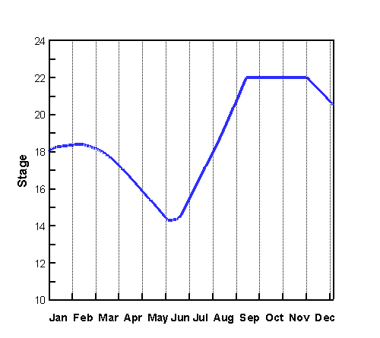
(a) Simulation 2-65-A | (b) Simulation 2-65-B
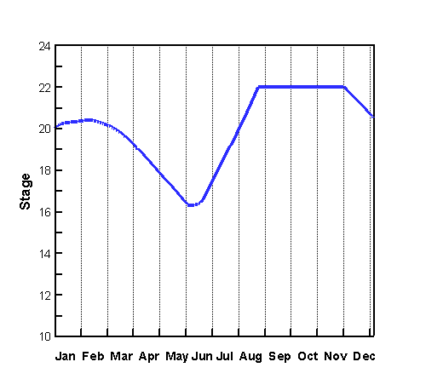 | 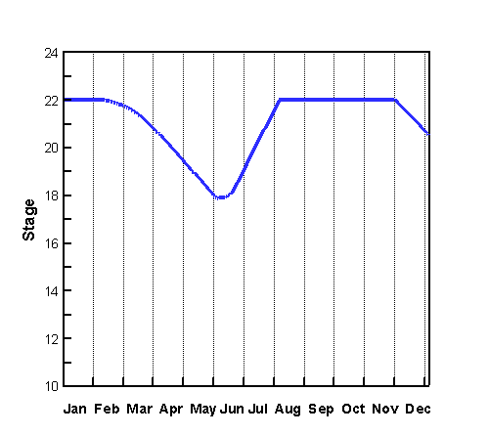
(c) Simulation 2-65-C | (d) Simulation 2-65-D
Figure 7.13 Water Stage of C-18 Reservoir from 1/1/95 through 12/31/95.

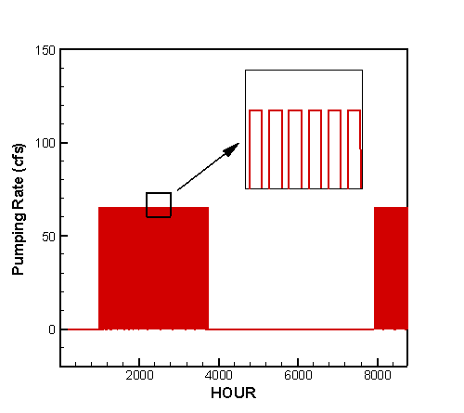 | 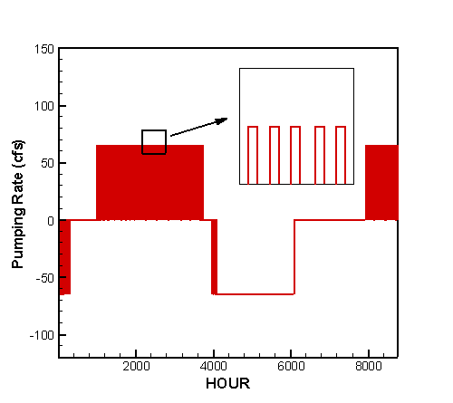
(a) Simulation 2-65-A | (b) Simulation 2-65-B
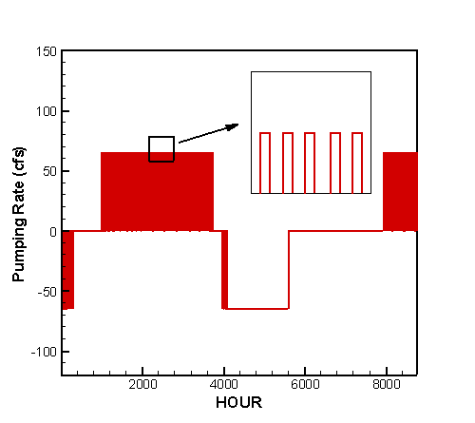 | 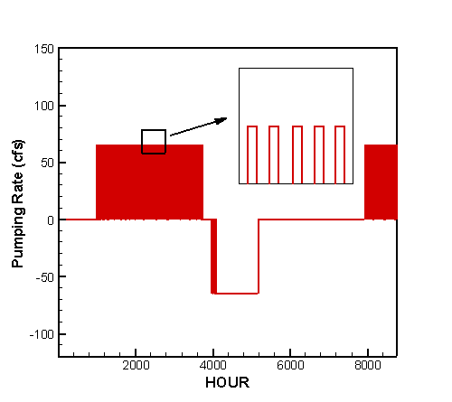
(c) Simulation 2-65-C | (d) Simulation 2-65-D
Figure 7.14 Pumping rate of pump at C-18 Reservoir from 1/1/95 through 12/31/95.

7.2.2.2 Case 2-100

Table 7.26 gives the parameters used in simulations A through F. In this case, the target minimum flow at Lainhart Dam was 100 cfs. Previous results (CASE 1-100) have shown that the C-18 Reservoir based a footprint of 1,000 acres failed to meet the 100-cfs target flow. In this section, the footprint of C-18 Reservoir was increased to 2,000 acres. The maximum water depth of the reservoir that represents its maximum storage capacity was 10 feet for simulations A through D, 12 feet for simulation E, and 15 feet for simulation F.

The operating rules of the pump station at C-18 Reservoir are given in Table 7.27. When the flow at Lainhart Dam fell to less than 100 cfs, and the C-18 Reservoir was not empty, water was pumped from the reservoir to the West Branch of C-18 Canal. There was no back pumping in simulation A. In simulations B through F, back pumping was enabled when the flow at Lainhart Dam exceeded 150 cfs and water stage in C-18 Canal at the pumping site was greater than 14 feet NGVD.

Table 7.26 Parameters for CASE 2-100
Simulation | Footprint of C-18 Reservoir (acre) | Max. Water Depth of  C-18 Reservoir  (feet) | Initial Water Depth of  C-18 Reservoir  (feet) | Target MF at Lainhart Dam  (cfs) | Back Pumping at C-18 Reservoir
2-100-A | 2,000 | 10 | 6 | 100 | No
2-100-B | 2,000 | 10 | 6 | 100 | Yes
2-100-C | 2,000 | 10 | 8 | 100 | Yes
2-100-D | 2,000 | 10 | 10 | 100 | Yes
2-100-E | 2,000 | 12 | 12 | 100 | Yes
2-100-F | 2,000 | 15 | 15 | 100 | Yes

Table 7.27 Pump operating rules for pump station at C-18 Reservoir
 | Pumping Rate (cfs) | Pumping Flow Direction
Flow at Lainhart Dam > 100 cfs | 0 | None
Flow at Lainhart Dam 100 cfs, and water depth of C-18 Reservoir > 0. | 100 | C-18 Reservoir → C-18 Canal
Back Pumping Option for simulations 2-100-B, 2-100-C, 2-100-D, 2-100-E, 2-100-F:  Flow at Lainhart Dam > 150 cfs, and water stage of C-18 Reservoir < Max. Water Depth, and water stage of C-18 Canal at pumping site > 14 ft | 100 | C-18 Canal → C-18 Reservoir
Otherwise | 0 | None

The target was to meet the 100-cfs minimum flows 100% of the time. Thus the pump station at C-18 Reservoir was operated to maintain a minimum flow of 100 cfs at Lainhart Dam. Table 7.28 gives the percent of time the target minimum flow was met at Lainhart Dam in the simulations. Table 7.29 shows the cumulative flows through structures S-46, G-92, and Lainhart Dam calculated in the simulations. Table 7.30 gives the percent of time that the pump at C-18 Reservoir is under operation and the amount of water being pumped. The effective capacity and effectiveness of C-18 Reservoir are shown in Table 7.31. The hydrograph at Lainhart Dam is presented in Figure 7.15. Figure 7.16 shows the variation of water stage in C-18 Reservoir in the year of simulation. The pumping rate of the pump at C-18 Reservoir is plotted as a function of time in Figure 7.17.

As shown in Table 7.28, in simulations D through F, the 100-cfs target minimum flow at Lainhart Dam was met 100% of the time during the year of simulation. In simulations A, B, and C, the C-18 Reservoir was drained to empty for a period of time, as shown by Figure 7.16 (a), (b) and (c). Therefore, the pump at C-18 Reservoir was shut off during the same period, as displayed by Figure 7.17 (a), (b) and (c). As a result, the flow at Lainhart Dam fell below 100 cfs (Figure 7.15 (a), (b), and (c)). Thus the target minimum flow of 100 cfs was missed by 9% of the time for simulations A and B and 2% for simulation C (Table 7.28).

In simulation A where backup pumping was disabled, 18247 acre-feet of water (Table 7.30) was pumped out of the reservoir during the dry season, the water stage in the reservoir fell dramatically, as shown in Figure 7.16 (a). Therefore, back pumping is necessary to keep the reservoir operating in a continuous manner. In simulations B through F, showing by Figure 7.16 (b) through (f), back pumping filled the C-18 Reservoir to its full capacity during the wet season.

In simulations D, the target minimum flow of 100 cfs was met 100% of the time for the year of simulation. However, as can be seen in Figure 7.16 (d), the water depth of C-18 Reservoir was 7 feet at the end of the simulation. This deficit from the starting condition increases the risk of insufficient water to maintain a minimum flow of 100 cfs during the dry season of subsequent year. Thus, a larger reservoir should be considered. For a reservoir based on a fixed footprint, a possible way to enlarge the reservoir is to increase the depth. In simulations E and F, the maximum water depth of C-18 Reservoir was increased by 2 feet and 5 feet to a total depth of 12 feet and 15 feet, respectively. The 100-cfs target flow was met 100% of the time and the amount of water stored in the reservoir at the end wet season was likely enough to meet the demand for the subsequent year.

In simulations C through F, the pump at C-18 Reservoir was turned on 31% of the time (2716 hours) pumping water out of the reservoir and 18% of the time (1577 hours) pumping water back to the reservoir, as shown in Table 7.30.

Table 7.31 shows the operational effective capacity and effectiveness of C-18 Reservoir in the year of simulation. In simulations A, B, and C, the C-18 Reservoir was drained to empty during the dry season. Thus, the operational effective capacity was 0 acre-feet and the effectiveness was 0%. The operational effectiveness increases from 16% in simulation D to 44% in simulation F. The results indicate that a deeper reservoir may provide larger operational effective capacity and higher effectiveness.

The conclusion from this section is that the C-18 Reservoir based on a 2000-acre footprint with a maximum water depth of 12 feet was able to meet the 100-cfs target minimum flow in the year of simulation.

Table 7.28 Percent of time the target minimum flow was met at Lainhart Dam
Simulation | Percent of Time The Following Target Flow Was Met  (1/1/95 -12/31/95)
Simulation | ≥ 35 (cfs) | ≥ 65 (cfs) | ≥ 100 (cfs)
2-100-A | 94% | 92% | 91%
2-100-B | 94% | 92% | 91%
2-100-C | 100% | 100% | 98%
2-100-D | 100% | 100% | 100%
2-100-E | 100% | 100% | 100%
2-100-F | 100% | 100% | 100%

Table 7.29 Cumulative flow through structures S-46, G-92 and Lainhart Dam
Simulation | Cumulative Flow through the Following Structures (acre-feet)  (1/1/95 -12/31/95)
Simulation | S-46 | G-92 | Lainhart Dam
2-100-A | 104770 | 77862 | 95357
2-100-B | 89260 | 77653 | 95147
2-100-C | 89266 | 81623 | 99118
2-100-D | 91817 | 82033 | 99528
2-100-E | 91817 | 82033 | 99528
2-100-F | 91817 | 82033 | 99528

Table 7.30 Pumping operation at C-18 Reservoir
Simulation | Percent of Time the Pump Is in Operation  (1/1/95-12/31/95) |  |  | Amount of Water Being Pumped  (acre-feet)
Simulation | Pumping | Back Pumping | Off | Pumping | Back Pumping
2-100-A | 25% | 0% | 75% | 18247 | 0
2-100-B | 25% | 22% | 53% | 18347 | 15702
2-100-C | 31% | 22% | 47% | 22247 | 15735
2-100-D | 31% | 18% | 51% | 22561 | 13173
2-100-E | 31% | 18% | 51% | 22561 | 13173
2-100-F | 31% | 18% | 51% | 22561 | 13173

Table 7.31 Operational Effective Capacity and Effectiveness of C-18 Reservoir
Simulation | C-18 Reservoir
Simulation | Total Capacity  (acre-feet) | Operational Effective Capacity  (acre-feet) | Operational Effectiveness
2-100-A | 20000 | 0 | 0%
2-100-B | 20000 | 0 | 0%
2-100-C | 20000 | 0 | 0%
2-100-D | 20000 | 3200 | 16%
2-100-E | 24000 | 7200 | 30%
2-100-F | 30000 | 13200 | 44%

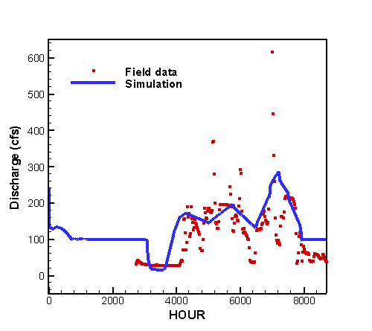 | 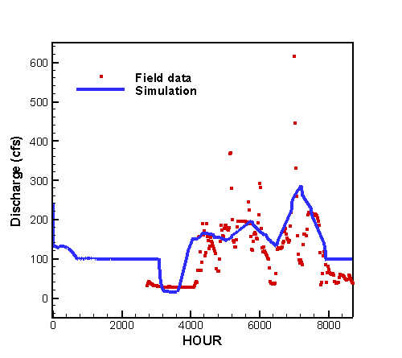
(a) Simulation 2-100-A | (b) Simulation 2-100-B
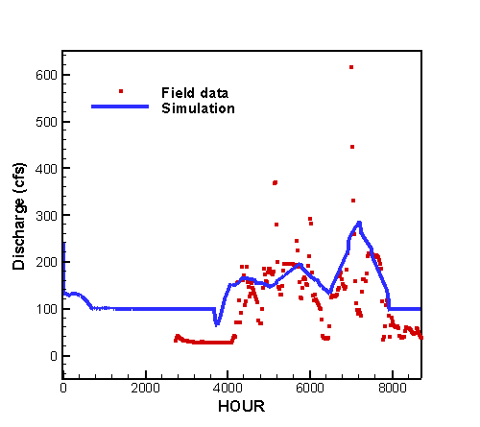 | 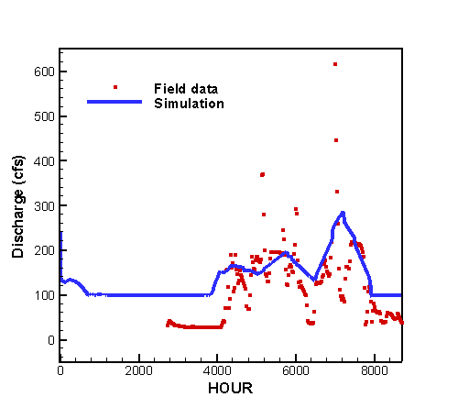
(c) Simulation 2-100-C | (d) Simulation 2-100-D
(e) Simulation 2-100-E | (f) Simulation 2-100-F

Figure 7.15 Hydrograph at Lainhart Dam from 1/1/95 through 12/31/95

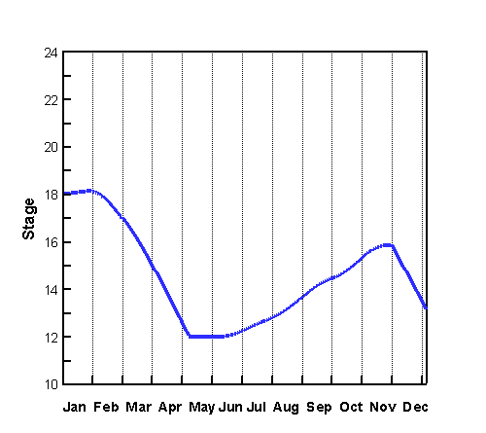 | 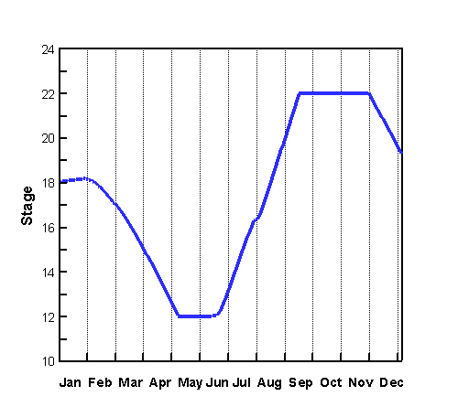
(a) Simulation 2-100-A | (b) Simulation 2-100-B
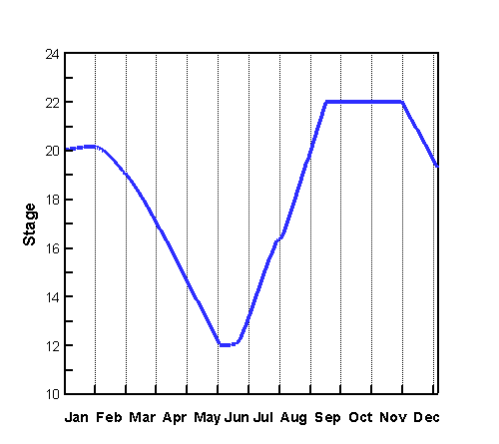 | 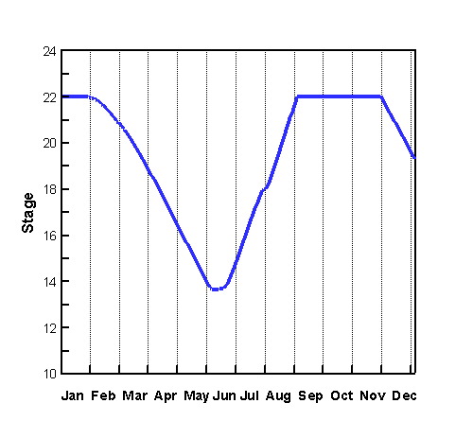
(c) Simulation 2-100-C | (d) Simulation 2-100-D
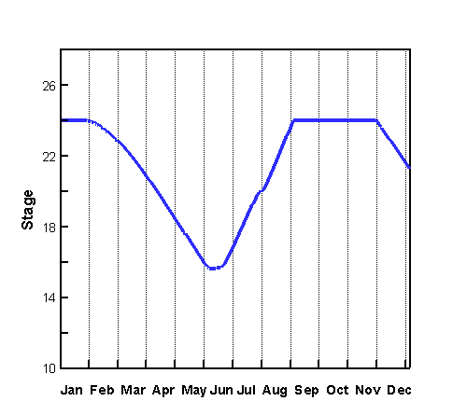 | 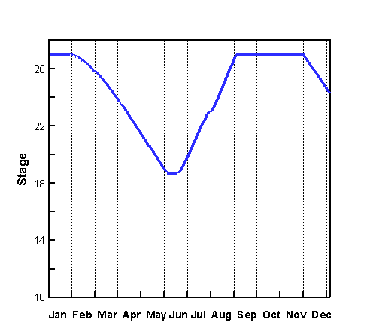
(e) Simulation 2-100-E | (f) Simulation 2-100-F
Figure 7.16 Water Stage of C-18 Reservoir from 1/1/95 through 12/31/95.

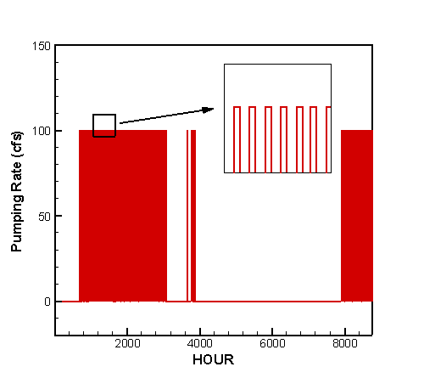 | 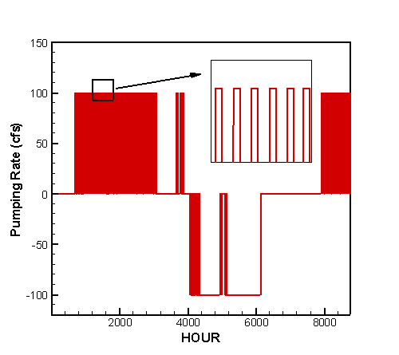
(a) Simulation 2-100-A | (b) Simulation 2-100-B
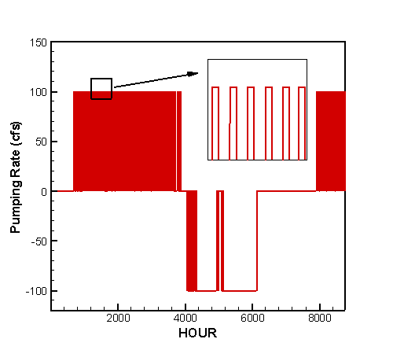 | 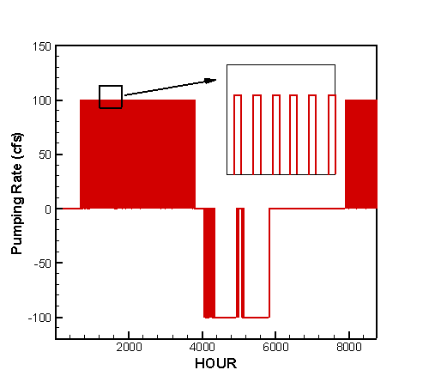
(c) Simulation 2-100-C | (d) Simulation 2-100-D
(e) Simulation 2-100-E | (f) Simulation 2-100-F
Figure 7.17 Pumping rate of pump at C-18 Reservoir from 1/1/95 through 12/31/95.
7.2.3 Case 3

The simulation results in Section 7.2.1 have shown that the C-18 Reservoir based on a footprint of 1,000 acres and with a reasonable maximum water depth (≤ 15 feet) could not provide enough water to maintain a 100-cfs target minimum flow 100% of the time. An obvious option is to increase the footprint of the reservoir, as shown in Section 7.2.2. However, this option may turn out to be impractical if either the land is not available or the land acquisition cost is too high to afford on C-18 Reservoir’s site. An alternative solution is to add another reservoir – the L-8 Alternative Reservoir to the system in L-8 Basin where land is available and land cost is much lower.

In this section, both C-18 Reservoir and L-8 Alternative Reservoir were modeled on a footprint of 1,000 acres with a maximum water depth ranging from 10 feet to 15 feet. Figure 7.18 displays schematically the layout of reservoirs and canal network system. More details on the reservoirs, canal reaches, and hydraulic structures can be found in Chapter 6. Under existing conditions, the connection between the Grassy Waters Preserve (GWP) and East Branch of C-18 Canal is by way of sheet flow. The current flow is negligible due to flow barrier created by construction of Northlake Boulevard. In order to deliver water from L-8 Alternative Reservoir to Lainhart Dam, two options may be considered: 1) improve conveyance from GWP to East Branch of C-18 Canal by building new gravity driven structures; 2) connect M-Canal and East Branch of C-18 Canal by a pipeline with a conveyance of up to 100 cfs. Option 1 may raise some issues concerning the possible impact to water quality in GWP. In option 2, the GWP is bypassed and the water quality issue is avoided. In the simulations reported in this section, option 2 was adopted.

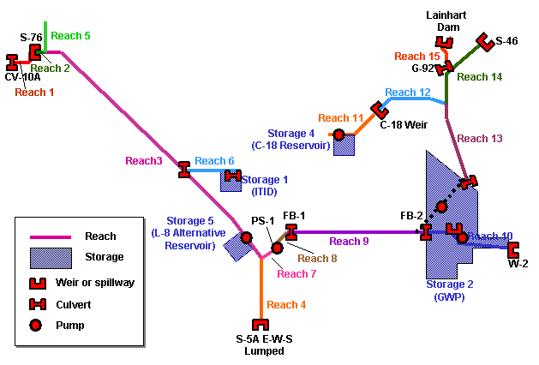
Figure 7.18 Reservoir and canal network system in CASE 3

A pump station with 100-cfs capacity was put between the C-18 Reservoir and the West Branch of C-18 Canal. Similarly, another 100-cfs pump station was put between the L-8 Alternative Reservoir and L-8 Canal. The operations of the pumps were determined by the target flow and the actual flow at Lainhart Dam, water depth in the reservoirs, and water stage in the canals near the pumping site. The predefined target in this case was to maintain a 100-cfs target minimum flow 100% of the time.

During the dry season in the simulation, when the flow at Lainhart Dam fell below the target flow, water was pumped out of the reservoirs into the canals. As water being transferred along the canals, the lost to evaporation should be considered. Figure 7.19 plots the flow lost to evaporation along the M-Canal between structures FB-1 and FB-2 as a function of time. The total lost in the year of simulation was 214 acre-feet.

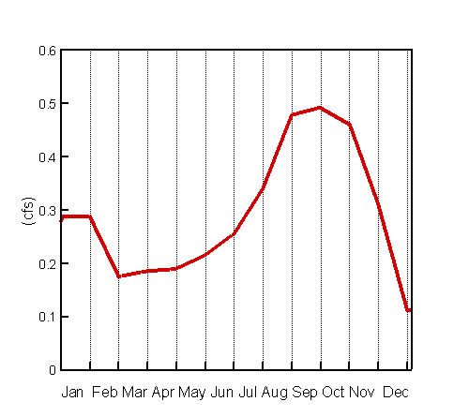

Figure 7.19 Flow lost to evaporation along the M-Canal
from 1/1/95 through 12/31/95

7.2.3.1 Case 3-100

In this case, the target was to maintain a minimum flow of 100 cfs 100% of the time at Lainhart Dam. Table 7.32 gives the parameters used in the simulations A through D. The C-18 Reservoir and L-8 Alternative Reservoir were modeled on a footprint of 1000 acres each. The maximum water depths of the reservoir were 6 ft, 8 ft, 10 ft, and 12 ft for simulations A through D.

The operating rules for the pump station at C-18 Reservoir are listed in Table 7.33. When the flow at Lainhart Dam fell to less than 100 cfs, and the C-18 Reservoir was not empty, water was pumped out of the reservoir to the West Branch of C-18 Canal at a rate of 50 cfs. There was no back pumping in simulation A. In simulations B through D, back pumping was activated when the flow at Lainhart Dam exceeded 150 cfs and water stage in C-18 Canal near the pumping site was greater than 14 feet GVD. The operating rules for the pump station at L-8 Alternative Reservoir showing in Table 7.34 are similar to that at C-18 Reservoir. When the flow at Lainhart Dam fell to less than 100 cfs, and the L-8 Alternative Reservoir was not empty, water was pumped out of the reservoir to the L-8 Canal at a rate of 50 cfs. When the flow at Lainhart Dam exceeded 150 cfs and water stage in L-8 Canal near the pumping site was greater than 12 ft, water was pumped back into the L-8 Alternative Reservoir by back pumping. The operation of pump station PS-1, located at the west end of M-Canal (Figure 7.18), was also altered to accommodate the extra water flow from L-8 Alternative Reservoir. When pump at L-8 Alternative Reservoir was pumping water out of the reservoir at 50 cfs, the pumping rate of pump PS-1 was increase by 50 cfs.

Table 7.32 Parameters for CASE 3-100
Simulation | Target MF at Lainhart Dam  (cfs) | Footprint of  C-18 Reservoir (acre) | Max. Water Depth of  C-18 Reservoir  (feet) | Initial Water Depth of  C-18 Reservoir  (feet) | Back Pumping at C-18 Reservoir | Footprint  L-8 Reservoir (acre) | Max. Water Depth of L-8 Reservoir  (feet) | Initial Water Depth of  L-8 Reservoir  (feet) | Back Pumping at L-8 Reservoir
3-100-A | 100 | 1,000 | 6 | 6 | Yes | 1,000 | 6 | 6 | Yes
3-100-B | 100 | 1,000 | 8 | 8 | Yes | 1,000 | 8 | 8 | Yes
3-100-C | 100 | 1,000 | 10 | 10 | Yes | 1,000 | 10 | 10 | Yes
3-100-D | 100 | 1,000 | 12 | 12 | Yes | 1,000 | 12 | 12 | Yes

Table 7.33 Pump operating rules for pump station at C-18 Reservoir
 | Pumping Rate (cfs) | Pumping Flow Direction
Flow at Lainhart Dam > 100 cfs | 0 | None
Flow at Lainhart Dam 100 cfs, and water depth of C-18 Reservoir > 0. | 100 | C-18 Reservoir → C-18 Canal
Back Pumping Option for simulations 3-100-B, 3-100-C, 3-100-D:  Flow at Lainhart Dam > 150 cfs, and water stage of C-18 Reservoir < Max. Water Depth, and water stage of C-18 Canal at pumping site > 14 feet | 100 | C-18 Canal → C-18 Reservoir
Otherwise | 0 | None

Table 7.34 Pump operating rules for pump station at

L-8 Alternative Reservoir
 | Pumping Rate (cfs) | Pumping Flow Direction
Flow at Lainhart Dam > 100 cfs | 0 | None
Flow at Lainhart Dam 100 cfs, and water depth of L-8 Reservoir > 0. | 100 | L-8 Reservoir → L-8 Canal
Back Pumping Option for simulations 3-100-B, 3-100-C, 3-100-D:  Flow at Lainhart Dam > 150 cfs, and water stage of L-8 Reservoir < Max. Water Depth, and water stage of L-8 Canal at pumping site > 12 feet | 100 | L-8 Canal →  L-8 Reservoir
Otherwise | 0 | None

The target was to meet a 100-cfs minimum flow 100% of the time in the year of simulation. Thus the pump stations at both C-18 Reservoir and L-8 Alternative Reservoir were operated to maintain a 100-cfs minimum flow at Lainhart Dam. Table 7.35 gives the percent of time the target minimum flow was met at Lainhart Dam in the simulations. The cumulative flows through structures S-46, G-92, and Lainhart Dam were calculated in the simulations, the results are shown in Table 7.36. Table 7.37 shows the percent of time that the pump at C-18 Reservoir is under operation and the amount of water being pumped out of or back to the reservoir. The pumping time and amount of water being pumped at the pump station associated with L-8 Alternative Reservoir are given in Table 7.38. The effective capacity and effectiveness of C-18 Reservoir and L-8 Alternative Reservoir are shown in Table 7.39 and Table 7.40. The hydrograph at Lainhart Dam is presented in Figure 7.20. Figure 7.21 and Figure 7.22 display the variation of water stage in C-18 Reservoir and L-8 Alternative Reservoir in the year of simulation. The pumping rates of the pumps at C-18 Reservoir and L-8 Alternative Reservoir are plotted as a function of time in Figure 7.23 and Figure 7.24.

As shown in Table 7.35, the 100-cfs target minimum flow was not met 100% in simulations A and B. In these simulations, both C-18 Reservoir and L-8 Alternative Reservoir were drained to empty for a period of time during the dry season, as shown by Figure 7.21 (a) (b) and 7.22 (a) (b). When the reservoirs were drained to empty, the pumps were shut off, as displayed by Figure 7.23 (a) (b) and 7.24 (a) (b). As a result, the flow at Lainhart Dam, showing in Figure 7.20 (a) (b), fell below 100 cfs. Thus the target minimum flow of 100 cfs was missed by 10% of the time in simulation A and by 3% in simulation B.

In simulation C, the 100-cfs target flow was met 100% of the time for the year of simulation. However, showing by Figure 7.21 (c) and Figure 7.22 (c), at the end of the year in simulation C, the water depth of C-18 Reservoir and L-8 Alternative Reservoir fell to 8 feet, which means that the amount of water stored in these reservoirs would not be able to provide enough water to meet the target flow in the year that follows. In simulation D, the maximum water depths of both reservoirs were increased by 2 feet to a total depth of 12 feet. The 100 cfs target flow was met 100% of the time in the year of simulation and the water storage in the reservoirs at the end of the wet season would probably meet the demand for the subsequent year.

The percent of time the pump stations at C-18 Reservoir and L-8 Alternative Reservoir were turned on for pumping and back pumping are given in Table 7.37 and Table 7.38.

Tables 7.39 and 7.40 show the operational effectiveness of C-18 and L-8 Alternative Reservoirs in the year of simulation. In simulations A and B, both Reservoirs were drained to empty due to out-pumping during the dry season. Thus, the operational effective capacity was 0 acre-feet and the operational effectiveness was 0%. The operational effectiveness increases in simulations C and D for both Reservoirs. The results indicate that a deeper reservoir may provide larger operational effective capacity and higher effectiveness. The shallow reservoirs would not meet the MFL.

The conclusion from this section is that the 100 cfs target minimum flow was met by integrating two reservoirs to the system: the C-18 Reservoir and the L-8 Alternative Reservoir, each was based on a 1,000-acre footprint with a maximum water depth of 12 feet.

Table 7.35 Percent of time the target minimum flow was met at Lainhart Dam
Simulation | Percent of Time The Following Target Flow Was Met  (1/1/95 -12/31/95)
Simulation | ≥ 35 (cfs) | ≥ 65 (cfs) | ≥ 100 (cfs)
3-100-A | 93% | 92% | 90%
3-100-B | 100% | 98% | 97%
3-100-C | 100% | 100% | 100%
3-100-D | 100% | 100% | 100%

Table 7.36 Cumulative flow through structures S-46, G-92 and Lainhart Dam
Simulation | Cumulative Flow through the Following Structures (acre-feet)  (1/1/95 -12/31/95)
Simulation | S-46 | G-92 | Lainhart Dam
3-100-A | 99627 | 77492 | 94915
3-100-B | 98112 | 81494 | 98916
3-100-C | 97778 | 82583 | 99781
3-100-D | 97778 | 82583 | 99781

Table 7.37 Pumping operation at C-18 Reservoir
Simulation | Percent of Time the Pump Is in Operation  (1/1/95-12/31/95) |  |  | Amount of Water Being Pumped  (acre-feet)
Simulation | Pumping | Back Pumping | Off | Pumping | Back Pumping
3-100-A | 25% | 14% | 61% | 8975 | 4917
3-100-B | 30% | 18% | 52% | 10954 | 6434
3-100-C | 31% | 19% | 50% | 11421 | 6768
3-100-D | 31% | 19% | 50% | 11421 | 6768

Table 7.38 Pumping operation at L-8 Alternative Reservoir
Simulation | Percent of Time the Pump Is in Operation  (1/1/95-12/31/95) |  |  | Amount of Water Being Pumped  (acre-feet)
Simulation | Pumping | Back Pumping | Off | Pumping | Back Pumping
3-100-A | 25% | 15% | 60% | 9123 | 5248
3-100-B | 31% | 20% | 49% | 11305 | 7281
3-100-C | 32% | 20% | 48% | 11421 | 7339
3-100-D | 32% | 20% | 48% | 11421 | 7339

Table 7.39 Operational Effective Capacity and Effectiveness of C-18 Reservoir
Simulation | C-18 Reservoir
Simulation | Total Capacity  (acre-feet) | Operational Effective Capacity  (acre-feet) | Operational Effectiveness
3-100-A | 10000 | 0 | 0%
3-100-B | 10000 | 0 | 0%
3-100-C | 10000 | 1500 | 15%
3-100-D | 10000 | 3500 | 35%

Table 7.40 Operational Effective Capacity and Effectiveness of L-8 Alternative Reservoir
Simulation | L-8 Alternative Reservoir
Simulation | Total Capacity  (acre-feet) | Operational Effective Capacity  (acre-feet) | Operational Effectiveness
3-100-A | 10000 | 0 | 0%
3-100-B | 10000 | 0 | 0%
3-100-C | 10000 | 1600 | 16%
3-100-D | 10000 | 3600 | 36%

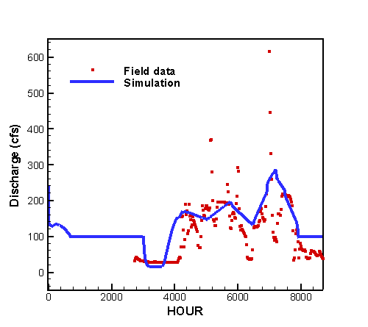 | 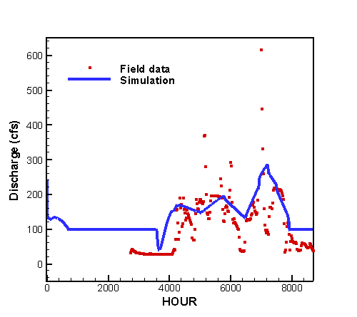
(a) Simulation 3-100-A | (b) Simulation 3-100-B
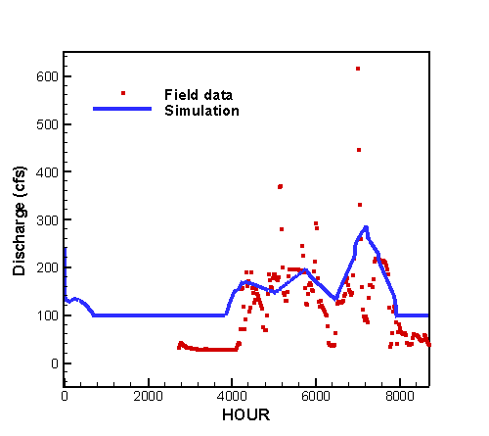
(c) Simulation 3-100-C | (d) Simulation 3-100-D

Figure 7.20 Hydrograph at Lainhart Dam from 1/1/95 through 12/31/95

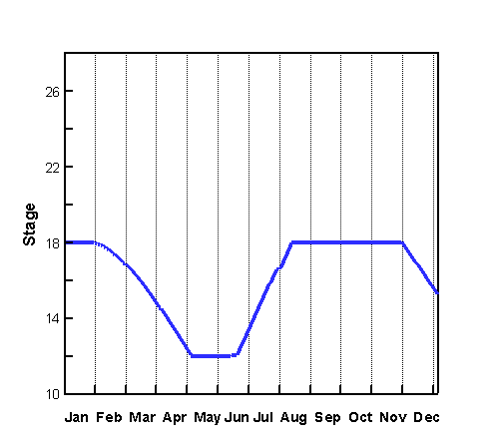 | 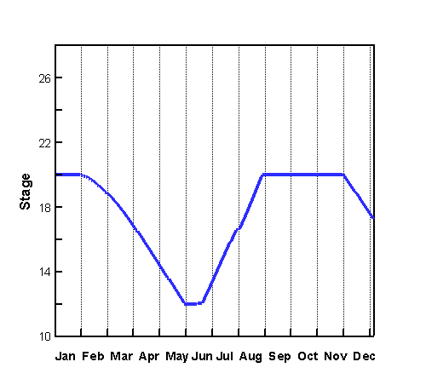
(a) Simulation 3-100-A | (b) Simulation 3-100-B
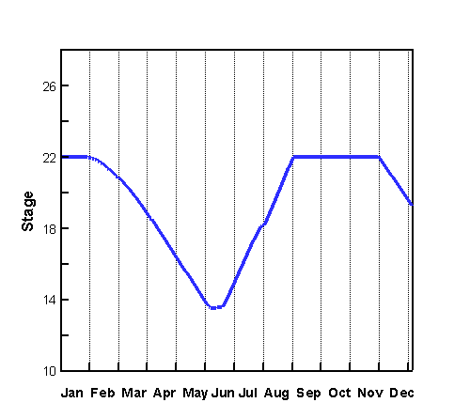 | 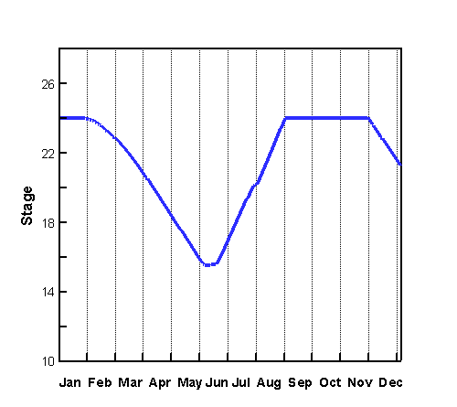
(c) Simulation 3-100-C | (d) Simulation 3-100-D
Figure 7.21 Water Stage of C-18 Reservoir from 1/1/95 through 12/31/95.

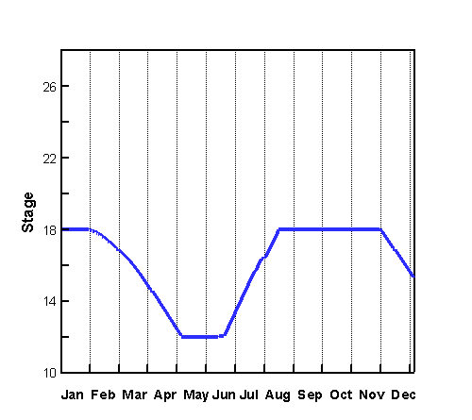 | 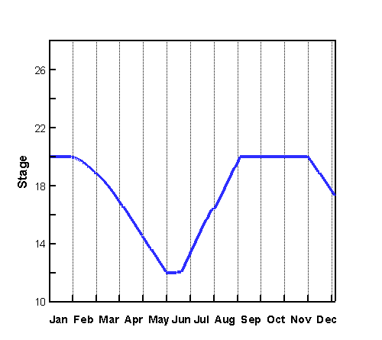
(a) Simulation 3-100-A | (b) Simulation 3-100-B
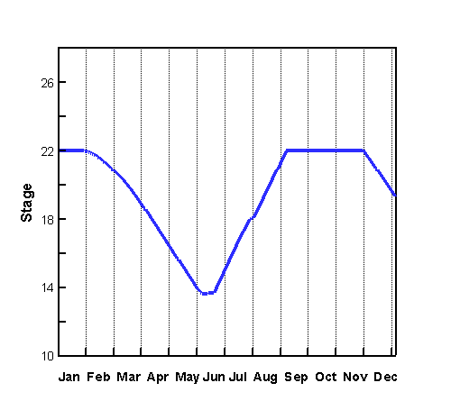 | 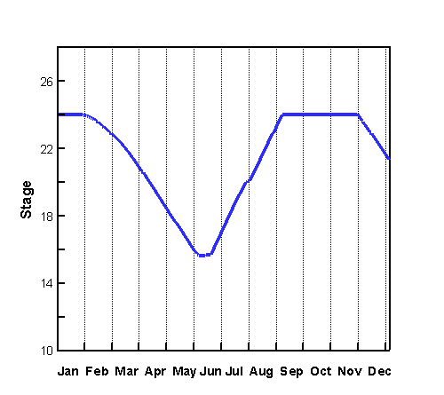
(c) Simulation 3-100-C | (d) Simulation 3-100-D
Figure 7.22 Water Stage of L-8 Alternative Reservoir from 1/1/95 through 12/31/95.

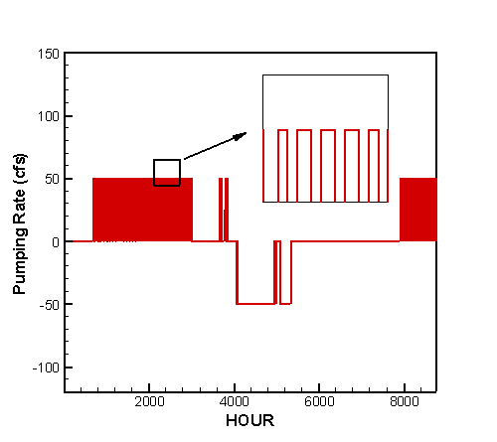 | 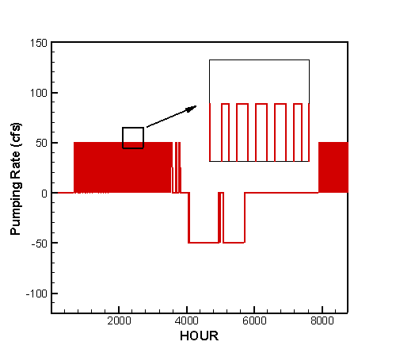
(a) Simulation 3-100-A | (b) Simulation 3-100-B
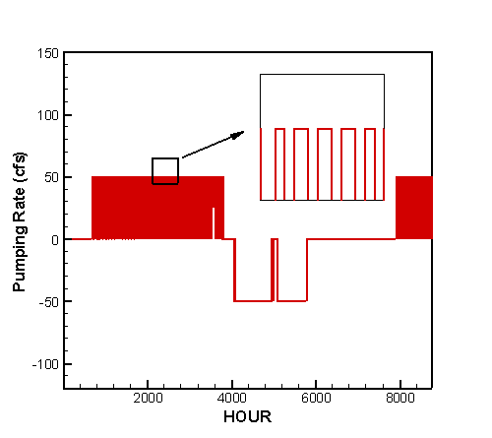
(c) Simulation 3-100-C | (d) Simulation 3-100-D
Figure 7.23 Pumping rate of pump at C-18 Reservoir from 1/1/95 through 12/31/95.

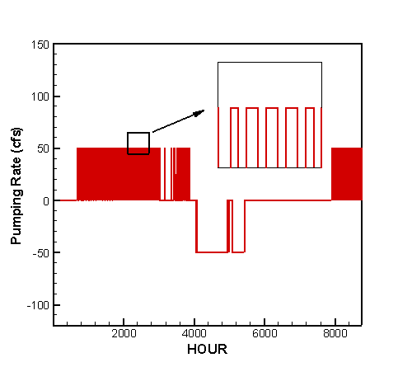 | 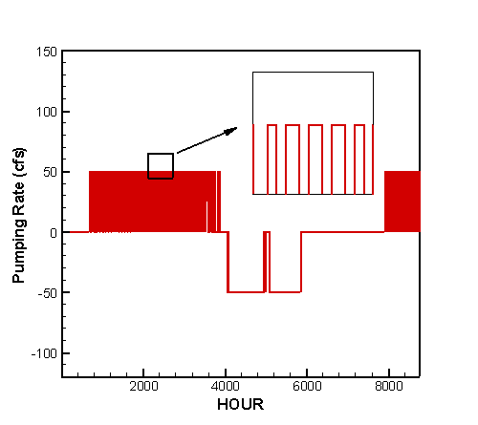
(a) Simulation 3-100-A | (b) Simulation 3-100-B
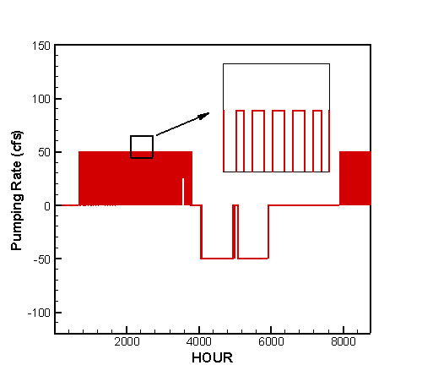
(c) Simulation 3-100-C | (d) Simulation 3-100-D
Figure 7.24 Pumping rate of pump at L-8 Alternative Reservoir
from 1/1/95 through 12/31/95.

7.2.4 Case 4

The L-8 Alternative Reservoir was modeled on a footprint of 2,000 acres with a maximum water depth ranging from 10 feet to 15 feet. Figure 7.25 shows the layout of reservoirs and canal network system. More details about the reservoirs, canal reaches, and hydraulic structures can be found in Chapter 6. Under existing conditions, the connection between the Grassy Waters Preserve (GWP) and East Branch of C-18 Canal is by way of sheet flow. The current flow is negligible due to flow barrier created by construction of Northlake Boulevard. In order to deliver water from L-8 Alternative Reservoir to Lainhart Dam, the M-Canal and the East Branch of C-18 Canal were assumed connected by a pipeline with conveyance up to 100 cfs.

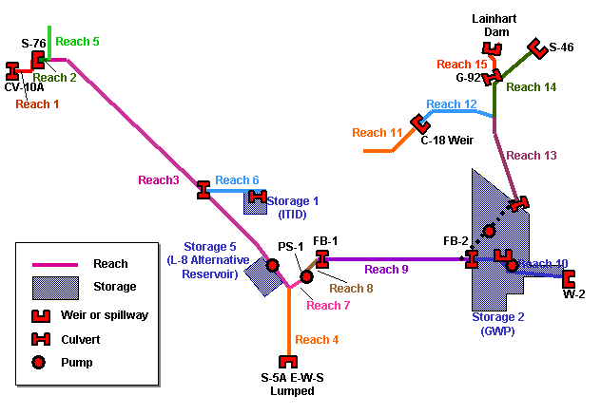
Figure 7.25 Reservoir and canal network system in CASE 4

The connection between the reservoir and L-8 Canal was by way of a pump station with a capacity of up to100 cfs. The operation of the pump was determined by the target minimum flow and the actual flow at Lainhart Dam, water depth in the L-8 Alternative Reservoir, and water stage of the L-8 Canal near the pumping site. The three predefined target minimum flows were 35 cfs, 65 cfs, and 100 cfs. Since the 35-cfs target minimum flow was met 100% of the time in Section 7.2.1 (CASE 1) where the 10 feet deep C-18 Reservoir was based on a footprint of 1,000 acres, the target flow will definitely be met with a 10 feet deep reservoir based on a 2,000-acre footprint. For the simulations in this section, the target flows were set to 65 cfs and 100 cfs, accordingly the subsections were named as CASE 4-65, and CASE 4-100. The results are presented in the subsequent sections.

7.2.4.1 Case 4-65

The target minimum flow at Lainhart Dam was set at 65 cfs. Table 7.41 gives the parameters used in the simulations A through D. The L-8 Alternative Reservoir had a footprint of 2,000 acres and a maximum water depth of 10 feet for simulations A and B, 12 feet for simulation C, and 15 feet for simulation D. The bottom elevation of the L-8 Alternative Reservoir was assumed to be 12 feet NGVD. In all four simulations, the reservoir was filled to its capacity at the beginning of the year. There was no back pumping in simulation A. The operating rules of the pump station at L-8 Alternative Reservoir are given in Table 7.42. When the flow at Lainhart Dam was less than the target minimum flow, and the L-8 Alternative Reservoir was not empty, water was pumped from the reservoir to the L-8 Canal. Back pumping was triggered when the flow at Lainhart Dam exceeded 130 cfs and water stage in L-8 Canal at the pumping site was greater than 12 feet. The operation of pump station PS-1, located at the west end of M-Canal (Figure 7.25), was also altered to accommodate the extra water flow from L-8 Alternative Reservoir. When pump at L-8 Alternative Reservoir was pumping water out of the reservoir at 65 cfs, the pumping rate of pump PS-1 was increase by 65 cfs.

Table 7.41 Parameters for CASE 4-65
Simulation | Footprint of  L-8 Alt. Reservoir (acre) | Max. Water Depth of  L-8 Alt. Reservoir  (feet) | Initial Water Depth of  L-8 Alt. Reservoir  (feet) | Target MF at Lainhart Dam  (cfs) | Back Pumping at L-8 Alt. Reservoir
4-65-A | 2,000 | 10 | 10 | 65 | No
4-65-B | 2,000 | 10 | 10 | 65 | Yes
4-65-C | 2,000 | 12 | 12 | 65 | Yes
4-65-D | 2,000 | 15 | 15 | 65 | Yes

Table 7.42 Pump operating rules for pump station at

L-8 Alternative Reservoir
 | Pumping Rate (cfs) | Pumping Flow Direction
Flow at Lainhart Dam > 65 cfs | 0 | None
Flow at Lainhart Dam 65 cfs, and water depth of L-8 Reservoir > 0. | 65 | L-8 Reservoir → L-8 Canal
Back Pumping Option for simulations 4-65-B, 4-65-C, 4-65-D:  Flow at Lainhart Dam > 130 cfs, and water depth of L-8 Reservoir < Max. Water Depth, and water stage of L-8 Canal at pumping site > 12 feet | 65 | L-8 Canal →  L-8 Reservoir
Otherwise | 0 | None

The target was to meet the 65-cfs minimum flows 100% of the time. Thus the pump station at L-8 Alternative Reservoir was operated to maintain a 65 cfs minimum flow at Lainhart Dam. Table 7.43 gives the percent of time that the 65 cfs target minimum flow was met at Lainhart Dam in the simulations, the percentages of meeting 35-cfs and 100-cfs minimum flow are also given for comparison. The cumulative flows through structures S-46, G-92, and Lainhart Dam showing by Table 7.44 were calculated in the simulations. Table 7.45 gives the percent of time that the pump at L-8 Alternative Reservoir is under operation and the amount of water being pumped. The effective capacity and effectiveness of L-8 Alternative Reservoir are shown in Table 7.46. The hydrograph at Lainhart Dam is presented in Figure 7.26. Figure 7.27 shows the variation of water stage in L-8 Alternative Reservoir in the year of simulation. The pumping rate of the pump at L-8 Alternative Reservoir is plotted as a function of time in Figure 7.28.

Showing in Table 7.43 as well as by Figure 7.26, the 65-cfs target minimum flow was met 100% of the time for all simulations in this case. In simulation A where back pumping was disabled, 11,651 acre-feet of water (Table 7.45) being pumped out of L-8 Alternative Reservoir during the year of simulation. At the end of year, water depth in the reservoir fell by 3 ft. In simulations B through D, back pumping was activated to allow water being pumped into the reservoir, and the reservoir was filled to its full capacity for a period of time during the wet season, as shown in Figure 7.27.

In simulations A through D, the pump at L-8 Alternative Reservoir was turned on 25% of the time (2190 hours) pumping water out of the reservoir. The percent of time for back pumping was 14% in simulation B through D.

Table 7.46 lists the operational effective capacity and effectiveness of L-8 Alternative Reservoir in the year of simulation. The operational effectiveness increases from 59% in simulation A to 73% in simulation D. The results indicate that a deeper reservoir has higher effectiveness.

The conclusion from this section is that the L-8 Alternative Reservoir based on a 2,000-acre footprint with a maximum water depth of 10 feet was able to meet the 65-cfs target minimum flow in the year of simulation.

Table 7.43 Percent of time the target minimum flow was met at Lainhart Dam
Simulation | Percent of Time The Following Target Flow Was Met  (1/1/95 -12/31/95)
Simulation | ≥ 35 (cfs) | ≥ 65 (cfs) | ≥ 100 (cfs)
4-65-A | 100% | 100% | 54%
4-65-B | 100% | 100% | 54%
4-65-C | 100% | 100% | 54%
4-65-D | 100% | 100% | 54%

Table 7.44 Cumulative flow through structures S-46, G-92 and Lainhart Dam
Simulation | Cumulative Flow through the Following Structures (acre-feet)  (1/1/95 -12/31/95)
Simulation | S-46 | G-92 | Lainhart Dam
4-65-A | 104522 | 71290 | 88724
4-65-B | 104522 | 71290 | 88724
4-65-C | 104522 | 71290 | 88724
4-65-D | 104522 | 71290 | 88724

Table 7.45 Pumping operation at L-8 Alternative Reservoir
Simulation | Percent of Time the Pump Is in Operation  (1/1/95-12/31/95) |  |  | Amount of Water Being Pumped  (acre-feet)
Simulation | Pumping | Back Pumping | Off | Pumping | Back Pumping
4-65-A | 25% | 0% | 75% | 11651 | 0
4-65-B | 25% | 14% | 61% | 11651 | 6784
4-65-C | 25% | 14% | 61% | 11651 | 6784
4-65-D | 25% | 14% | 61% | 11651 | 6784

Table 7.46 Operational Effective Capacity and Effectiveness of L-8 Alternative Reservoir
Simulation | L-8 Alternative Reservoir
Simulation | Total Capacity  (acre-feet) | Operational Effective Capacity  (acre-feet) | Operational Effectiveness
4-65-A | 20000 | 11800 | 59%
4-65-B | 20000 | 11800 | 59%
4-65-C | 24000 | 15800 | 66%
4-65-D | 30000 | 21800 | 73%

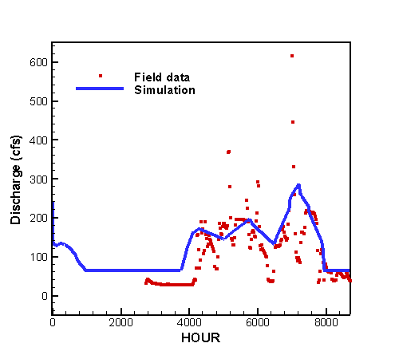
(a) Simulation 4-65-A | (b) Simulation 4-65-B
(c) Simulation 4-65-C | (d) Simulation 4-65-D

Figure 7.26 Hydrograph at Lainhart Dam from 1/1/95 through 12/31/95

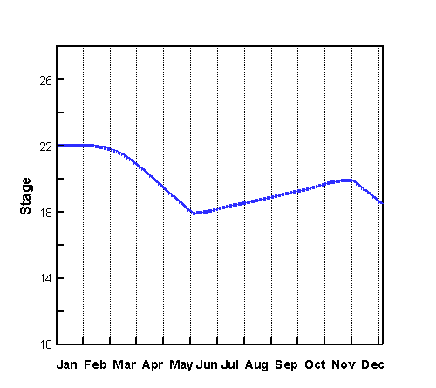 | 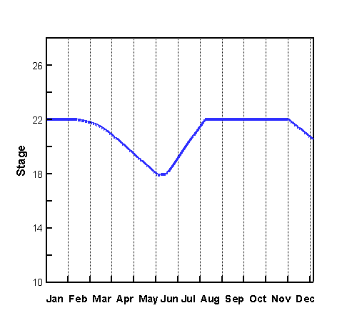
(a) Simulation 4-65-A | (b) Simulation 4-65B
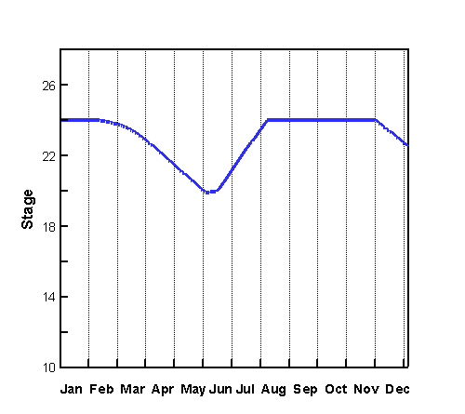 | 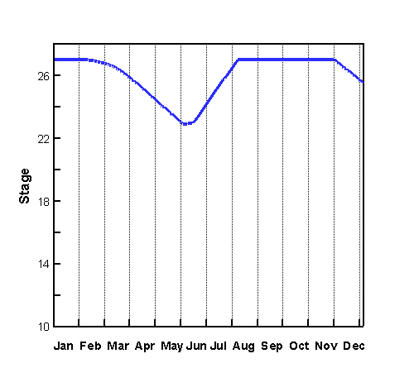
(c) Simulation 4-65-C | (d) Simulation 4-65-D
Figure 7.27 Water Stage of L-8 Alternative Reservoir from 1/1/95 through 12/31/95.

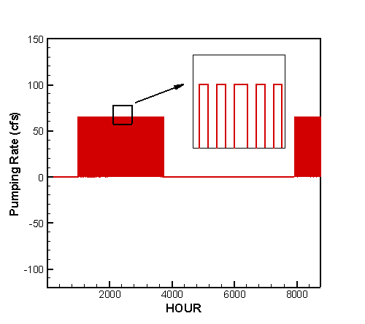 | 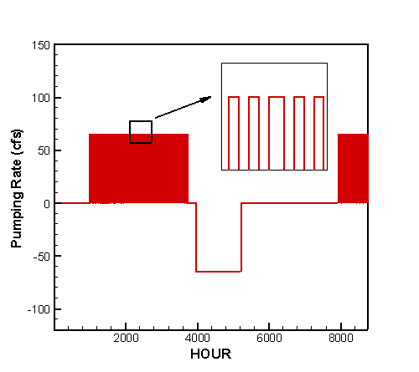
(a) Simulation 4-65-A | (b) Simulation 4-65-B
(c) Simulation 4-65-C | (d) Simulation 4-65-D
Figure 7.28 Pumping rate of pump at L-8 Alternative Reservoir
from 1/1/95 through 12/31/95.

7.2.4.2 Case 4-100

In this case, the target minimum flow at Lainhart Dam was set at 100 cfs. Table 7.47 gives the parameters for simulations A through D. The footprint of L-8 Alternative Reservoir was 2000 acres. The maximum water depth of the reservoir that represents its maximum storage capacity was 10 feet for simulations A and B, 12 feet for simulation C, and 15 feet for simulation D. The L-8 Alternative Reservoir was filled to its full capacity at the beginning of simulation. The bottom elevation of L-8 Alternative Reservoir was assumed to be 12 feet NGVD.

The operating rules of the pump station at L-8 Alternative Reservoir are given in Table 7.48. When the flow at Lainhart Dam fell to less than 100 cfs, and the L-8 Alternative Reservoir was not empty, water was pumped out of the reservoir to the L-8 Canal. In simulation A, back pumping was disabled. In simulations B through D, back pumping was triggered when the flow at Lainhart Dam exceeded 150 cfs and the water stage in L-8 Canal near the pumping site was greater than 12 feet. The operation of pump station PS-1, located at the west end of M-Canal (Figure 7.25), was also altered to accommodate the extra water flow from L-8 Alternative Reservoir. When pump at L-8 Alternative Reservoir was pumping water out of the reservoir at 100 cfs, the pumping rate of pump PS-1 was increase by 100 cfs.

Table 7.47 Parameters for CASE 4-100
Simulation | Footprint of  L-8 Alt. Reservoir (acre) | Max. Water Depth of  L-8 Alt. Reservoir  (feet) | Initial Water Depth of  L-8 Alt. Reservoir  (feet) | Target MF at Lainhart Dam  (cfs) | Back Pumping at L-8 Alt. Reservoir
4-100-A | 2,000 | 10 | 10 | 100 | No
4-100-B | 2,000 | 10 | 10 | 100 | Yes
4-100-C | 2,000 | 12 | 12 | 100 | Yes
4-100-D | 2,000 | 15 | 15 | 100 | Yes

Table 7.48 Pump operating rules for pump station at

L-8 Alternative Reservoir
 | Pumping Rate (cfs) | Pumping Flow Direction
Flow at Lainhart Dam > 100 cfs | 0 | None
Flow at Lainhart Dam 100 cfs, and water depth of L-8 Reservoir > 0. | 100 | L-8 Reservoir → L-8 Canal
Back Pumping Option for simulations 4-100-B, 4-100-C, 4-100-D:  Flow at Lainhart Dam > 150 cfs, and water stage of L-8 Reservoir < Max. Water Depth, and water stage of L-8 Canal at pumping site > 12 feet | 100 | L-8 Canal →  L-8 Reservoir
Otherwise | 0 | None

The target was to meet the 100-cfs minimum flows 100% of the time. Thus the pump station at C-18 Reservoir was operated to maintain a 100 cfs minimum flow at Lainhart Dam. Table 7.49 summarizes the percent of time the target minimum flow was met at Lainhart Dam in the simulations. The cumulative flows through structures S-46, G-92, and Lainhart Dam showing in Table 7.50 were calculated in the simulations. Table 7.51 gives the percent of time that the pump at L-8 Alternative Reservoir is under operation and the amount of water being pumped. The effective capacity and effectiveness of L-8 Alternative Reservoir are shown in Table 7.52. The hydrograph at Lainhart Dam is presented in Figure 7.29. Figure 7.30 shows the variation of water stage in L-8 Alternative Reservoir in the year of simulation. The pumping rate of the pump at L-8 Alternative Reservoir is plotted as a function of time in Figure 7.31.

As shown by Table 7.49 and Figure 7.29, the percent of time that the target was met was 100% for all simulations in this case. According to Table 7.51, the volume of water being pumped out of the reservoir in the year of simulation was 22,611 acre-feet. In simulation B, the water depth in the reservoir fell below 8 ft at the end of the year, and it was unlikely to meet the 100-cfs target flow in the subsequent year. In simulations C and D, the target flow of 100 cfs was met 100% of the time in the year of simulation and the amount of water stored in the reservoir at the end of the year was sufficient to meet the demand in the subsequent year.

In simulations B through D, the pump at L-8 Alternative Reservoir was under operation 31% of the time (2716 hours) pumping water out of the reservoir and 20% of the time (1752 hours) pumping water back to the reservoir, as shown in Table 7.51. The operation profiles of the pump for all simulations in this case are displayed in Figure 7.31.

Table 7.52 shows the operational effective capacity and effectiveness of L-8 Alternative Reservoir in the year of simulation. The results indicate that a deeper reservoir has higher operational effectiveness for the period of simulation.

The conclusion from this section is that the L-8 Alternative Reservoir based on a 2,000-acre footprint with a maximum water depth of 12 feet was able to meet the 100-cfs target minimum flow in the year of simulation.

Table 7.49 Percent of time the target minimum flow was met at Lainhart Dam
Simulation | Percent of Time The Following Target Flow Was Met  (1/1/95 -12/31/95)
Simulation | ≥ 35 (cfs) | ≥ 65 (cfs) | ≥ 100 (cfs)
4-100-A | 100% | 100% | 100%
4-100-B | 100% | 100% | 100%
4-100-C | 100% | 100% | 100%
4-100-D | 100% | 100% | 100%

Table 7.50 Cumulative flow through structures S-46, G-92 and Lainhart Dam
Cumulative Flow through the Following Structures (acre-feet)
(1/1/95 -12/31/95)
 | S-46 | G-92 | Lainhart Dam
4-100-A | 104524 | 82408 | 99829
4-100-B | 104524 | 82408 | 99829
4-100-C | 104524 | 82408 | 99829
4-100-D | 104524 | 82408 | 99829

Table 7.51 Pumping operation at L-8 Alternative Reservoir
Simulation | Percent of Time the Pump Is in Operation  (1/1/95-12/31/95) |  |  | Amount of Water Being Pumped  (acre-feet)
Simulation | Pumping | Back Pumping | Off | Pumping | Back Pumping
4-100-A | 31% | 0% | 69% | 22611 | 0
4-100-B | 31% | 20% | 49% | 22611 | 14602
4-100-C | 31% | 20% | 49% | 22611 | 14602
4-100-D | 31% | 20% | 49% | 22611 | 14602

Table 7.52 Operational Effective Capacity and Effectiveness of L-8 Alternative Reservoir
Simulation | L-8 Alternative Reservoir
Simulation | Total Capacity  (acre-feet) | Operational Effective Capacity  (acre-feet) | Operational Effectiveness
4-100-A | 20000 | 3200 | 16%
4-100-B | 20000 | 3200 | 16%
4-100-C | 24000 | 7200 | 30%
4-100-D | 30000 | 13200 | 44%

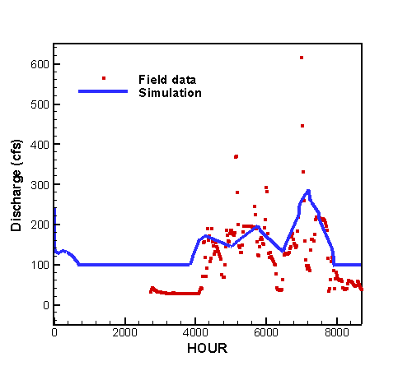
(a) Simulation 4-100-A | (b) Simulation 4-100-B
(c) Simulation 4-100-C | (d) Simulation 4-100-D

Figure 7.29 Hydrograph at Lainhart Dam from 1/1/95 through 12/31/95

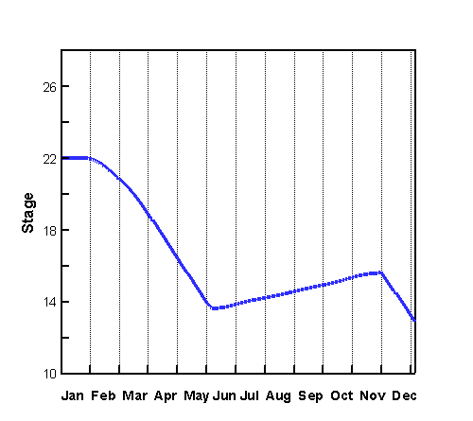 | 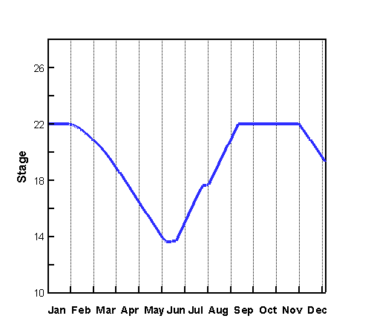
(a) Simulation 4-100-A | (b) Simulation 4-100-B
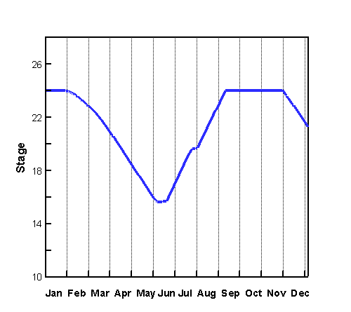 | 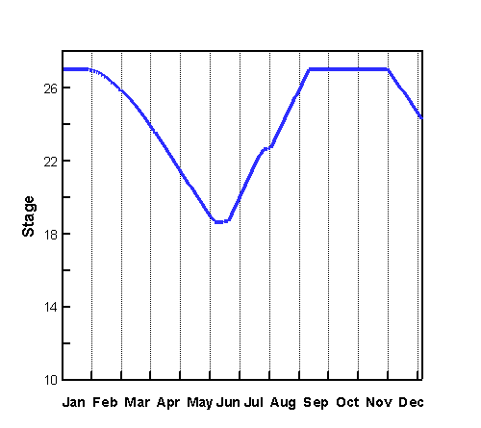
(c) Simulation 4-100-C | (d) Simulation 4-100-D
Figure 7.30 Water Stage of L-8 Alternative Reservoir from 1/1/95 through 12/31/95.

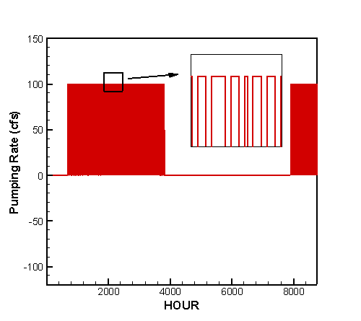 | 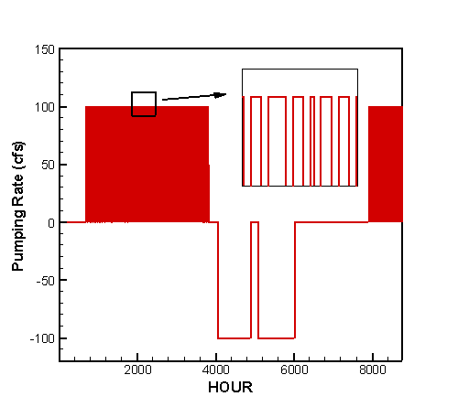
(a) Simulation 4-100-A | (b) Simulation 4-100-B
(c) Simulation 4-100-C | (d) Simulation 4-100-D
Figure 7.31 Pumping rate of pump at L-8 Alternative Reservoir
from 1/1/95 through 12/31/95.

7.3 Conclusions and Suggestions

The focus of the simulations reported in this chapter is to study the possibility of maintaining the target minimum flow at Lainhart Dam based on the four scenarios proposed in Section 7.1 and listed below.

- Scenario 1 included the C-18 Reservoir based on a 1,000 acre footprint located in the area upstream of the West Branch of C-18 Canal.
- Scenario 2, the footprint of C-18 Reservoir was increased to 2000 acres.
- Scenario 3 introduced the combination of two reservoirs: the C-18 Reservoir and the L-8 Alternative Reservoir. Both reservoirs were based on a 1000-acre footprint. The L-8 Alternative Reservoir was located near the junction of the L-8 Canal and the South L-8 Tieback Canal and immediately west of the L-8 Canal.

In all scenarios, a pump station was put near each reservoir to transfer water from the reservoir to the canal (pumping) or in the opposite direction (back pumping).

The criteria of minimum flow at Lainhart Dam were set at 35 cfs, 65 cfs, and 100 cfs. The simulations results have been presented in detail in previous sections. For the 35 cfs target minimum flow, the results are summarized in Table 7.53. A 10 feet deep reservoir based on 1,000 acre footprint will definitely meet the 35 cfs target. The required water depth of the reservoir is less than 10 feet for a reservoir based on 2000-acre footprint or for a combination of two reservoirs based on 1,000 acre footprint each. Back pumping, as described in previous sections, plays important role in catching and storing excess runoff during the wet seasons, therefore is recommended for all scenarios.

Table 7.53 Simulation results for 35-cfs target minimum flow
Scenario | Reservoirs Included | Water Depth of the Reservoir Required  (feet) | Pump(s) Capacity  (cfs) | Back Pumping
1 | C-18 Reservoir on a 1,000-acre footprint | 10 | 35 | Yes
2 | C-18 Reservoir on a 2,000-acre footprint | < 10 | 35 | Yes
3 | C-18 Reservoir and  L-8 Alternative Reservoir on a 1000-acre footprint each | < 10 | 17.5 each | Yes
4 | L-8 Alternative Reservoir on a 2000-acre footprint | < 10 | 35 | Yes

The summarized results for the 65-cfs target flow are presented in Table 7.54. For a reservoir based on a 1,000 acre footprint, the water depth required is at least 12 ft. For a reservoir based on 2,000 acre footprint or for a combination of two reservoirs based on 1,000 acre footprint each, a 10 feet water depth will meet the requirement.

Table 7.54 Simulation results for 65-cfs target minimum flow
Scenario | Reservoirs Included | Water Depth of the Reservoir Required  (feet) | Pump(s) Capacity  (cfs) | Back Pumping
1 | C-18 Reservoir on a 1000-acre footprint | 12 | 65 | Yes
2 | C-18 Reservoir on a 2000-acre footprint | 10 | 65 | Yes
3 | C-18 Reservoir and  L-8 Alternative Reservoir on a 1,000 acre footprint each | 10 | 32.5 each | Yes
4 | L-8 Alternative Reservoir on a 2,000 acre footprint | 10 | 65 | Yes

The summarized results for the 100 cfs target flow are presented in Table 7.55. A reservoir based on a 1,000 acre footprint cannot meet the target flow if the water depth of the reservoir is less than or equal to 15 feet. For a reservoir based on 2,000 acre footprint or for a combination of two reservoirs based on 1,000 acre footprint each, the water depth required is at least 12 feet.

Table 7.55 Simulation results for 100-cfs target minimum flow
Scenario | Reservoirs Included | Water Depth of the Reservoir Required  (ft) | Pump(s) Capacity  (cfs) | Back Pumping
1 | C-18 Reservoir on a 1000-acre footprint | > 15 | 100 | Yes
2 | C-18 Reservoir on a 2000-acre footprint | 12 | 100 | Yes
3 | C-18 Reservoir and  L-8 Alternative Reservoir on a 1000-acre footprint each | 12 | 50 each | Yes
4 | L-8 Alternative Reservoir on a 2000-acre footprint | 12 | 100 | Yes

To further improve accuracy of simulation by the Northern Palm Beach County Regional Model, the following efforts should be considered:

- Meteorological data – collect daily rainfall and evaporation for the study area.
- Surface water data – collect field data including flow, stage, and structure operation at more sites for model calibration.
- Canal cross-sectional data – collect data for existing cross-sections of L-8 North Tieback Canal, L-8 South Tieback Canal, L-8 Outfall Canal, M-Canal.
- Modeling – incorporating overland model and subsurface module of WASH123D to provide accurate runoff and ground water input to current Northern Palm Beach County Regional Model.
- Perform sensitivity analysis on the benefit (additional water captured) and cost (increased capital costs) of increasing the backpumping capacity at each reservoir and the conveyance capacity from the L-8 to the C-18 Basin.

Reference

- South Florida Water Management District, 1988. Technical Memorandum DRE-244, An Atlas of Eastern Palm Beach County Surface Water Management Basins.
- South Florida Water Management District, 1989. Technical Memorandum DRE-274, An Atlas of the Everglades Agricultural Area Surface Water Management Basins.
- South Florida Water Management District, 1996. Technical Memorandum #1B, Data Acquisition for the Loxahatchee Slough.
- South Florida Water Management District, 1997. Technical Memorandum #2B, Hydrologic Model for the Loxahatchee Slough Basin.
- South Florida Water Management District, 1997. Technical Memorandum #3B, Hydrologic Model for the Loxahatchee Slough Basin.
- South Florida Water Management District, 1996. Technical Memorandum #1A, Data Acquisition for the Southern L-8 Basin.
- South Florida Water Management District, 1996. Technical Memorandum #2A, Hydrologic Model for the Southern L-8 Basin.
- South Florida Water Management District, 1997. Technical Memorandum #3A, Hydraulic Model for the Southern L-8 Basin.
- South Florida Water Management District, 1995. West Palm Beach Water Catchment Area Water Conservation Study, Technical Memorandum #3.
- South Florida Water Management District, 2000. Lower East Coast Regional Water Supply Plan, Planning Document.
- South Florida Water Management District, 2000. Lower East Coast Regional Water Supply Plan, Appendices Volume I.
- South Florida Water Management District, 2002. Minimum Flows and Levels for the Loxahatchee River and Estuary (Draft).
- South Florida Water Management District, 2002. Northern Palm Beach County Comprehensive Water Management Plan, Planning Document Volume I.
- South Florida Water Management District, 2003. Northern Palm Beach County CERP Project-Part 1 Project PIR/EIS, Goals, Objectives and Performance Measures.
- South Florida Water Management District, 2003. DBHYDRO: South Florida Water Management District’s corporate environmental online database. (Web site URL: http://www.sfwmd.gov/org.ema/dbhydro/)
- U.S. Army Corps of Engineers Jacksonville District, 2001. Existing Conditions Hydrology and Hydraulic, L-8 Basin, Palm Beach County, Florida. (Contract No. DACW17-99-D-0050, Burns & McDonnel)

