Chapter 6 Northern Palm Beach County Model

6.1 Overview

According to the Northern Palm Beach County Comprehensive Water Management Plan (NPBCCWMP, 2002) developed by the South Florida Water Management District (SFWMD) and the City of West Palm Beach, the following objectives have been identified:

- Provide supplemental water to the Loxahatchee Slough sufficient to maintain water levels such that they do not fall below the target hydroperiod by more than 6 inches during normal years, and for no more than 30 days during droughts with a return frequency of up to ten years.
- Provide supplemental water to maintain a flow of up to 65 cubic feet per second (cfs) over the Lainhart Dam to maintain bottom salinities of 2 ppt in the Northwest Fork of the Loxahatchee River.
- Improve the timing and volume of flow provided from tributaries to the Northwest Fork of the Loxahatchee River (NFWLR). Improved flow from other sources will reduce the amount of supplemental water that is needed from the C-18 Basin (delivered through G-92 and subsequently over the Lainhart Dam) and the regional system.
- Provide 5 cfs of baseflow to the Southwest Fork of the Loxahatchee River.
- Provide a dependable public water supply through 2020 for the utilities in the region for a drought with an average return frequency of 1-in-10 years, to be consistent with water supply plans.
- Identify alternative sources and quantities of water that will enable public water supply utilities to meet drought demands and/or minimize drought restrictions.
- Assist the Indian Trail Improvement District (ITID) with peak flow management to provide additional flood protection.

One of the primary goals was to provide supplemental water to maintain up to 65 cfs flow over Lainhart Dam to maintain appropriate salinities in the Northwest Fork of the Loxahatchee River and to meet current and projected future public, agricultural and industrial water supply, flood control, and environmental resource protection needs in northern Palm Beach County. Under current conditions, there is not enough water storage capacity in the basin to consistently meet objectives during dry periods. Review of USGS flow records over the last 10 years show that the 65-cfs flow target is met only 57% of time under current conditions.

This report includes the development of a hydrologic and hydraulic regional model for the North Palm Beach County area and study different scenarios on how to deliver supplemental water to the Northwest Fork of Loxahatchee River to meet the target flow rates.

This chapter is organized as follows. Section 6.2 includes a brief introduction of the study area. Section 6.3 gives delineation of sub-basins. Section 6.4 introduces the method of runoff estimation. The existing hydraulic structures in the study area are described in Section 6.5. Sections 6.6 and 6.7 explain the meteorological data and surface water data used in the study. The layout of the regional model can be found in Section 6.8. The calibration of the model is presented in Section 6.9.

6.2 Study Area Description

The study area of this project includes the L-8 Basin, the C-18 Basin. The aerial picture of the study area and the basin boundaries are displayed in Figure 6.1. The basin boundaries relative to local roads and landmarks are shown in Figure 6.2.

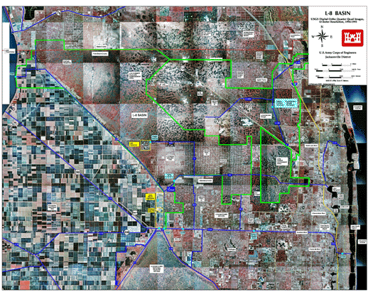

Figure 6.1 Aerial picture of northern Palm Beach County. The L-8 Basin, C-18 Basin, and West Palm Beach Water Catchment Area (a.k.a Grassy Waters Preserve) are delineated by light green lines.

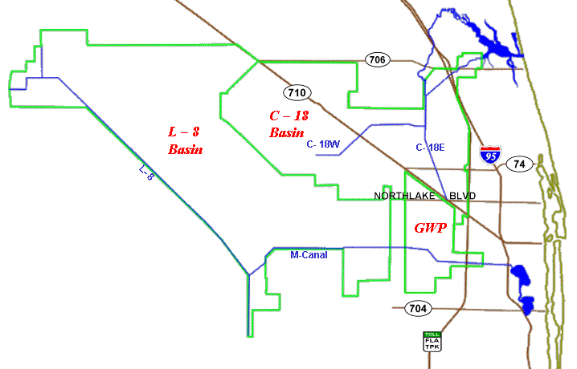

Figure 6.2 Study area boundary and local roads and landmarks.

The L-8 Basin encompasses 163.9 square miles in northwestern Palm Beach County and 2.1 square miles in southwestern Martin County. The basin boundary relative to local roads and landmarks is shown on Figure 6.1. Most of the northern part of this basin is undeveloped wetlands and uplands in the J.W. Corbett Wildlife Management Area. The southern and eastern portions of the basin contain agricultural and low-density residential land uses. This basin drains primarily to the south into the western end of C-51 Canal.

There are four project canals in the L-8 Basin: the L-8 Canal, the L-8 North Tieback Canal, the L-8 South Tieback Canal, and the City of West Palm Beach’s M-Canal. The L-8 Canal connects Lake Okeechobee to Water Conservation Area 1 (WCA 1). The connection to Lake Okeechobee is by way of Culvert #10A (CV-10A) at the north end of L-8 Canal. The connection to WCA 1 is by way of S-5A structures at the south end of L-8 Canal and the north tip of the WCA 1. The L-8 North Tieback Canal drains a small portion of the L-8 Basin. It extends about two miles and makes an open channel connection with the L-8 Canal just east of S-76 about three miles east of the Lake Okeechobee. The L-8 South Tieback Canal is the connecting link between the L-8 Canal and the M-Canal. Its confluence with the L-8 Canal is about four miles north of WCA 1. The M-Canal is aligned along the boundary between the L-8 and C-51 Basins and connects the L-8 South Tieback Canal to the Grassy Waters Preserve (GWP) (formerly known as West Palm Beach Water Catchment Area).

The C-18 Basin is 105.8 square miles in area and is located in the northeastern portion of Palm Beach County. The basin boundary relative to local roads and landmarks is shown on Figure 6.1. The C-18 Basin is part of the coastal floodplain of the lower east coast of south Florida and is characterized by extremely flat terrain and heavy vegetation interspersed with numerous wetlands. The C-18 Canal was design to discharge to the Southwest Fork of the Loxahatchee River through the S-46 Control structure with a design capacity of 3,420 cfs. However, during low flow periods in the NWFLR flow are discharged to the NWFLR via the G-92 structure (400 cfs capacity with 0.8 feet of head across the structure), the SIRWCD C-14 canal.

The C-18 Canal is the only project canal in the C-18 Basin. It has two branches. The west branch is aligned approximately west to east. Flow in this branch is to the east. The east branch is aligned approximately south to north. Flow in this branch is to the north.
The C-18 Canal is operated and maintained by the South Florida Water Management District, as part of the Central and Southern Florida Flood Control Project. It bisects the original slough and conveys water to the northwest and southwest forks of the Loxahatchee River. The C-18 Canal veers to the northeast and feeds into the southwest fork of the Loxahatchee River at the South Florida Water Management District (SFWMD) S-46 Structure in Jupiter. The slough ends at the southern boundary of the South Indian River Water Control District (SIRWCD), where residential development has occurred about 3 miles south of Indiantown Road. The SIRWCD maintains Canal C-14, which connects the slough and C-18 Canal with the northwest fork of the Loxahatchee River via the G-92 Structure.
6.3 Sub-basin Delineation

6.3.1 L-8 Sub-basins

Based on the aerial pictures and earlier work (Burns & McDonnell, 2001), the entire L-8 basin was divided into twenty-two sub-basins, as shown on Figure 6.3 and listed in Table 6.1. The table also gives the area and land cover/land use for each sub-basin. The annual average U.S. Soil Conservation Service (SCS) curve number (CN) in the last column was obtained from the North Palm Beach County Surface Water Model.

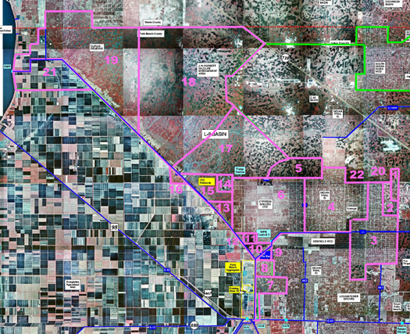

Figure 6.3 Sub-basins in L-8 Basin

Table 6.1 Sub-basins in L-8 Basin

Subbasin  No. | Description | Area  (acres) | Land Cover  Land Use | Curve  Number
1 | Kramer | 344 | Low-density Residential | 83.1
2 | Stonewal | 973 | Low-density Residential | 83.1
3 | ITID-lower M-1 basin | 7077 | Low-density Residential | 83.1
4 | ITID-upper M-1 basin | 11062 | Low-density Residential | 83.1
5 | Corbett wildlife area-South East | 3996 | Wetlands, Forested | 79.8
6 | Cypress Grove CDD (CGCDD) | 8459 | Agricultural citrus | 76.6
7 | Dear Run | 1313 | Low-density Residential | 82.0
8 | Dear Run Phase II | 828 | Low-density Residential | 82.0
9 | Dellwood | 298 | Low-density Residential | 80.7
10 | Unnamed | 900 | Low-density Residential | 73.5
11 | Unnamed | 83 | Agricultural citrus | 73.5
12 | Unnamed | 39 | Low-density Residential | 73.5
13 | South impoundment area for CGCDD | 798 | Wetlands, Undeveloped | 78.5
14 | ITID impoundment area | 720 | Reservoir | 95.0
15 | North impoundment area for CGCDD | 1957 | Wetlands, Undeveloped | 78.5
16 | Barbara L. VanNees | 76 | Agricultural, sugar cane | 83.3
17 | Corbett wildlife area-South | 11450 | Wetlands, Forested | 79.7
18 | Corbett wildlife area-North | 29421 | Wetlands, Forested | 79.7
19 | Dupuis reserve | 13974 | Uplands, Forested | 79.7
20 | School "H" | 50 | High-density Residential | 83.1
21 | US sugar Corporation | 9611 | Agricultural | 76.6
22 | North Lake Blvd | 27 | High-density Residential | 83.1

6.3.2 C-18 Sub-basins

According to earlier work (SFWMD, 1996), thirty-one sub-basins were delineated within the C-18 Basin, as shown in Table 6.2. The area and land cover/land use for each sub-basin are also listed in the table. The annual average U.S. Soil Conservation Service (SCS) curve number (CN) in the last column was obtained from the SFWMD’s North Palm Beach County Surface Water Model.

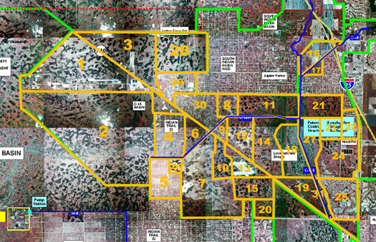

Figure 6.4 Sub-basins in C-18 Basin

Table 6.2 Sub-basins in C-18 Basin

Subbasin  No. | Description | Area  (acres) | Land Cover  Land Use | Curve  Number
1 | Pratt & Whitney | 6233 | Wetlands, Industrial | 72.5
2 | Corbett Wildlife Management Area | 13363 | Wetlands, Undeveloped | 62.7
3 | NPBCID Unit Numbers 10 and 16 | 3607 | Residential, Undeveloped | 72.5
4 | ITWCD | 1825 | Low-density Residential | 65.2
5 | Ranch Grove | 1442 | Agricultural | 65.9
6 | Proposed Save Our River Site | 1277 | Wetlands, Undeveloped | 64
7 | Vavrus | 4879 | Wetlands, Undeveloped | 54.4
8 | Palm Beach Gardens PDA | 664 | Low-density Residential | 48.7
9 | Fox Trail, Inc. | 309 | Low-density Residential | 55.9
10 | North Palm Beach County Airport (W) | 854 | Wetlands, Undeveloped | 65.5
11 | Loxahatchee Slough (North) | 1970 | Wetlands, Undeveloped | 71.1
12 | Sandhill Tract | 1336 | Wetlands, Undeveloped | 39.4
13 | North Palm Beach County Airport (E) | 963 | Wetlands, Airport Facilities | 70.3
14 | Loxahatchee Slough (West) | 2648 | Wetlands | 48.3
15 | Palm Beach Gardens Municipal Galf Course | 1212 | Wetlands, Golf Course | 69.9
16 | MacArthur Foundation | 972 | Wetlands, Agricultural | 54.3
17 | Undeveloped | 267 | Wetlands | 33.9
18 | Loxahatchee Slough | 2220 | Wetlands | 40.9
19 | Undeveloped Tract | 1240 | Wetlands | 43.6
20 | City of WPB Water Catchment Area | 556 | Wetlands, Undeveloped | 61.2
21 | Loxahatchee Slough (Eest) | 1444 | Wetlands, Undeveloped | 65.2
22 | NPBCID Unit No. 14 (Eastpointe) | 711 | Residential, Golf Course | 70.6
23 | NPBCID Unit No. 21 (Old Marsh PUD) | 697 | Residential, Golf Course | 70.6
24 | Future Golf Digest | 2275 | Undeveloped | 70.6
25 | NPBCID Unit No. 11 (PGA National PUD) | 1836 | Residential, Golf Course | 73.5
26 | Unnamed | 236 | Wetlands | 54.4
27 | Unnamed | 1393 | Wetlands | 40.9
28 | Unnamed | 3084 | Wetlands, Undeveloped | 62.7
29 | Unnamed | 1293 | Commercial/Industrial | 55.9
30 | Unnamed | 1795 | Low-density Residential | 55.9
31 | Unnamed | 338 | Wetlands | 53.3

6.4 Runoff (SCS CN method)

The volume of runoff can depend on number of factors: rainfall, land cover and use, soil type, and antecedent moisture conditions. One of the widely accepted methods for estimating the amount of runoff from a given rainstorm was developed by the U.S. Soil Conservation Service (SCS) and is generally referred to as the curve number (CN) method. In this project, the SCS curve number method was selected based on the availability of data and the time frame. Though the two-dimensional overland flow module of WASH123D model is capable of modeling the runoff in the study area in a more accurate way, the effort of data collection is beyond the time frame of this project.

  - Hydraulic Structures

In this model, the hydraulic structures and facilities are treated as internal or external boundaries of the river reaches. The existing hydraulic structures on L-8, C-18, C-14 and M- Canals are identified and summarized in the sub-sections that follow.

6.5.1 Structures on L-8 Canal

The existing hydraulic structures on L-8 Canal are listed in Table 6.3. C-10A is a gated culvert located at Lake Okeechobee and L-8 Canal. It is treated as an external boundary in the model. The discharge through C-10A is determined by the water stage of Lake Okeechobee and L-8 Canal, and the operation of the gates. The structure S-76 is a gated spillway. The gates will normally be operated to prevent stage at the structure from exceeding 19.0 ft NGVD. The structure was modeled as an internal boundary in the model and the gate remained fully open for most cases. The structures S-5AE, S-5AW, and S-5AS are located at the south end of L-8 Canal. Since the operation rule of these structures are not clearly defined and there is no obvious correlation between the water stage and discharge, the three structures are lumped into one external boundary and the discharge through the boundary were determined from field data.

Table 6.3 Structures on L-8 Canal and L-8 Outfall Canal

Structure  I.D. | Type | Location | Description | Included in Model
C-10A | Gated Culvert | L-8 and Lake Okeechobee | Five 185 ft × 120 in dia. CMP, Invert elevation = 5.5 ft NGVD | Yes
S-76 | Gated Spillway | L-8 Canal (north) | 7.5 ft high × 12.0 ft wide. Crest elevation = 7.0 ft NGVD | Yes
S-5AE | Gated Box Culvert | L-8 Canal (south) | Two 7 ft × 7 ft × 65 ft, Invert elevation =1.0 ft NGVD | Yes
S-5AW | Gated Box Culvert | L-8 Canal (south) | Two 7 ft × 7 ft × 80 ft,  Invert elevation= -1.75 to 0.3 ft NGVD | Yes
S-5AS | Gated Spillway | L-8 Canal (south) | Two 19.3 ft high × 22.8 ft wide, Net crest length=44.0 ft, Crest elevation =1.0 ft NGVD | Yes
S-5A | Pump Station | L-8 Canal (south) | 6 units × 800 cfs | No
N/A | Culvert with Riser | L-8 Outfall Canal at ITID impoundment area | Three 140 ft ×54 in dia. CMP, Invert elevation = 15.0 ft NGVD, riser top elevation = 24.5 ft NGVD | Yes
N/A | Culvert with Riser | L-8 Outfall Canal at L-8 Canal | Two 100 ft ×72 in dia. CMP, Invert elevation = 8.0 ft NGVD, riser top elevation = 14.0 ft NGVD | Yes

6.5.2 Structures on M-Canal

The existing hydraulic structures on the M Canal are given in Table 6.4.The pump station PS-1 (or Control No. 2) has two 65,000 gpm (145 cfs) pumps, one pump is driven by diesel engine and the other by an electric motor, but only one pump can be operated at a time. The pump station is an internal boundary in the model. The operation of the pump is determined by the head- and tail-water stages. Structure FB-2 is a culvert with riser. It is treated as an internal boundary. Structure W-2 is modeled as an external boundary. The flashboard is set at 17 ft NGVD.

Table 6.4 Structures on M-Canal

Structure  I.D. | Type | Location | Description | Included in Model
PS-1 | Pump Station | M Canal (west) | 2 units × 145 cfs | Yes
FB-1 | Flashboard Riser | M Canal (west) | Three 50 ft × 66 in dia. BCCMP, Invert elevation = 12.5 ft NGVD, riser top elevation = 22.9 ft NGVD | Yes
FB-2 | Flashboard Riser | M Canal (west) | Two 34 ft × 72 in dia. CMP, Invert elevation = 11.0 ft NGVD, riser top elevation = 21.0 ft NGVD | Yes
W-2 | Weir | M Canal (west) | 60.5 ft steel sheet piling weir, top elevation =22.5 ft NGVD, with two 8 ft wide stop log bays sill elevation = 10 ft, board at 17 ft NGVD | Yes

    - Structures on C-18 and C-14 Canals

The existing hydraulic structures on the SFWMD C-18 and the SIRWCD C-14 Canals are listed in Table 6.5. The structure C-18W is a uncontrolled weir located on the west leg of C-18 Canal. In the model, this structure is an internal boundary. The structure G-92 is a gated culvert with a design discharge of 400 cfs. This structure is operated via remote telemetry from the SFWMD Operations Control Room under a joint agreement with the SIRWCD to permit conveyance of environmental flows to the Northwest Fork of the Loxahatchee River. It also functions to convey excess water from SIRWCD into C-18 Canal during extreme storm events. In the simulation, G-92 is modeled as a gravity driven connection unit that divers flow from C-18 Canal to C-14 Canal. The structure S-46 is a gated spillway located on C-18 just north of Indiantown Road. The structure is operated to maintain an optimum headwater elevation of 14.8 ft through automatic operation of the gates (S-46 Gate opens when water level exceeds 14.8 feet NGVD). Water supply to the NWFLR stop when the stage in the C-18 canal reach 12.5 feet due to side slope stability risks associated with the fine sands layers within the project area. In this model, S-46 is treated as an external boundary. The automatic controls on the gates are as follows:

- When the headwater elevation rises to 15.0 ft, the gates will open at a speed of 0.4 inches per minute.
- When the headwater elevation rises or falls to 14.8 feet, the gates will become stationary.
- When the headwater elevation falls to 14.5 ft, the gates will close at a speed of 0.4 inches per minute.

Lainhart dam locates on north end of C-14 Canal. It serves as an external boundary in this model. The rating curve is fitted based on field data.

Table 6.5 Structures on C-18 and C-14 Canals

Structure  I.D. | Type | Location | Description | Included in Model
C-18 W | Weir | C-18 Canal  West Leg | Sheet pile, fixed-crest weir, crest length=93 ft, crest elevation = 17.64 ft NGVD | Yes
G-92 | Gated Box Culvert | SIRWCD  C-14 Canal | 10 ft × 8 ft × 100 ft | Yes
S-46 | Gated Spillway | C-18 Canal  East Leg | Three gates 20 ft × 8 ft, crest length=60 ft, crest elevation = 6.7 ft NGVD | Yes
Lainhart  Dam | Weir | C-18 Canal  East Leg | Modeled by rating curve obtained from field data | Yes

  - Meteorological Data

The rainfall and evaporation data used in this model were provided by SFWMD. The data is on a monthly basis from 1965 to 1995 and on 127 2-mile by 2-mile cells (shown in Figure 6.5) that cover the study area. In 1995, the average rainfall and evaporation over these cells are 69.3 inches and 30.4 inches, respectively.

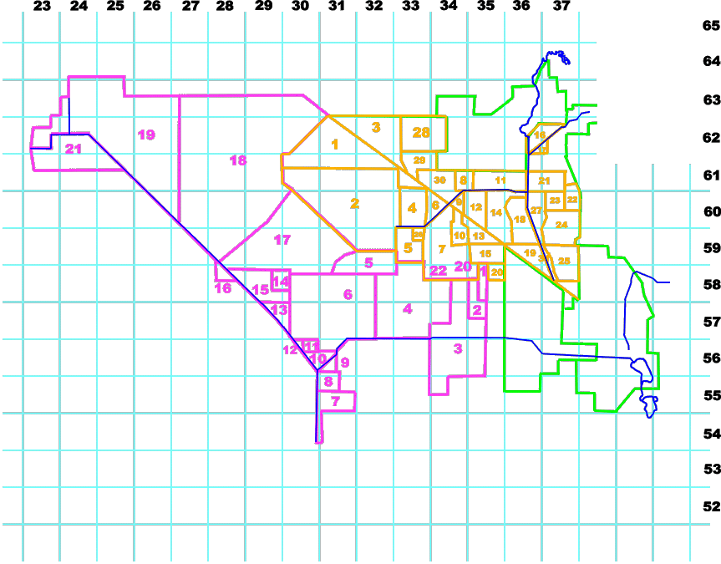

Figure 6.5 2-mile by 2-mile rainfall cells covered the study area.

The meteorological data for scattered field stations were also available from DBHYDRO, the South Florida Water Management District’s online corporate environmental database. Some meteorological data downloaded from the database were used to estimate rainfall and evaporation on reservoir sites. More details can be found in Chapter 2 and Appendices of this report.

6.7 Surface Water Data

Table 6.6 shows the surface water data downloaded directly from DBHYDRO, the SFWMD’s online corporate environmental database. These field data were used to set up boundary conditions and calibrate the model.

Table 6.6 Surface Water Data
Station/  Site | Data  Type | Description | Start Date | End Date
CULV10A_H | Water  Elevation | 1/4 mile east of structure CV-10A | 7/31/1992 | 12/30/2002
L_OKEE | Water  Elevation | Lake Okeechobee | 1/01/1984 | 8/31/2002
S5AE | Flow | S-5AE culvert on Canal C-51 at Levee L-8 | 1/1/1985 | 2/9/2000
S5AS_S | Flow | S-5AS spillway at Conservation Area 1 | 5/31/1985 | 4/2/2000
S5AW_C | Flow | S-5AW culvert on West Palm Beach Canal at Levee L-8 | 5/31/1985 | 4/30/200
C18W_W | Flow | At structure C18W | 7/31/1992 | 9/16/2002
S46_S | Flow | At southwest fork of Loxahatchee River | 11/8/1992 | 9/16/2002
G92_C | Flow | G-92 culvert from C-18 to west branch of Loxahatchee River | 5/10/1988 | 1/26/2003
LNHRT | Flow | Lainhart Dam on Loxahatchee River | 4/25/1995 | 9/17/2002

6.8 Model Configuration

Figure 6.6 provides a schematic representation of the model’s layout. The primary canal network system consists of eight canals: the L-8 Canal, L-8 North Tieback Canal, L-8 South Tieback Canal, L-8 Outfall Canal, M-Canal, C-18 Canal West Branch, C-18 Canal East Branch, and SIRWCD C-14 Canal. There are four water storage areas: Indian Trail Improvement District (ITID) impoundment area, Grassy Waters Preserve (GWP), Southern L-8 Reservoir (Rock Pits), and C-18 Reservoir.

The L-8 Canal connects Lake Okeechobee to Water Conservation Area 1 (WCA 1). It starts at Culvert 10A at the north end. At the south end, the connection to WCA 1 is by way of S-5A structures.

The L-8 North Tieback Canal drains a small portion of the L-8 basin. It connected with L-8 Canal just east of structure S-76.

The L-8 Outfall Canal connects the ITID impoundment area and the L-8 Canal. On its east end, it makes connections with the impoundment through a culvert structure with riser. On its west end, the connection is also in the form of culvert with riser.

The L-8 South Tieback Canal connects the L-8 Canal and the M-Canal. The northeast end of the canal is a pump station PS-1 (Control #2) owned and operated by the City of West Palm Beach.

The M-Canal starts at PS-1 and extends eastward. In the scope of this model, the east boundary of the M-Canal is a weir structure W-2 located west of the Haverhill Road.

The East Branch of C-18 Canal starts at GWP and extends northward. In the scope of current model, the C-18 Canal ends at structure S-46 which supplies water to the Southwest Fork of the Loxahatchee River.

The West Branch of C-18 Canal begins at the northeast corner of section of Range 40E-Township 42S. It extends eastward and confluences with the East Branch.

The SIRWCD C-14 Canal originates at the G-92 Structure and ends at Lainhart dam – a small weir structure (with a small culvert) located upstream of the Northwest Fork of the Loxahatchee River.

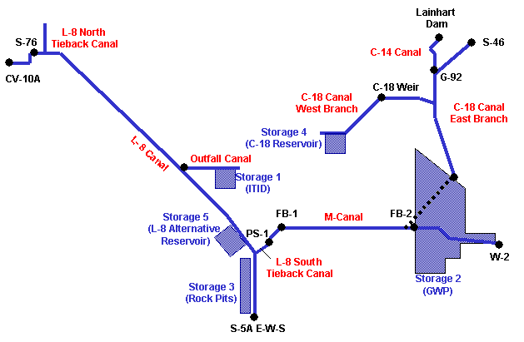

Figure 6.6 Model layout

6.8.1 Canal Networks

Fifteen canal reaches were created for modeling purpose as shown in Figure 6.7. Each reach is delimited either by structure, junction, dead end, or external boundary. The length and description of each reach are given as follows and also shown in Table 6.7.

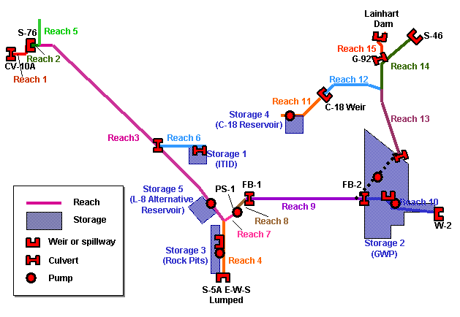

Figure 6.7 Canal reaches in the model

Reach 1
The portion of the L-8 Canal located between culvert C-10A and structure S-76 was modeled as Reach 1. The external boundary condition at culvert C-10A was obtained from field data. The other end of the reach at structure S-76 is an internal weir boundary.

Reach 2
The portion of the L-8 Canal located between structure S-76 and the junction of the North Tieback Canal and L-8 Canal was modeled as Reach 2. The internal weir boundary condition was imposed at the start node of Reach 2 at structure S-76. The boundary of the reach at North Tieback Canal is an internal junction boundary.

Reach 3
The portion of the L-8 Canal from its junction with North L-8 Tieback Canal to the junction with South L-8 Tieback Canal is Reach 3 which is over 19 miles long. The boundaries at both ends of Reach 3 are internal junctions.

Reach 4
Reach 4 covers the portion of L-8 Canal from the junction of the L-8 Canal and the South L-8 Tieback Canal to the S-5A structures (S-5AE, S-5AW, and S-5AS). At the north end of the reach, a junction boundary condition was imposed. The boundary condition at the south end was obtained from the field data.

Reach 5
The North Tieback Canal was modeled as Reach 5. The north end of the reach is treated as a dead end. The south end is a junction with Reach 2 and Reach 3.

Reach 6
The L-8 Outfall Canal is Reach 6. The east end of the reach is a dead end. The west end boundary is a culvert structure with riser. The culvert opens to L-8 Canal (Reach3).

Reach 7
Reach 7 is the South L-8 Tieback Canal that connects L-8 Canal and M-Canal. The southwest end of the reach is the junction with Reach 3 and Reach 4. The northeast end is the pump station PS-1. The pump station is used to supply water to the South L-8 Tieback Canal to M Canal. The current capacity of the pump station is 145 cfs.

Reach 8
The portion of M canal between pump station PS-1 and structure FB-1 is Reach 8. The structure FB-1, including three culverts with risers, is treated as an internal boundary of the reach.

Reach 9
The portion of M-Canal located between structure FB-1 and structure FB-2 is modeled as Reach 9. FB-1 is an internal boundary with Reach 8. The structure FB-2, including two culverts with risers, is also an internal boundary of the reach in the model.

Reach 10
Reach 10 starts at structure FB-2 and ends at the east edge of the Grassy Waters Preserve (GWP) where the structure W-2 locates. W-2 is a steel sheet piling weir, which serves as an external boundary of the model.

Reach 11
Reach 11 starts at the west end of the C-18 Canal West Branch and ends at the structure C-18W Weir. The west end of the reach is treated as a dead end. The C-18W Weir is an internal boundary.

Reach 12
The West Branch of C-18 Canal between C-18W Weir and the confluence with the East Branch of C-18 Canal is Reach 12. The upstream boundary of this reach is an internal weir boundary. The downstream end is an internal junction boundary.

Reach 13
The portion of C-18 Canal East Branch from the north edge of GWP at Beeline Highway to the junction with C-18 Canal West Branch is Reach 13. The south end of the reach is treated as a dead end. At the confluence, a junction boundary condition is imposed.

Reach 14
Reach 14 is the C-18 Canal East Branch located between its junction with C-18 Canal West Branch and structure S-46. S-46 is a gated spillway. The gate opening is controlled by headwater elevation automatically. It is modeled as an external boundary in the model.

Reach 15
The SIRWCD C-14 Canal modeled as Reach 15 starts at structure G-92 and terminates at the Lainhart Dam near the Indiantown Road. The G-92 is a gated culvert capable of passing up to 400 cfs in either direction. It was modeled as an internal connection structure in the model. The boundary condition at the Lainhart Dam was the rating curve obtained from the field data.

Table 6.7 Canal reaches in the model
Reach | Length  (100 ft) | Description
1 | 127.6 | From C-10A to S-76
2 | 21.4 | From S-76 to the junction of the L-8 Canal and the L-8 North Tieback Canal
3 | 1003.6 | From the junction of the L-8 Canal and the L-8 North Tieback Canal to the junction of the L-8 Canal and the South L-8 Tieback Canal
4 | 203.2 | From the junction of the L-8 Canal and the South L-8 Tieback Canal to S-5A
5 | 107.6 | The L-8 North Tieback Canal
6 | 170.9 | The L-8 Outfall Canal
7 | 88.7 | From the junction of the L-8 Canal and the South L-8 Tieback Canal to PS-1
8 | 41.0 | From PS-1 to FB-1
9 | 437.4 | From FB-1 to FB-2
10 | 366.4 | From FB-2 to W-2
11 | 174.3 | West leg of C-18 Canal to the west of C-18 Weir
12 | 238.6 | From C-18 Weir to the junction of the C-18W Canal and the C-18E Canal
13 | 265.7 | From the Beeline Culvert to the junction of the C-18W Canal and the C-18E Canal
14 | 244.8 | From the junction of the C-18W Canal and the C-18E Canal to structure S-46
15 | 118.9 | From G-92 to the Lainhart Dam

6.8.2 Cross-Sections

The cross-section information of L-8 Canal was obtained from Burns & McDonnell (2001). Table 6.8 gives the locations of some cross-sections of the L-8 Canal. It also gives the canal reach that contains the cross-section. Plots of these cross-sections are shown in Figure 6.8.

Table 6.8 Typical cross-sections of L-8 Canal
Cross-Section  No. | River Mileage  (100 ft) | Reach  No.
1 | 0.00 | 1
2 | 67.60 | 1
3 | 127.60 | 2
4 | 147.70 | 2
5 | 149.00 | 3
6 | 279.60 | 3
7 | 467.60 | 3
8 | 658.20 | 3
9 | 834.22 | 3
10 | 850.65 | 4
11 | 1016.97 | 4
12 | 1107.75 | 4
13 | 1152.60 | 4
14 | 1153.10 | 5
15 | 1223.29 | 5
16 | 1302.49 | 5
17 | 1355.72 | 5

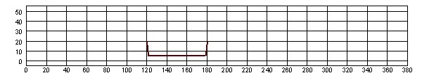
(a) L-8 Canal Cross Section # 1
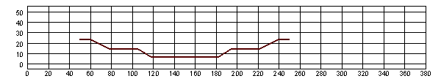
(b) L-8 Canal Cross Section # 2
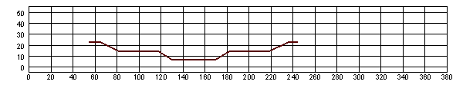
(c) L-8 Canal Cross Section # 3
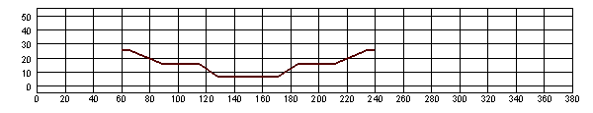
(d) L-8 Canal Cross Section # 4
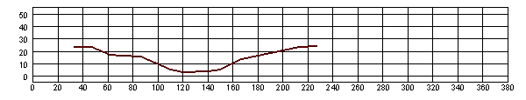
(e) L-8 Canal Cross Section # 5
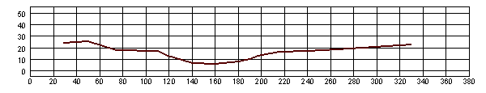
(f) L-8 Canal Cross Section # 6
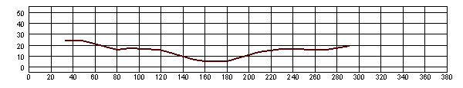
(g) L-8 Canal Cross Section # 7
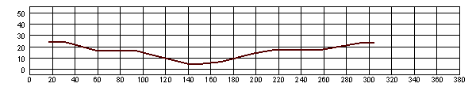
(h) L-8 Canal Cross Section # 8
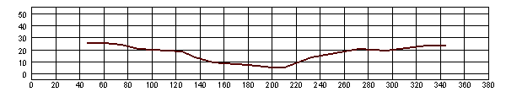
(i) L-8 Canal Cross Section # 9
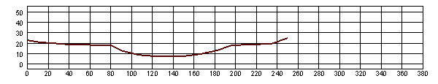
(j) L-8 Canal Cross Section # 10
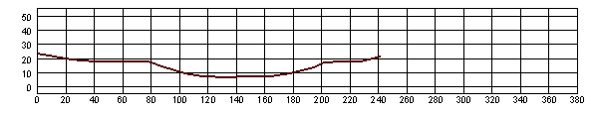
(k) L-8 Canal Cross Section # 11
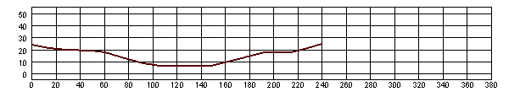
(l) L-8 Canal Cross Section # 12
(m) L-8 Canal Cross Section # 13
(n) L-8 Canal Cross Section # 14
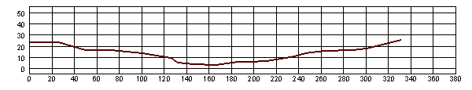
(o) L-8 Canal Cross Section # 15
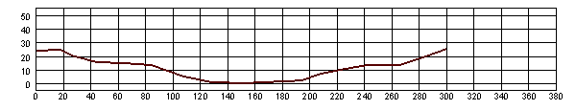
(p) L-8 Canal Cross Section # 16
(q) L-8 Canal Cross Section # 17

Figure 6.8 Typical cross-sections of L-8 Canal

The cross-section information of C-18 Canal was obtained from the record drawing of Corps of Engineers, prepared in 1958. The record drawing contains nine cross-sections of C-18 Canal West Branch, as shown in Table 6.9. These cross-sections locate on Reach 11 and 12 in the model. The plots of the sections are displayed in Figure 6.9. For C-18 Canal East Branch, the Corps’ record drawing provides the geometry of fourteen cross-sections located on Reach 13 and 14 in the model, as shown in Table 6.10. Figure 6.10 shows the plots of the sections.

Table 6.9 Typical cross-sections of C-18 Canal West Branch

Cross-Section  No. | River Mileage  (100 ft) | Reach  No.
1 | 0.00 | 11
2 | 52.00 | 11
3 | 92.00 | 11
4 | 132.00 | 11
5 | 174.00 | 12
6 | 230.00 | 12
7 | 256.00 | 12
8 | 308.00 | 12
9 | 362.00 | 12

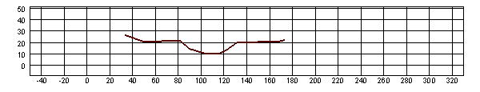
(a) C-18 Canal West Branch Cross Section # 1
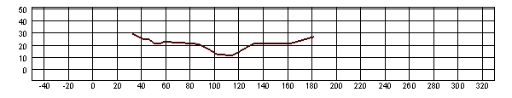
(b) C-18 Canal West Branch Cross Section # 2
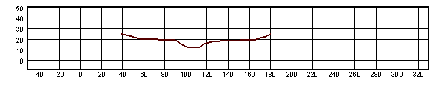
(c) C-18 Canal West Branch Cross Section # 3
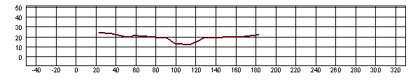
(d) C-18 Canal West Branch Cross Section # 4
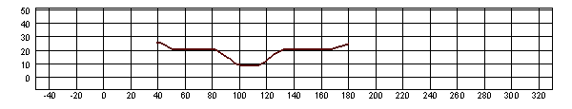
(e) C-18 Canal West Branch Cross Section # 5
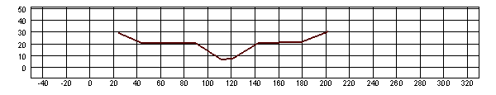
(f) C-18 Canal West Branch Cross Section # 6
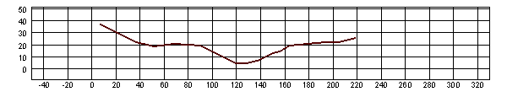
(g) C-18 Canal West Branch Cross Section # 7
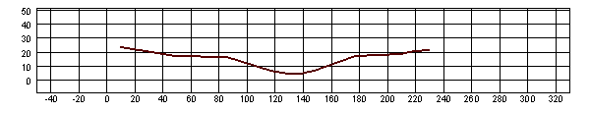
(h) C-18 Canal West Branch Cross Section # 8
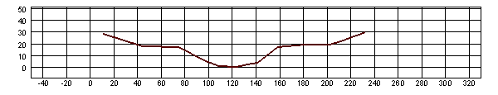
(i) C-18 Canal West Branch Cross Section # 9

Figure 6.9 Cross-Sections of C-18 Canal West Branch

Table 6.10 Typical cross-sections of C-18 Canal East Branch
Cross-Section  No. | River Mileage  (100 ft) | Reach  No.
1 | 0.00 | 13
2 | 45.00 | 13
3 | 101.00 | 13
4 | 155.00 | 13
5 | 211.00 | 13
6 | 267.00 | 14
7 | 315.00 | 14
8 | 367.00 | 14
9 | 372.00 | 14
10 | 409.00 | 14
11 | 457.00 | 14
12 | 471.00 | 14
13 | 489.82 | 14
14 | 506.25 | 14

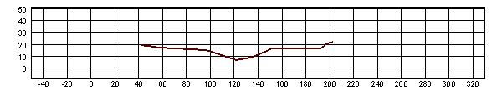
(a) C-18 Canal East Branch Cross Section # 1
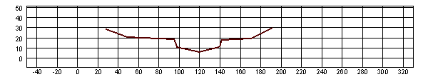
(b) C-18 Canal East Branch Cross Section # 2
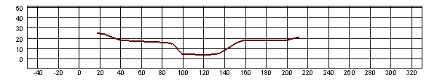
(c) C-18 Canal East Branch Cross Section # 3
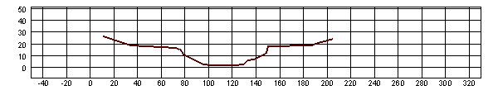
(d) C-18 Canal East Branch Cross Section # 4
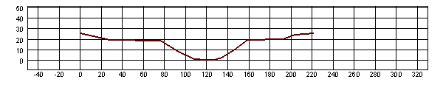
(e) C-18 Canal East Branch Cross Section # 5
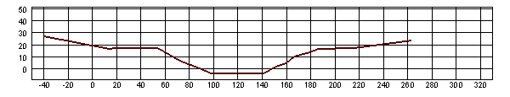
(f) C-18 Canal East Branch Cross Section # 6
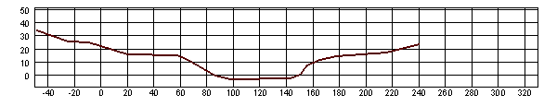
(g) C-18 Canal East Branch Cross Section # 7
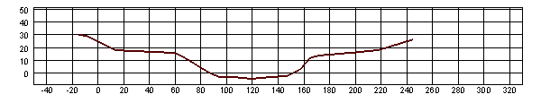
(h) C-18 Canal East Branch Cross Section # 8
(i) C-18 Canal East Branch Cross Section # 9
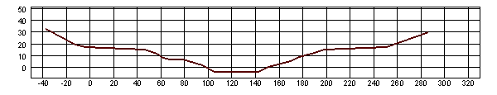
(j) C-18 Canal East Branch Cross Section # 10
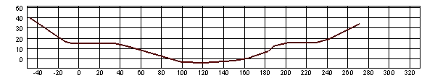
(k) C-18 Canal East Branch Cross Section # 11
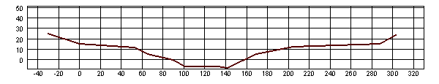
(l) C-18 Canal East Branch Cross Section # 12
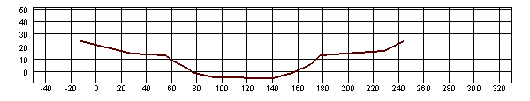
(m) C-18 Canal East Branch Cross Section # 13
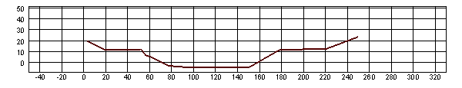
(n) C-18 Canal East Branch Cross Section # 14

Figure 6.10 Cross-Sections of C-18 Canal East Branch

6.8.2 Water Storage Area and Reservoirs

Water storage area and reservoirs are considered as key components in a regional water management strategy. There are three existing water storage areas: the Indian Trail Improvement District (ITID) impoundment area (Storage 1), the Grassy Waters Preserve (GWP) (Storage 2), and the Southern L-8 Reservoir (or Rock Pits) (Storage 3). The two proposed surface water reservoirs include the C-18 Reservoir (Storage 4) and the L-8 Alternative Reservoirs (Storage 5). The reservoir operations were simulated using the reservoir module introduced in Chapter 2. The connections between the reservoirs and canal reaches are by way of hydraulic structures and pump stations.

The Indian Trail Improvement District (ITID) impoundment area located at sub-basin No. 14 of the L-8 Basin. The maximum storage of the area is around 3300 acre-feet at a water depth of 5 feet. The connection between the impoundment area and the L-8 Outfall Canal is by way of a culvert structure with riser. The riser is in the impoundment area and the culverts open to the L-8 Outfall Canal.

The Grassy Waters Preserve (GWP) formerly known as the City of West Palm Beach Water Catchment Area is an approximately 19 square mile impounded area that is predominantly wetland in nature. Currently, GWP is owned and maintained by the City of West Palm Beach and serves as a surface water storage reservoir for public water supply. Water from this wetland is discharged to the east through the M-Canal to Lake Mangonia and Clear Lake, and subsequently enters the City’s water treatment plant in West Palm Beach.

The Southern L-8 Reservoir is proposed to use the abandoned rock mining pits to provide a combined above-ground and in-ground storage capacity of approximately 48,000 acre-feet. It is located immediately west of the L-8 Canal and near the junction of L-8 and C-51 Canals. An area of 1,200 acres may be available and the operation depth is 35 feet (20 feet in ground and 15 feet above ground). The purpose of this reservoir is to increase water supply availability, and attenuate discharge to Lake Worth Lagoon and provide compatible drainage benefits for northern Palm Beach County area. It will also provide flows to enhance hydroperiods in the Loxahatchee Slough, increase base flows to the Northwest Fork of the Loxahatchee River, and reduce high discharges to the Lake Worth Lagoon (Northern Palm Beach County Comprehensive Water Management Plan, SFWND, 2002).

The C-18 Reservoir was modeled on a footprint of 1,000 acres or 2,000 acres with maximum depths ranging from 10 feet to 15 feet. The total storage volume ranges from 10,000 acre-feet to 30,000 acre-feet. The connection between the reservoir and C-18 Canal West Branch is by way of a pump station with a capacity of up to 100 cfs. This reservoir is designed for the purpose of catching and storing wet season water for use during the dry season to meet the minimum flow criteria to the Northwest Fork of the Loxahatchee River.

The L-8 Alternative Reservoir was placed near the junction of the L-8 Canal and the South L-8 Tieback Canal and west side of L-8 Canal. This reservoir was modeled with a foot print of 1,000 acres or 2,000 acres. Maximum depths ranging from 10 feet to 15 feet were evaluated. The total storage volume ranges from 10,000 acre-feet to 30,000 acre-feet. A pump station with a capacity of 100 cfs connected the reservoir to L-8 Canal.

6.9 Model Calibration

For the purpose of calibration, the flow data recorded at several sites as described in Table 6.11 were downloaded from SFWMD’s online database. Under the existing condition, the conveyance between the Grassy Waters Preserve (GWP) and the East Branch of C-18 Canal is severely constrained (< 10 cfs), thus the L-8 Canal system and C-18 Canal system can be considered as decoupled. Within this project, since the daily rainfall and evaporation data for the entire area were not available, the rainfall and evaporation input to the model was on a monthly basis. Thus it would be very difficult to calibrate the model against the daily field data but using monthly data as input. Therefore, one-year accumulative discharges through the three structures listed in Table 6.11 were used to calibrate the model.

Table 6.11 Surface water data for model calibration

Station/  Site | Interval | Description | Start Date | End Date
S46_S | Daily | At southwest fork of Loxahatchee River | 11/8/1992 | 9/16/2002
G92_C | Daily | G-92 culvert from C-18 to west branch of Loxahatchee River | 5/10/1988 | 1/26/2003
LNHRT | Daily | Lainhart Dam on Loxahatchee River | 4/25/1995 | 9/17/2002

Under the assumption that C-18 Canal system is isolated from the L-8 Canal system, the amount of water that enters the C-18 Canal system is thus divided among direct rainfall, surface runoff, and groundwater seepage. Water inflows to C-18 Canal system contributed by direct rainfall onto the canal and surface runoff from the thirty two sub-basins of the C-18 drainage area can be modeled or obtained from field data. The groundwater seepage is difficult to estimate without modeling. Though the three-dimensional groundwater module of WASH123D model is capable of precisely predicting the groundwater seepage to C-18 Canal, the time frame of this project would not allow us to do so. Thus, the estimation of groundwater seepage became part of the calibration procedure. The outlet of the system consists of two structures: S-46 and G-92. The object of the calibration is to match the cumulative discharge and the base flow at structure G92.

The year of 1995 was selected for calibration, since the rainfall and evaporation input was from 1965 through 1995 and there were more field data available in 1995. Table 6.12 gives the cumulative discharge at the structures.

Table 6.12 Measured cumulative flow in 1995

Station/  Site | Start Date | End Date | Cumulated Discharge  (acre-feet )
S46_S | 1/1/1995 | 12/31/1995 | 124230
G92_C | 1/1/1995 | 12/31/1995 | 59091
LNHRT | 4/25/1995 | 12/31/1995 | 59920

Structure G-92 is a gated culvert; it diverts water from C-18 Canal to C-14 Canal. The structure is operated via remote telemetry from the SFWMD Operations Control Room under a joint agreement with the SIRWCD to permit conveyance of flows to the Northwest Fork of the Loxahatchee River through Lainhart Dam. In current simulation, since the operation rule of G-92 was not provided by SFWMD, the gate was set at fixed openings, as shown in Table 6.13, 12.5% for CASE A, and 15% for CASE B.

Table 6.13 Gate opening at Structure G-92
CASE | Gate Opening of G-92
A | 12.5%
B | 15%

The simulation results are shown in Table 6.14. The results indicate that when the gate opening of structure G-92 was 15%, the cumulative flow through the structure is very close to the field data. Therefore, the gate opening of 15% was chosen for a series of simulations. In 1995, the field data at Lainhart Dam starts on 4/25. The cumulative flows through the structures S-46, G-92 and Lainhart Dam from 4/25/95 to 12/31/95 are displayed in Table 6.15. Though these numbers are not matched as well as for structure G-92, generally the model calibration is still acceptable.

Table 6.14 Cumulative flow through different structures
Cumulative Flow through the Following Structures (acre-feet)
(1/1/95 -12/31/95)
 | S-46 | G-92 | Lainhart Dam
Field Data | 124230 | 59091 | N/A
A | 111795 | 52980 | 70507
B | 104770 | 60027 | 77555

Table 6.15 Cumulative flow through Lainhart Dam compared with field data
Cumulative Flow through the Lainhart Dam (acre-feet)
(4/25/95 -12/31/95)
Field Data | 59920
A | 57244
B | 63628

The goal of this project is to study the capability of water storage reservoirs of providing supplement water to the Northwest Fork of the Loxahatchee River to meet the minimum flow request in the dry season. The minimum flow request was tested at Lainhard Dam for both CASE A and B. The target minimum flows were set at 35 cfs, 65cfs, and 100 cfs. The percent of time the target flow was met under existing conditions in the year of simulation is shown in Table 6.16. The results are the same for both gate openings at structure G-92. The percent of time that the minimum flow of 35 cfs, 65cfs, and 100 cfs were met were 70%, 60%, and 54%, respectively. As indicated by the Loxahatchee River Minimum Flows and Levels, over the past decade, the 35 cfs and 65 cfs flow target for the Lainhart Dam, were met about 75% and 57% of the time ^{[14]}. To compare with the field data, the percent of time was calculated again from 4/25/95 through 12/31/95. The results are displayed in Table 6.17. In simulation with both 12.5% and 15% gate openings, the simulated time percentage is higher than field data for 65 cfs and 100 cfs, but lower for 35 cfs.

Table 6.16 Percent of time the target minimum flow is met at Lainhart Dam
CASE | Percent of Time The Following Target Flow Is Met  (1/1/95 -12/31/95)
CASE | ≥ 35 (cfs) | ≥ 65 (cfs) | ≥ 100 (cfs)
1-A | 70% | 60% | 54%
1-B | 70% | 60% | 54%

Table 6.17 Percent of time the target minimum flow is met.
A comparison with field data
CASE | Percent of Time The Following Target Flow Is Met  (4/25/95 -12/31/95)
CASE | ≥ 35 (cfs) | ≥ 65 (cfs) | ≥ 100 (cfs)
Field Data | 79% | 60% | 52%
1-A | 72% | 69% | 67%
1-B | 72% | 69% | 67%

Figure 6.11(a) shows the hydrograph at structure G-92 with a gate opening of 12.5% in 1995 obtained from CASE A in comparison with field flow data. The hydrograph at structure G-92 obtained from CASE B is displayed in Figure 6.11(b). In this case, the gate opening of G-92 was 15%. The data in Table 6.14 and 6.15 indicates that the larger gate opening allowed the passing of more water through structure G-92. But the Figure 6.11 shows that his only happens during the wet seasons, in the dry season, both openings pass the same amount of water. The large deviations between the simulation results and the field data can be attributed to the following two factors: 1) The rainfall data used for the simulation was on a monthly basis; 2) The operation rule the gate at structure G-92 was not clear, so the gate opening was fixed in the simulation. However, in both cases, the yearly cumulative flows were quite close to the field data as shown previously in Table 6.14

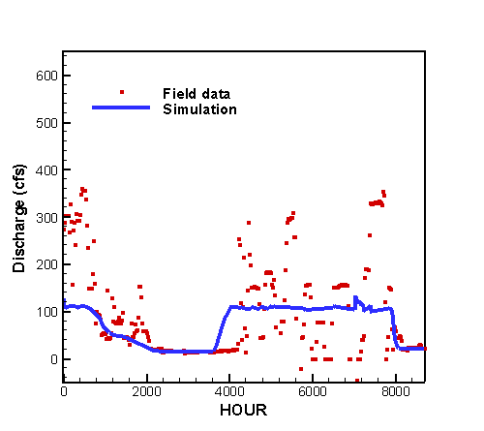 | 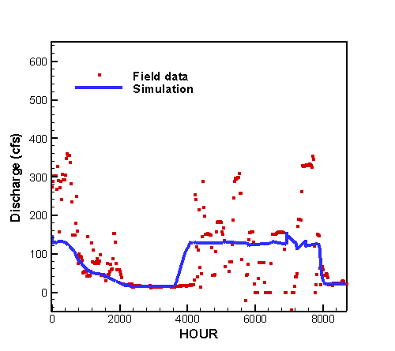
(a) CASE A | (b) CASE B

Figure 6.11 Hydrograph at structure G-92 from 1/1/95 through 12/1/95

The Lainhart Dam is an uncontrolled weir. The simulated hydrographs are displayed in Figures 6.12. Obviously the simulation results are in much better agreement with the field data than that of G-92 even though the input data was on monthly basis.

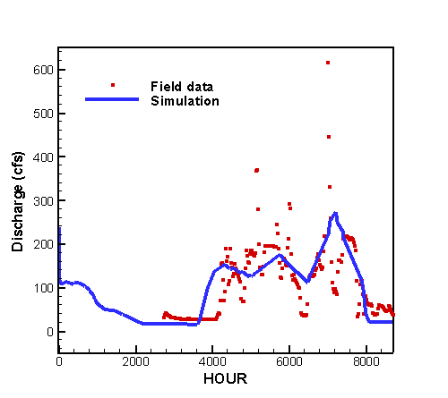 | 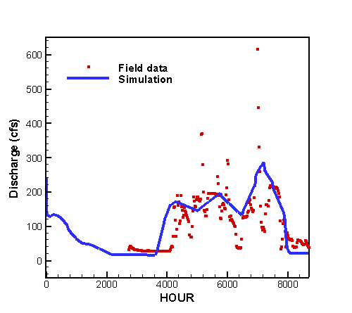
(a) CASE 1-A | (b) CASE 1-B
Figure 6.12 Hydrograph at Lainhart Dam from 1/1/95 through 12/1/95.

Reference

- Chow, V.T., Maidment, D.R. and Mays, L.W. 1988. Applied Hydrology, New York, McGraw-Hill.
- McCuen, R. H. 1989. Hydrologic Analysis and Design, Prentice-Hall, Englewood Cliffs, NJ.
- South Florida Water Management District, 1988. Technical Memorandum DRE-244, An Atlas of Eastern Palm Beach County Surface Water Management Basins.
- South Florida Water Management District, 1989. Technical Memorandum DRE-274, An Atlas of the Everglades Agricultural Area Surface Water Management Basins.
- South Florida Water Management District, 1996. Technical Memorandum #1B, Data Acquisition for the Loxahatchee Slough.
- South Florida Water Management District, 1997. Technical Memorandum #2B, Hydrologic Model for the Loxahatchee Slough Basin.
- South Florida Water Management District, 1997. Technical Memorandum #3B, Hydrologic Model for the Loxahatchee Slough Basin.
- South Florida Water Management District, 1996. Technical Memorandum #1A, Data Acquisition for the Southern L-8 Basin.
- South Florida Water Management District, 1996. Technical Memorandum #2A, Hydrologic Model for the Southern L-8 Basin.
- South Florida Water Management District, 1997. Technical Memorandum #3A, Hydraulic Model for the Southern L-8 Basin.
- South Florida Water Management District, 1995. West Palm Beach Water Catchment Area Water Conservation Study, Technical Memorandum #3.
- South Florida Water Management District, 2000. Lower East Coast Regional Water Supply Plan, Planning Document.
- South Florida Water Management District, 2000. Lower East Coast Regional Water Supply Plan, Appendices Volume I.
- South Florida Water Management District, 2002. Minimum Flows and Levels for the Loxahatchee River and Estuary (Draft).
- South Florida Water Management District, 2002. Northern Palm Beach County Comprehensive Water Management Plan, Planning Document Volume I.
- U.S. Army Corps of Engineers Jacksonville District, 2001. Existing Conditions Hydrology and Hydraulic, L-8 Basin, Palm Beach County, Florida. (Contract No. DACW17-99-D-0050, Burns & McDonnel)

