Chapter 2 Effective Capacity, Alternative Reservoirs, and Power Plant Option

2.1 Introduction

Surface water storage reservoirs are important components of the Comprehensive Everglades Restoration Plan (CERP). One purpose of building a storage reservoir in northern Palm Beach County area is to capture excess water (e.g. storm water runoff) before it is discharged from the L-8 Basin. The stored water can be used to meet the water supply needs of the North Palm Beach County (NPBC) Service Area. For example water can currently be supplied to the Grassy Waters Preserve (GWP) and the City of West Palm Beach by routing this potentially stored water through the M-Canal. The design and construction of the G-161 structure will allow water to discharge from the GWP into the Loxahatchee Slough and subsequently into the NWFLR (through the G-160 and G-92 structures). The GWP was formerly known as West Palm Beach Water Catchment Area,.

The heterogeneities in design (e.g. reservoir location, depth, area, and geometry ) and site specific attributes (e.g. large seepage losses due to highly transmissive soils) make direct comparison of the storage volume insufficient. In order to make reasonable comparisons among proposed reservoirs a measure of what each proposed reservoir actually provides is necessary. Throughout this report, a concept of effective storage capacity will be used. A Reservoir Evaluation Model was developed at the University of Central Florida using the WASH123D model which calculates the effective capacity and effectiveness of reservoirs. The Reservoir Evaluation Model can also provide estimates of temporal variations of water stage and water temperature under given meteorological conditions for different reservoir configurations.

This Chapter is organized as follows. In Section 2.2 the concept of effective capacity and effectiveness of a reservoir is described in detail. The Section 2.3 provides a description of the Reservoir Evaluation Model. Section 2.4 provides information on the meteorological data used in the study. In Section 2.5, the Reservoir Evaluation Model is applied to several alternatives containing reservoirs. In Section 2.6, The L-8 rock pits (Palm Beach Aggregates) are modeled as part of the cooling system for a power plant.

2.2 Effective Capacity

At first look a measure of the reservoir's yield or water supply would seem to be simply the storage volume provided by the reservoir (e.g. depth multiplied by area). This measure alone is insufficient because, at the very least, it does not take into account the volumes the reservoirs collect naturally (through rainfall) and lose naturally (through evaporation / transpiration). In addition, this overly simple approach neglects the following substantive factors.

- The availability and timing of water to fill the reservoir. There has to be sufficient water and collection capacity (e.g. canals and pumps) to allow filling of the reservoir when excess water is available.
- The proximity and timing of demands. Is the reservoir located where (with the proposed modification) it can provide water supply sufficient to empty the reservoir.
- The synergy with Aquifer Storage and Recovery (ASR) systems. Specifically, the ability to capture water before it is discharged to tide and supply it to an ASR system for long term storage.
- The impacts of other uses of the Reservoir. For example the additional water loss associated with maintaining a Storm Water Treatment Area (STA) to provide water quality treatment of the discharged water or the additional evaporation caused by using the reservoir as a cooling pond.

The effective capacity of a reservoir is defined as the volume supplied for a fixed period of evaluation (e.g. 1 year, 10 years, or 36 years). It should be noted that depending on the timing and magnitude of runoff, the timing and magnitude of the demands, and the storage volume provided, it is possible for a reservoir to supply more water annually than its storage volume. Said in another way it is possible for smaller reservoirs to completely or partially fill and empty several times during a calendar year. The addition of ASR and higher levels of service (e.g. provide water for a drought with and average return period of ten years) will increase the effective yield of reservoirs. The calculation of the effective yield of reservoir requires the careful accounting of all volumes discharged from the reservoir. For example, water removed from the reservoir and stored underground by an ASR system for subsequent return (with the appropriate storage losses) to the reservoir during dry period would not be tallied as water supply. Similarly water discharged from the reservoir to recover storage volume for storm attenuation purposes which was subsequently discharged to tide would not be considered as water supply.

The examples provided in this report use a simplified approach which uses a one year period and measures the volume of the reservoir used by comparing the maximum and minimum water levels in this one year period. In Figure 2.1, the left diagram shows the variation of water stage in a year. The effective capacity for this example corresponds to the volume between the maximum water level and the minimum water level.. The effectiveness is defined as the ratio between the effective capacity and the total capacity.

$\text{Effectiveness} (\text{\%})=\frac{\text{Effective} \text{Capacity}}{\text{Total} \text{Capacity}}$ (2.1)

Without any surface water inflows or outflows, the minimum water-surface level is determined solely by the meteorological condition, i.e., precipitation and evaporation. Generally, if two reservoirs with the same storage capacity but different depths are considered under the same meteorological condition and demands, the effectiveness of the deeper reservoir is greater than that of the shallower one.

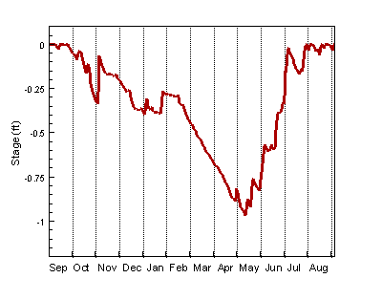

Figure 2.1 Schematic diagram for effective capacity.

2.3 Reservoir Modeling

From the point of view of mathematics, the Reservoir Evaluation Model contains a water budget equation and an energy budget equation.

The water budget equation based on the conservation of mass describes the water balance of all inflows and outflows to the reservoir. Water inflow to the reservoir may be from rainfall, stream flow, surface runoff, subsurface runoff, pumping inflow, and gravity driven inflow through hydraulic structures. Outflow from the reservoir may include evaporation, stream flow discharge, subsurface seepage losses, and pumping outflow, and gravity driven outflow through structures. The water budget equation is expressed as

$\frac{d S}{d t}= Q_{P}+Q_{G}+Q_{R}−Q_{E}+ Q_{\text{In}}− Q_{\text{Out}}+Q_{S}$ (2.2)

where S is reservoir storage. Q_{P} is the pumping rate of inflow or outflow. The volumetric rate of flow through gravity-driven hydraulic structure is denoted by Q_{G}. The rate of inflow from rainfall is Q_{R}. The outflow rate from evaporation is Q_{E}. The rate of stream flow, subsurface runoff, and any human operation are lumped into Q_{In} and Q_{Out}. Q_{S} is the rate of inflow or outflow due to seepage.

The pumping rate is calculated by the pump station module, which will be introduced in more detail in Chapter 5. The pumping rate is defined as positive when water is pumped into the reservoir and negative when water is pumped out of the reservoir. The flow rate associated with gravity-driven hydraulic structures is defined in a similar way. The structure can be of any type, such as weir, gate, spillway, and culvert. The details of the gravity-driven structure module will be given later in Chapter 5. The rainfall intensity is obtained from rainfall record or estimated from weather forecast. The rate of evaporation is calculated either by the Penman method (McCuen, 1989) or by directly solving the energy equation of the water body.

The Reservoir Evaluation Model includes the capability to estimate the temperature of the water in the reservoir including the case of a reservoir being used simultaneously for water storage and as a cooling pond for a power plant. If water temperatures need to be estimated the following energy equation based on the principle of conservation of thermal energy should be solved:

$ρ C_{P}\frac{d( S T)}{d t}= Φ_{P}+Φ_{G}+Φ_{R}−Φ_{E}+ Φ_{\text{In}}− Φ_{\text{Out}}+ Φ_{\text{Net}}−Φ_{C}+Φ_{S}$ (2.3)

where$ρ$ is the density of water. T is water temperature. C_{p} is the specific heat of water. The solar radiation incident, the reflected solar radiation, and the longwave radiation exchange between the atmosphere and the water body are lumped into the net radiation term Φ_{Net}. The energy utilized for evaporation is Φ_{E}. The energy loss/gain due to conduction between the water and atmosphere is denoted by Φ_{C} . The energy gains/losss due to other types of source/sink are denoted by Φ_{In} and Φ_{Out}. Φ_{P} and Φ_{G} are the energy entering or leaving the reservoir due to pumping and flow through gravity driven structures, respectively. The energy entering the water body due to rainfall is Φ_{R}. Seepage also introduces energy flow Φ_{S}.

The outflow rate due to evaporation (Q_{E}) in Equation (2.2) and the energy utilized for evaporation (Φ_{E}) in Equation (2.3) are given by

$Q_{E} = A E_{a}$ and $Φ_{E} = A H_{a}$ (2.4)

in which $E_{a}$ is the evaporation flux, A is water surface area, and $H_{a}$is the latent heat flux which can be expressed as

$H_{a} = ρ L E_{a}$ (2.5)

where$ρ$ is the density of water, L the latent heat of water, and$E_{a}$the evaporation flux.

The heat conduction term (Φ_{C}) in Equation (2.3) can be expressed as

$Φ_{C} = A H_{c}$ (2.6)

A is the water surface area. $H_{c}$ is the sensible heat flux, which is related to the latent heat flux $H_{a}$ through the Bowen ratio as the following:

$H_{c} = R_{b} H_{a}$ (2.7)

where $R_{b}= c_{b} \frac{T_{s}−T_{a}}{e_{s}−e_{a}}$ is the Bowen ratio; $T_{s}$ and $T_{a}$ are the temperature of water surface and air, respectively; $e_{s}$ is vapor pressure at water surface, which can be calculated when the water temperature is known; $e_{a}$ is vapor pressure of air; $c_{b} = \frac{C_{P} p_{a}}{0\text{.}\text{622} L}$ is the psychometric constant; $p_{a}$ is the atmospheric pressure, and L the latent heat of water.

The evaporation flux ($E_{a}$) in Equation (2.4) is calculated by the following simplified aerodynamic equation:

$E_{a}=f(W)(e_{s}−e_{a})$ (2.8)

where$f(W)$is the wind function. $W$is the wind speed.

When the energy equation (2.3) is not solved, the evaporation outflow rate in Equation (2.2) is computed with the Penman equation which is based on the following simplified energy balance on the water surface:

$H_{n}−H_{a}−H_{c}=0$ (2.9)

where$H_{n}$, $H_{a}$, and $H_{c}$are the net radiation flux, latent heat flux, and sensible heat flux, respectively. For more details on the Penman equation, one can refer to Hydrologic Analysis and Design by R. H. McCuen (1989).

The following meteorological parameters are required in the simulation: air temperature, air humidity, wind speed, short-wave solar radiation, and average sunshine percentage. The short-wave solar radiation, and average sunshine percentage can be replaced by the net radiation.

A computer program was developed for the Reservoir Evaluation Model. Figure 2.2 shows a schematic flowchart of the model. The pre-processing module reads in meteorological data and reservoir configuration data and generates input files for the main program. The Reservoir Evaluation Model consists of four elements: the water budget module, the energy budget module, the pump station module, and the hydraulic structure module. The post-processing module generates output data files and animation data, which can be passed to third-party software to make animation movies.

Input
Files
Reservoir Model
Water
Budget
Energy
Budget
Pump
Station
Hydraulic
Structure
Meteorological Data
Reservoir
Data

Preprocessing

Post-processing
Output
Data
Animation
Data

Figure 2.2 Schematic flowchart of reservoir model

2.4 Meteorological Data

The meteorological data was downloaded from DBHYDRO, the South Florida Water Management District’s online database. The following data are needed: air temperature, air humidity, wind speed, net radiation, and rainfall. By a brief review, some stations where the meteorological data mentioned above are available were found and listed in Table 2.1. The table also gives the location of the stations and the start and end date of the data record.

In practice, in order to conduct the simulation for a particular reservoir, the meteorological data taken from the reservoir’s site are used. However, the purpose of the work presented in this report is to study the dependence of the effectiveness of a reservoir on its dimensions (area and depth) using one set of meteorological data. Also, there was one site (S331-W) that had very few missing data points. Thus the meteorological data from station (S331-W) were used for all twelve reservoirs (see next section). The downloaded meteorological data set can be found in Appendices on the enclosed CD-R disk. Station S331-W was also used because it had very few missing data points. The downloaded meteorological data were first fed into a preprocessing module where amendment was made to replace the missing or corrupted data. The resulting data were then converted to the appropriate format required by the input file for the model.

Table 2.1 Meteorological data from DBHYDRO

Station | ENR 308 | S331-W | ENR 105 | S7WX | S-5A
Description | Weather station near interior levee in cell3 | S-331 Weather station on L-31N | Weather station near G254B culvert in ENR project | S7 Weather Station | S-5A pumps on W.P.B. Canal at cons. Area 1
Location  Latitude:  Longitude: | 263721.24  802620.179 | 253639.383  803035.205 | 263921.235  802441.177 | 262009.283  803212.191 | 264104.231  802202.172
Start Date | 04-07-1994 | 07-21-1994 | 04-07-1994 | 01-11-1998 | 08-31-1985
End Date | 06-11-2002 | 08-07-2002 | 03-04-1999 | 08-07-2002 | 04-30-2000
Frequency | Daily | Daily | Daily | Daily | Daily
Air Temperature | ✓ | ✓ | ✓ | ✓ | N/A
Air Humidity | ✓ | ✓ | ✓ | ✓ | N/A
Net Radiation | ✓ | ✓ | ✓ | ✓ | N/A
Wind Speed | ✓ | ✓ | ✓ | ✓ | ✓
Rainfall | ✓ | ✓ | ✓ | ✓ | ✓
Pan Evaporation | N/A | N/A | N/A | N/A | ✓

Table 2.1 Meteorological data from DBHYDRO (Cont.)

Station | FPWX | JDWX | LOXWS | S65DWX | WRWX
Description | Flint Pen Strand, Weather station | Jonathan Dickinson state park, weather station | Loxahachee weather station at CA1-8C and L-40 | Weather station at S65D | Walker Ranch, weather station
Location  Latitude:  Longitude: | 262557.289  814324.268 | 270142.189  800955.156 | 262956.257  801320.159 | 271851.303  810119.74 | 280254.057  812358.224
Start Date | 09-03-1997 | 09-12-1997 | 06-29-1993 | 02-23-2000 | 04-16-1997
End Date | 08-01-2002 | 07-11-2002 | 07-06-2002 | 08-09-2002 | 08-26-2002
Frequency | Daily | Daily | Daily | Daily | Daily
Air Temperature | ✓ | ✓ | ✓ | ✓ | ✓
Air Humidity | ✓ | ✓ | ✓ | ✓ | ✓
Net Radiation | ✓ | ✓ | ✓ | ✓ | ✓
Wind Speed | ✓ | ✓ | ✓ | ✓ | ✓
Rainfall | ✓ | ✓ | ✓ | ✓ | ✓
Pan Evaporation | N/A | N/A | N/A | N/A | N/A

Figure 2.3 plots the variation of daily mean air temperature from September 1988 through August 1999 downloaded from station S331-W. The daily cumulative rainfall data from the same station in the same period is displayed in Figure 2.4. This figure indicates that the dry season starts in November 1998 and ends in April 1999. To eliminate the effect of initial conditions on the result of the simulation, a five-year run was conducted on a five-year meteorological data obtained by simply cycling the one-year data for five times.

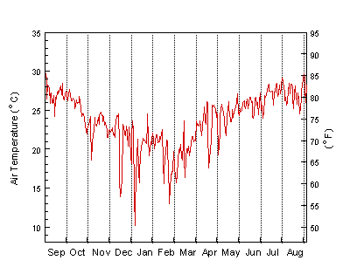
Figure 2.3 Daily mean atmospheric temperature from September 1998 through August 1999 measured at weather station S331-W.

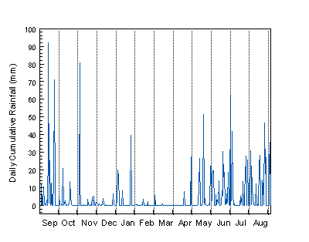
Figure 2.4 Daily cumulative rainfall from September 1998 through August 1999
measured at weather station S331-W.

2.5 Alternative Reservoirs

For the purposes of illustrating the methodologies several relevant CERP storage projects, and some non-CERP projects were evaluated as shown in Table 2.2. The table lists the major CERP reservoirs along with the component number from CERP. The CERP component number is used throughout this analysis. To this list we added a facility recently completed by the Tampa Bay Water Authority and a SFWMD identified L-8 Alternative.

Table 2.2 Alternative Reservoirs

Facility | CERP Identifier | Report Identifier
North of Lake Okeechobee Storage Reservoir | A; A7 | A7
Taylor Creek/Nubbin Slough Storage and Treatment | W; W2 | W2
C-43 Basin Storage Reservoir | D; D5 | D5
C-44 Basin Storage Reservoir | B | B
C-23/C-24/C-25 Northfork and Southfork Storage Reservoir | UU; UU7 | UU7
Everglades Agricultural Storage Reservoirs | G; G5 | G5
Palm Beach County Agricultural Reserve Reservoir | V V; V V6 | V6
Hillsborough (Site 1) Impoundment | M; M6 | M6
Hillsborough (Site 1) Impoundment |  | M6_A
Tampa Bay Water |  | TBW
Rock Pits |  | RP
L-8 Alternative Reservoir |  | L-8 ALT

A numerical simulation of the twelve reservoirs listed in Table 2.2 was conducted using the Reservoir Evaluation Model. The simulation was based on a five-year run under year-by-year repeating meteorological conditions. For each year, the computation started on September 1 and ended on August 31. The reservoirs were filled to their full capacity at beginning of the first year. It was also assumed that all twelve reservoirs are constructed with a seepage collection system sufficient to collect and return all seepage and were therefore modeled without seepage A further assumption is that the simulation is conducted under all natural conditions without inflows or outflows, i.e., the reservoirs collect water naturally through rainfall and lose water naturally through evaporation. The meteorological data used in the simulation is presented in the previous section. The simulation result gives a day-by-day variation of water stage and temperature in each of the reservoirs. The output from the simulation also includes the temporal variation of cumulative amount of rainfall into the reservoir and evaporation from the reservoir. The average annual cumulative rainfall and evaporation are calculated from the five-year result. The lowest water stage, from which the effective capacity and the effectiveness are calculated, is identified from the temporal variation data obtained from simulation. The lowest and the highest average water temperature in the reservoirs are also identified from the data.

Figure 2.5 and 2.6 shows the variation of water stage and water temperature as a function of time, respectively. The results from twelve reservoirs are plotted in the same figure for comparison. The simulation results for the twelve alternative reservoirs are displayed in Table 2.2. The surface area and depth of each reservoir is presented in the same table.

It is observed from Figure 2.5 that water stage decreases during the dry season and reaches the lowest point in May. For all the twelve reservoirs, the water stage reduction is approximately one foot with only minor differences. This is because all the reservoirs are simulated under the same meteorological conditions. However, a similar stage reduction gives different effectiveness for the twelve reservoirs. The effectiveness is about 76% for reservoir B compared to almost 98% for reservoir TBW. Among the twelve reservoirs, reservoir B is the shallowest one while TBW is the deepest one. The results simply indicate that deeper reservoirs have a higher effectiveness than the shallower ones.

The intent of the simulation presented in this report is to reveal the necessity of introducing the concept of the effective capacity and choosing the effectiveness as an important parameter in reservoir planning and design. Hence, the same meteorological data was used for all twelve reservoirs. In practice, the meteorological data obtained on the reservoir site will be used. The reservoir’s operating rule can be easily incorporated in the Reservoir model through Q_{In} and Q_{Out} in Equation (2.2).

Table 2.3 Computational Results for Alternative Reservoirs

 | A7 | W2 | D5 | B | UU7 | G5
Surface Area  (acre) | 17500.00 | 5000.00 | 20000.00 | 10000.00 | 39000.00 | 60000.00
Depth  (ft) | 11.50 | 10.00 | 8.00 | 4.00 | 8.00 | 6.00
Evaporation  (Annual) (ac-ft) | 60557.88 | 17311.60 | 69312.36 | 34822.98 | 135160.80 | 208279.37
Rainfall  (Annual) (ac-ft) | 84030.55 | 24008.79 | 96035.24 | 48017.39 | 187268.52 | 288105.27
Net Evaporation  (Annual) (ac-ft) | -23472.67 | -6697.18 | -26721.88 | -13192.41 | -52107.72 | -79825.90
Temperature High  ( ºC) | 31.82 | 31.96 | 32.16 | 32.63 | 32.16 | 32.37
Temperature Low  ( ºC) | 16.63 | 16.29 | 15.58 | 12.36 | 15.58 | 14.69
Stage Reduced  (ft) | -0.909 | -0.906 | -0.913 | -0.942 | -0.913 | -0.923
Reduced Capacity  (ac-ft) | -15904.91 | -4529.91 | -18257.78 | -9415.01 | -35602.67 | -55380.72
Effective Capacity  (ac-ft) | 185345.09 | 45470.09 | 141742.22 | 30584.99 | 276397.33 | 304619.28
Total Capacity  (ac-ft) | 201250.00 | 50000.00 | 160000.00 | 40000.00 | 312000.00 | 360000.00
Effectiveness  (%) | 92.10% | 90.94% | 88.59% | 76.46% | 88.59% | 84.62%

Table 2.4 Computational Results for Alternative Reservoirs (Continued)

 | V6 | M6 | M6_A | TBW | RP | L-8 ALT
Surface Area  (acre) | 1660.00 | 2460.00 | 1680.00 | 930.00 | 1200.00 | 3994.00
Depth  (ft) | 12.00 | 6.00 | 8.00 | 50.00 | 35.00 | 10.00
Evaporation  (Annual) (ac-ft) | 5742.26 | 8539.46 | 5822.32 | 3181.12 | 4129.71 | 13828.51
Rainfall  (Annual) (ac-ft) | 7970.93 | 11812.32 | 8066.93 | 4465.63 | 5762.13 | 19178.22
Net Evaporation  (Annual) (ac-ft) | -2227.67 | -3272.86 | -2244.61 | -1284.51 | -1632.43 | -5349.70
Temperature High  ( ºC) | 31.77 | 32.37 | 32.16 | 30.09 | 30.09 | 31.96
Temperature Low  ( ºC) | 16.71 | 14.69 | 15.58 | 19.50 | 19.50 | 16.29
Stage Reduced  (ft) | -0.910 | -0.923 | -0.913 | -1.006 | -0.968 | -0.906
Reduced Capacity  (ac-ft) | -1510.29 | -2270.61 | -1532.84 | -935.21 | -1161.65 | -3618.56
Effective Capacity  (ac-ft) | 18409.71 | 12489.39 | 11906.16 | 45564.79 | 40838.35 | 36321.44
Total Capacity  (ac-ft) | 19920.00 | 14760.00 | 13440.00 | 46500.00 | 42000.00 | 39940.00
Effectiveness  (%) | 92.42% | 84.62% | 88.59% | 97.99% | 97.23% | 90.94%

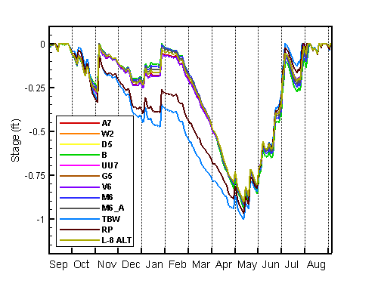
Figure 2.5 Variation of water surface elevation in a year

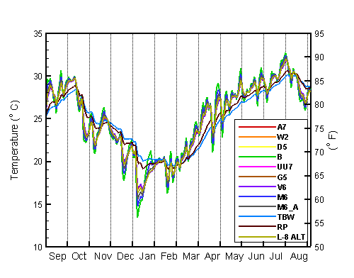
Figure 2.6 Variation of water temperature in a year

2.6 Rock Pits with Power Plant

The objective of the Southern L-8 Storage Reservoir can be summarized as follows:
- Capture excess storm water of L-8 basin to meet water supply demands in the Northern Palm Beach County Service Area including the environmental supply to the GWP, Loxahatchee Slough, and the NWFLR .

- Capture excess storm water of L-8 basin to meet water supply demands and there by reduce discharges to the C-51 Canal and the corresponding discharges to the Lake Worth Lagoon.
- Potentially provide water for the cooling system of a power plant.

The existing limerock quarries (rock pits) which are located immediately west of the L-8 Canal and North of the C-51 Canal are being considered for the proposed Southern L-8 Storage Reservoir. Conceptually, excess runoff volumes in the L-8 Canal will be diverted through culverts and control structures into the rock pits with a storage capacity up to 31,500 ac-ft. The water will be stored in the pits for a period of time, and subsequently released into L-8 Canal by pumping. The rock pits would function as surface runoff storage and recovery units to assist in capturing flows in the L-8 basin that would otherwise be discharged to tide through C-51 Canal. Furthermore, one or more rock pits could function as the cooling volume of water for a thermal power plant, which might be built nearby. The thermal discharge from the power plant will alter water temperature in the rock pits and correspondingly increase evaporation from the rock pits. Therefore the effectiveness and the yield of the reservoir will be changed.

The purpose of this analysis is to determine the effect of thermal discharge on the effectiveness of water storage in the rock pits. Since some of the required meteorological data were not available from the weather station near the rock pits, the meteorological data from station S331-W, as described in the previous section, was used in the simulation. An aerial picture of the site for the rock pits is displayed in Figure 2.7. The current modeling configuration contains seven inter-connected rock pits (Pit A through E, Pit-2 and Pit-3) with the same depth but different surface area as presented in Table 2.4. The current plans for the rock pits indicate a cover area of 600 acres and provide a total storage capacity of approximately 21,000 ac-ft.

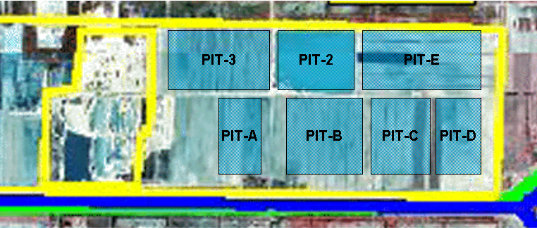

Figure 2.7 Aerial picture of the site for rock pits.

Table 2.4 Rock Pits

 | Surface Area  (ac) | Maximum Depth  (ft) | Storage  (ac-ft) | Bottom Elevation  (ft)
Pit-A | 59.70 | 35 | 2089.52 | -15
Pit-B | 92.30 | 35 | 3265.49 | -15
Pit-C | 79.30 | 35 | 2775.67 | -15
Pit-D | 69.97 | 35 | 2449.12 | -15
Pit-E | 119.22 | 35 | 4172.57 | -15
Pit-2 | 70.04 | 35 | 2451.38 | -15
Pit-3 | 108.78 | 35 | 3807.47 | -15
Total | 600.32 | -- | 21011.22 | --

Figure 2.8 shows a schematic layout of the seven rock pits and the power plant. The inter-connected rock pits are a part of a closed-loop cooling system of the power plant. In Figure 2.8, water is drawn from the Pit-A at a rate of 75 cubic feet per second (cfs) and routed to the power plant. When it flows through the power plant, the water temperature increases by 95 ºF (35 ºC). The hot water is discharged into Pit-3 at the same rate at which water is withdrawn from Pit-A, (75 cfs). The flow from one rock pit to another through the connecting hydraulic structures is driven by gravity. For a fixed reservoir and hydrological conditions the discharge rate and the temperature increase of discharge water determine the thermal loading which in term determines the resulting temperature increase of the reservoir. This temperature increase increases evaporation and reduces the volume of water available for water supply; effectiveness of the reservoir storage. Obviously these parameters depend on the design and operation of the power plant. As a preliminary study, the discharge rate is set at 12.5 cfs and 75 cfs, and the water temperature increase at the power plant is set to be 25 ºC and 35 ºC. A simulation without thermal discharge was also carried out for comparison.

A one-year simulation was conducted based on the meteorological data from 09/01/1998 through 08/31/1999. The seven rock pits were filled to their maximum capacity at the beginning of the simulation. The discharge rate and temperature increase were set to be constant for each run. It should be noted that the 1998 through 1999 period was a period of average rainfall (approximately 55 inches per year). During average years, such as this, the rainfall equals or exceeds evaporation (approximately 48 inches per year). During drought years rainfall is substantively below evaporation. A similar analysis with drought year results in even lower effectiveness for the shallower reservoirs.

Shown in Figure 2.8 are the average temperatures in the rock pits on 06/12/1999 for one simulation with a discharge of 75 cfs and a temperature increase of 35°C. An animation file (75cfs35_2d.avi) showing the day-by-day variation of the average temperature in the rock pits can be found on the attached CD-R disk.

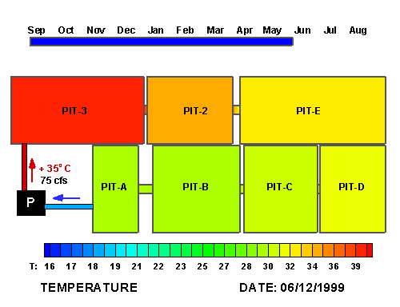
Figure 2.8 Average temperature in the rock pits on 06/12/1999
with a discharge of 75 cfs and a temperature increase of 35°C

More results are presented in Table 2.5, where the first two columns (Case 1 and 2) are corresponding to a same discharge rate of 12.5 cfs, but with different temperature increase, the third and the fourth columns (Case 3 and 4) are arranged in a similar manner, the last column (Case 5) is the result without the power plant. The annual evaporation and rainfall are displayed as the sum from all seven pits. The thermal discharged will increase evaporation. Compared to the Case 5 where there is no thermal discharge, the evaporation from the pits is increased by 12.65% and 19.08% for Case 1 and 2. For a larger discharge rate in Case 3 and 4, the increase in evaporation is 82.28% and 116.18%. The highest and lowest water temperatures are also displayed in Table 2.5. The water temperature increases dramatically in Case 3 and 4. In terms of water stage, it drops approximately 1 ft for Case 1, 2 and 5, the pits lost 2.5 ft in water stage in Case 4. Thus, the storage effective falls below 90% for Case 4 compared to 97% in Case 5.

Table 2.5 Computational Results for Rock Pits

 | Case 1 | Case 2 | Case 3 | Case 4 | Case 5
Discharge Rate | 12.5 cfs |  | 75 cfs |  | Natural
Temperature Increase | + 25 ºC | + 35 ºC | + 25 ºC | + 35 ºC | W/O Plant
Evaporation  (Annual) (ac-ft) | 2364.39 | 2477.43 | 3792.20 | 4497.46 | 2080.41
Rainfall  (Annual) (ac-ft) | 2887.20 | 2887.20 | 2887.20 | 2887.20 | 2887.20
Net Evaporation  (Annual) (ac-ft) | -522.80 | -409.77 | 905.00 | 1610.26 | -806.79
Temperature High  ( ºC) | 34.12 | 34.77 | 40.87 | 44.01 | 32.46
Temperature Low  ( ºC) | 14.35 | 14.38 | 14.83 | 15.00 | 14.21
Stage Reduced  (ft) | -1.19 | -1.31 | -2.69 | -2.54 | -0.92
Reduced Capacity  (ac-ft) | -715.62 | -784.14 | -1611.24 | -2125.62 | -554.10
Effective Capacity  (ac-ft) | 20284.38 | 20215.86 | 19388.76 | 18874.38 | 20445.90
Total Capacity  (ac-ft) | 21000.00 | 21000.00 | 21000.00 | 21000.00 | 21000.00
Effectiveness  (%) | 96.59% | 96.27% | 92.33% | 89.88% | 97.36%

The temporal variation of water stage and cumulative evaporation/rainfall recorded during the simulation are presented in Figure 2.9 through Figure 2.12. Figure 2.9 shows the variation of water stage in Pit-3 as a function of time for a discharge rate of 12.5 cfs and different temperature increase at the power plant. The blue curve is corresponding to Case 5, and the green and the red curves are from Case 1 and 2, respectively. For Case 1, 2 and 5, the pit will be filled to its full capacity at the end of August, because the cumulative rainfall is greater than the cumulative evaporation, as shown in Figure 2.11, where the brown curve (rainfall) overtakes all other curves (evaporation). In Figure 2.11, the water stage of the Pit-3 from simulation of Case 3 and 4 drop severely, and they are not able to recover at the end of August, because the cumulative rainfall is less than the cumulative evaporation, as shown in Figure 2.12. The results indicate that under meteorological conditions (09/98-08/99 at S331-W) used in the simulation, collecting water naturally from rainfall while being used as the cooling pond of the power plant, the rock pits loses more water to evaporation than it gains from rainfall each year, which means that supplemental water is needed to prevent the rock pits from emptying.

Figure 2.13 shows the variation of water temperature in the rock pits as a function of time from Case 4. The water temperature varies in a similar manner as the air temperature shown in Figure 2.2. On the same day, the temperatures are different for different rock pits. It is because the hot water is discharged directly into Pit-3, where the highest temperature occurs. The variation of temperature in Case 5 is displayed in Figure 2.14. The comparison between Figure 2.13 and 2.14 shows that the augment above the natural water temperature, driven by thermal discharge, is approximately 12°C and 3°C for Pit-3 and Pit-A, respectively.

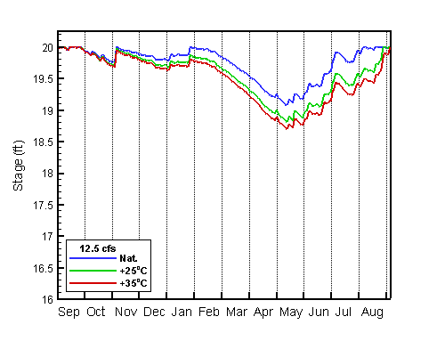
Figure 2.9 Variation of water surface elevation of Pit-3 in a one-year simulation for
12.5 cfs thermal discharge and different temperature increase.

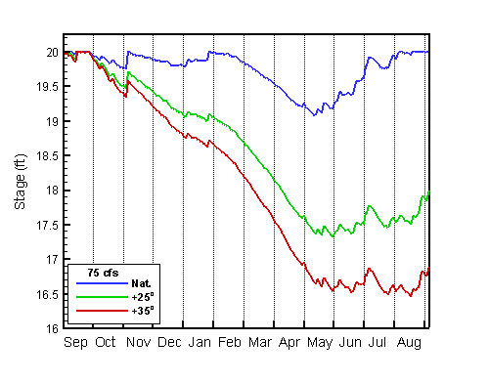
Figure 2.10 Variation of water surface elevation of Pit-3 in a one-year simulation for
75 cfs thermal discharge and different temperature increase.

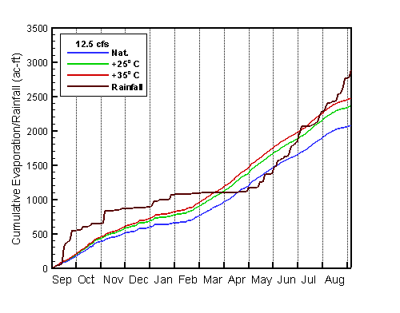
Figure 2.11 Variation of cumulative Evaporation/Rainfall of Pit-3 in a one-year simulation for 12.5 cfs thermal discharge and different temperature increase.

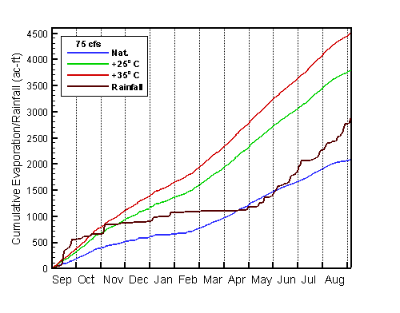
Figure 2.12 Variation of cumulative Evaporation/Rainfall of Pit-3 in a one-year simulation for 75 cfs thermal discharge and different temperature increase.

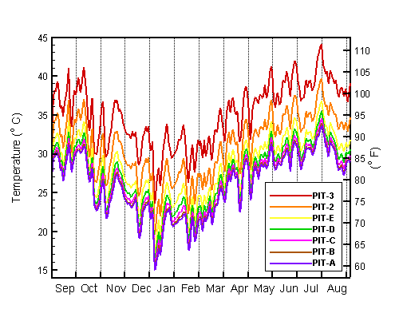
Figure 2.13 Variation of water temperature in a one-year simulation for
75 cfs thermal discharge at a temperature increase of 35°C

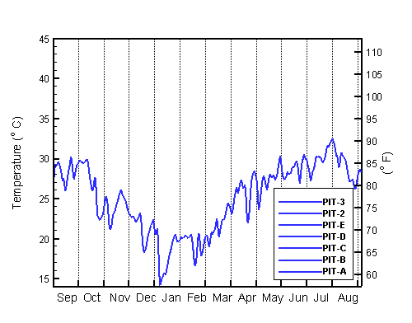
Figure 2.14 Variation of water temperature in a one-year simulation without thermal discharge.

Reference

- Chow, V.T., Maidment, D.R. and Mays, L.W. 1988. Applied Hydrology, New York, McGraw-Hill.
- Dunkelberger Engineering & Testing, 2002. L8 Basin Pilot Study Geohydrological Report (Pit A), Palm Beach County, FL.
- McCuen, R. H. 1989. Hydrologic Analysis and Design, Prentice-Hall, Englewood Cliffs, NJ.
- South Florida Water Management District, 1996. Technical Memorandum #1A, Data Acquisition for the Southern L-8 Basin.
- South Florida Water Management District, 1996. Technical Memorandum #2A, Hydrologic Model for the Southern L-8 Basin.
- South Florida Water Management District, 1997. Technical Memorandum #3A, Hydraulic Model for the Southern L-8 Basin.
- South Florida Water Management District, 2000. Lower East Coast Regional Water Supply Plan, Planning Document.
- South Florida Water Management District, 2000. Lower East Coast Regional Water Supply Plan, Appendices Volume I.
- South Florida Water Management District, 2002. Northern Palm Beach County Comprehensive Water Management Plan, Planning Document Volume I.
- South Florida Water Management District, 2003. DBHYDRO: South Florida Water Management District’s corporate environmental online database. (Web site URL: http://www.sfwmd.gov/org.ema/dbhydro/)

