STORMWATER REUSE

Marty Wanielista
University of Central Florida
Orlando, Florida

ABSTRACT:

Stormwater runoff stored in a surface pond or in the surficial aquifer and then used as a source of irrigation water can reduce potable water use in an area and reduce total maximum daily loadings from stormwater. The design process for the storage volume and reuse rate of a surface detention pond is presented, with examples from systems operating in Florida.

INTRODUCTION:

Pollutants in stormwater have been well documented (Wanielista, 1993, Wanielista, 1997). They are either dissolved in solution or in particulate form. Detention or the temporary storage of stormwater has an effective on removing some of the particulate load of pollutants. To remove additional pollutants, the associated dissolved materials are either removed by vegetative uptake, filtered, or by other means. However, when stored waters are evaporated, infiltrated or irrigated from the pond, additional pollutants are prevented from surface discharge. There is less flow from the pond, and thus less pollutant mass. Thus the pollutant loads are reduced from pond surface discharges.

Some of the materials in the pond, such as nutrients are important for vegetative growth if applied in a controlled manner. Irrigation of detained stormwaters is one way of removing a fraction of the detained waters from a pond and its associated nutrient loads. Some of the benefits of irrigation are that the pollutant loads are reduced from surface discharge from the detention ponds and the detained waters are a source of irrigation quality water.

On the average, and in most of the State of Florida, approximately 50% of the potable water delivered to residential units is used for irrigating lawns. The potable water used for irrigation may be supplemented with non-potable water from stormwater detention facilities. The use of detention stormwater in new developments is very probable (Wanielista and Hartman, 2003), because the cost of irrigating the detained stormwater is significantly less than the cost of potable water and in most cases about 5-25% the cost of potable water. In specific new development locations in the State of Florida, the cost of irrigation water from detention ponds is certainly competitive.

When reclaimed water is insufficient to meet demand or when the cost of water is of concern, detained stormwater is most useful. Most recently, Total Maximum Daily stormwater pollutant loadings to our natural waters are being regulated. The reuse of stormwater is an alternative source of non-potable water and most likely the major use is for irrigation.

DESIGN of DETENTION PONDS FOR IRRIGATION

A detention pond has a permanent pool, and a volume of water that is detained before released. The detained water volume is called in this paper the reuse volume, implying that the water can be reused and not discharged to another surface water. The permanent pool is regulated by the groundwater table or in some cases artificially regulated at a certain depth if an impermeable membrane is used between the ground and the detained water. Stormwater runoff is stored in a detention pond and most likely in the reuse volume above the permanent pool. A designer is faced with the decision on how large to make the reuse volume, the rate of reuse, and the percentage of water to retain. A schematic of a detention pond used for irrigation is shown in Figure 1.

To help determine the size of the detention pond and the water available for irrigation, simulations of the runoff volumes, the rate of irrigation, and the size of the reuse pool are determined for the rainfall, evaporation, and runoff conditions for an area. A long-term simulation for the schematic shown in Figure 1 can result in the design charts of Figure 2. Thus the designer of the pond has the freedom to specify the reuse volume for a particular runoff capture efficiency, and then calculate the reuse rate over an equivalent impervious area. The use of Figure 2 requires that two of the three variables must be known. Then the remaining variable is calculated. One use is for the reduction in stormwater mass. Thus the efficiency is know, and the reuse volume and size of pond can be read from the Figure, and different combinations of reuse rate and reuse volume are possible. With the different combinations, the designer is free to optimize under various sets of criteria.

A mass balance is used for the runoff and pond simulation, and the calculations can be performed using a spreadsheet or a computer program (Wanielista and Bradner, 1992). An example of the equations used for the calculations and the parameters are:

INPUTS – OUTPUTS = STORAGE CHANGE
S₁ + RP + RI + R + Gin –ET – D – RU - Gout = S₂

Where: S₁ = Pond storage volume at the start of each time period (usually daily)

S₂ = Pond storage volume at the end of each time period

RP = Precipitation volume on the pond

RI = Indirect runoff volume from adjacent area not conveyed by pipes

Gin = Volume of water moving into the pond from the ground

Gout = Volume of water moving from the pond to the ground

D = Discharge volume

ET = Evapotranspiration volume

RU = Reuse volume

R = Rainfall or rainfall excess volume from impervious areas

EXAMPLE DESIGNS

1. A pond in a commercial area that services about 25 acres with only 4.2 pervious acres was design with a need to provide non-potable water for truck washing and lawn irrigation. The pond was designed for the runoff of 8 inches over the equivalent impervious area. The pond is now 22 years old and is still in operation. It has never gone dry, has never failed to provide non-potable water, and has never overflowed. It was really designed as a retention pond. The consumer cost of this system is about $0.10/1000 gallons.

- A detention pond in a park area receiving runoff from a commercial area was designed to irrigate about 50% of the runoff water. The reuse volume was calculated as 1 inch over 3.42 acres of directly connected impervious area. The operation of the pond was documented as to the % of water reused over a one-year period (Bradner and Wanielista, 1992). The design curve of Figure 2 was used. The one-year operation validated the design curve. A City operates this detention system and the cost of the system amortized over 20 years was about $0.15/1000 gallons.

3. A 900 home residential area had an irrigation system designed for it using stormwaters stored in the surficial aquifer. This gave the added benefit of filtering the stormwater before being used for irrigation. The consumer cost includes the cost of additional retrofits and was about $0.50/1000 gallons.

4. A mixed-use 32000-acre area drawing waters from horizontal wells, canals and detention ponds is also operational. The consumer cost is about $0.27/1000 gallons.

5. Another system was designed to service an agricultural area of approximately 550,000 acres. The detained waters are in surface ponds and in shallow ground water supplies. The consumer cost is about $19.2/1000 gallons.

REFERENCES:

Bradner, J.N., and Wanielista, M.P., Project SMART, Florida Department of Environmental Regulation, Orlando, Florida, May 31, 1992, 98 pages.
Wanielista, M.P., and Bradner, J.N., Project SMART, a Restoration/Demonstration. University of Central Florida, December 1992, 107 pages.
Wanielista, M.P., Yousef, Y.A., Harper, G.M., and Dansereau, L.D., "Design Curves For The Reuse of Stormwater", Florida Department of Environmental Regulation, November, 1991, 133 pages.
Wanielista, M.P. and Yousef, Y.A., Stormwater Management, J.Wiley and Sons, New York, 1993, 579 pages.
Wanielista, M. P. and Kersten, R. and Eaglin, R. Hydrology and Water Quality Control, J. Wiley and Sons, N.Y. 1997, 567 pages.
Wanielista, M.P. and Gerry Hartman, G. Irrigation Quality Water, ASCE, Water Resources Conference, Orlando, April 4, 2003.

BIO:

Marty Wanielista is the Director of the Stormwater Management Academy. He is a professor at the University of Central Florida in Orlando, Florida. He can be contacted at 407-823-2156, or by email at wanielis@mail.ucf.edu. You may also contact the Academy at www.stormwater.ucf.edu.

Figure 1. A Schematic of a Detention Pond used for Reuse.

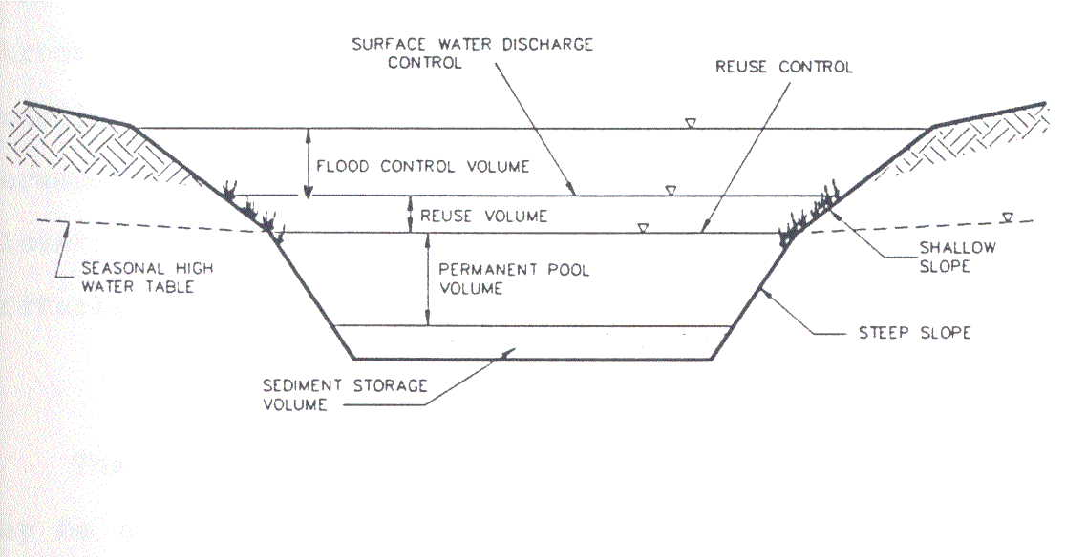

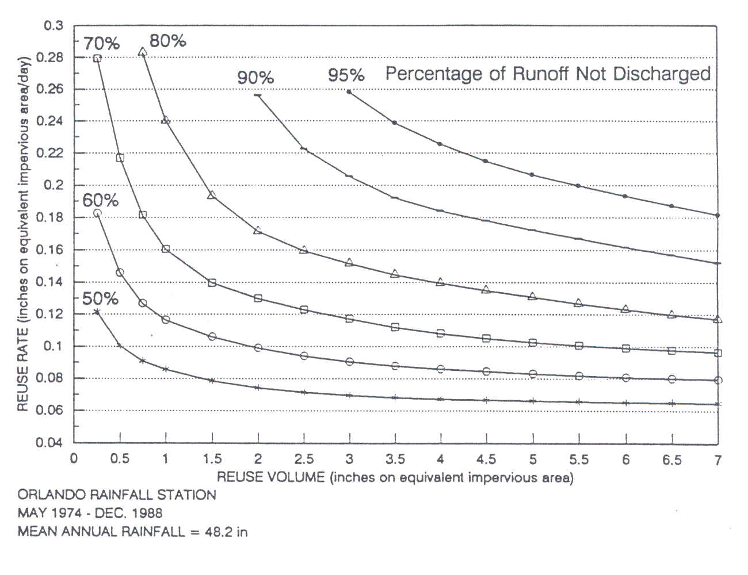

Figure 2. An Example REV (Reuse, Efficiency, and Volume) Chart.

